REDTAIL LABORATORY EXERCISE
Directional Wiper Controller
DE1-SoC with SystemVerilog
LEVEL Intermediate | TIME 90-120 minutes | PLATFORM Altera DE1-SoC

Build a two-bit SystemVerilog controller that remembers the windshield-wiper travel direction and reverses it at each endpoint. The simulation animates the blade, while your module owns stop, direction, and fault commands.
The Wiper 2-Bit 3D simulation and original remote-laboratory exercise were created by Giovanna Lani and WebLab-Deusto at the University of Deusto in Spain. This lesson adapts their directional challenge to REDTAIL's current SystemVerilog workflow and mapping. The completed implementation is available separately to verified instructors.
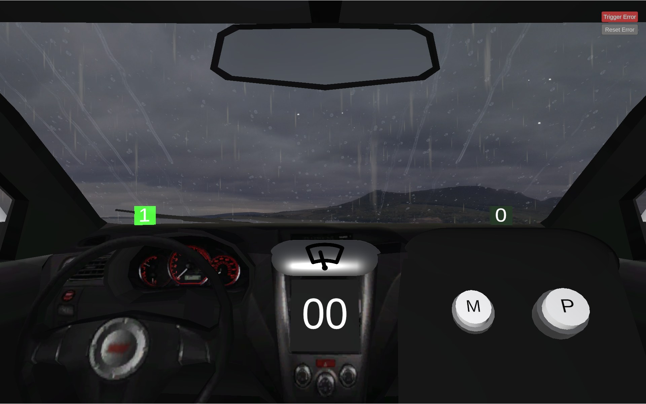
Figure 1. Wiper 2-Bit 3D simulation by Giovanna Lani and WebLab-Deusto, University of Deusto (Spain).
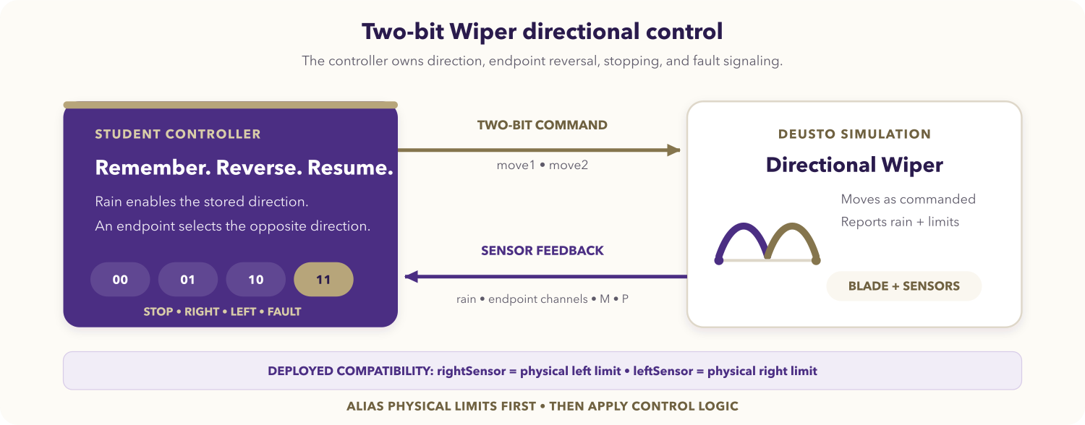
Figure 2. Directional two-bit Wiper control loop.

Learning objectives
After completing the activity, you should be able to:
- implement a small state machine with always_ff and always_comb;
- encode four command meanings on a two-bit output;
- preserve travel direction while movement is paused;
- reverse safely at physical endpoints;
- use semantic aliases to contain an external naming mismatch;
- verify reset, sequence, fault, and button-isolation behavior.

Prerequisites
You should know SystemVerilog modules, enumerated types, blocking versus nonblocking assignments, always_ff, and always_comb. You need the DE1-SoC SystemVerilog Code-IDE and the Wiper 2-Bit simulation.
Open the REDTAIL Wiper 2-Bit simulation and the current DE1-SoC mapping before starting.

Compatibility contract
The deployed endpoint channel names are reversed relative to physical position:
Runtime input | Physical meaning
rightSensor | Blade is at the physical left-hand limit.
leftSensor | Blade is at the physical right-hand limit.

Immediately alias these signals as at_left_limit and at_right_limit and write the controller in physical terms. Do not swap pins or alter the deployed channel names.

Required behavior
The pair {move1, move2} uses this contract:
move1 | move2 | Physical command
0 | 0 | Stop
0 | 1 | Move physically right
1 | 0 | Move physically left
1 | 1 | Fault

Rain enables movement; dry conditions stop without erasing direction. Begin toward the physical right after reset, reverse at each endpoint, output 11 for simultaneous endpoints, and keep M/P outside the core policy.

DE1-SoC signal mapping
Runtime signal | SystemVerilog access | Direction | Semantic use
M button | V_GPIO[23] | Simulation to FPGA | Optional extension
P button | V_GPIO[24] | Simulation to FPGA | Optional extension
move1 | V_GPIO[26] | FPGA to simulation | First command bit
move2 | V_GPIO[27] | FPGA to simulation | Second command bit
Rain sensor | V_GPIO[28] | Simulation to FPGA | Movement request
rightSensor | V_GPIO[29] | Simulation to FPGA | Physical left limit
leftSensor | V_GPIO[30] | Simulation to FPGA | Physical right limit
Reset | V_BT[0] | Board to design | Active low

The REDTAIL mapping is authoritative over endpoint tables in older guide versions.
Use only V_GPIO[35:23]; lower lanes alias V_BT pins in the shared constraints and must not appear beside V_BT in the same top level.

Assignment

1. Design the state machine
Use two named direction states. Draw endpoint transitions and identify the conditions that preserve state. Rain should gate the output only; a dry pause must not reset the direction register.

2. Create the module
Create wiper_2bit_deusto.sv:
module wiper_2bit_deusto (
input logic CLOCK_50,
input logic [3:0] V_BT,
inout wire [35:23] V_GPIO,
output logic [9:0] G_LEDR
);
// Alias deployed endpoint names to physical limits.
// Store direction in always_ff; derive commands in always_comb.
// Drive only V_GPIO[26] and V_GPIO[27].
endmodule
Complete the module yourself. Give every combinational path a default, keep sequential and output logic separate, and assign all diagnostic LED bits.

3. Review priority and assertions
Give simultaneous endpoints highest command priority. Make a coherent endpoint override the registered direction immediately, then update the direction state on the clock. Add or describe assertions that reject unknown/invalid commands and verify that dry cycles retain direction.

4. Compile and program
- Select the DE1-SoC SystemVerilog environment and Wiper 2-Bit simulation.
- Add the .sv source and select its matching top level.
- Synthesize and resolve relevant latch, width, unknown, or multiple-driver warnings.
- Program the FPGA and compare command bits with physical motion.

Required test sequence
Test | Action | Expected command and behavior
Reset, dry | Reset and release with rain off. | 00; default direction is right.
Rain start | Enable rain between endpoints. | 01; move physically right.
Right endpoint | Assert leftSensor. | 10; reverse physically left.
Dry pause/resume | Pause while moving left, then restore rain. | 00, then 10; direction persists.
Left endpoint | Assert rightSensor. | 01; reverse physically right.
Button isolation | Toggle M and P while dry. | 00; core direction and command do not change.
Sensor fault | Assert both endpoint inputs. | 11.
Fault recovery | Clear the contradiction with rain active. | Coherent endpoint or stored direction determines travel.

Deliverables
Submit the state diagram, wiper_2bit_deusto.sv, compatibility aliases, assertion or test results, live test evidence, and an explanation of dry-state retention and fault priority.

Optional extensions
- Define a documented manual role for M or P.
- Synchronize the external inputs before state transitions.
- Latch and acknowledge a visible diagnostic fault.
- Add functional coverage for every command and transition.

Completion checklist
- The source is SystemVerilog and uses explicit sequential/combinational logic.
- Endpoint names are translated to physical aliases exactly once.
- Direction reverses at each physical endpoint and persists while dry.
- Dual endpoints produce 11; M and P do not affect the core.
- Reset and every required sequence have been verified.

