REDTAIL LABORATORY EXERCISE
Directional Wiper Controller
STM32 NUCLEO-WB55RG with Mbed OS
LEVEL Intermediate | TIME 90-120 minutes | PLATFORM STM32 NUCLEO-WB55RG

Implement a stateful two-bit windshield-wiper controller for the STM32 NUCLEO-WB55RG. Your Mbed application owns stop, physical direction, and the fault command; the simulation owns the rendered blade motion.
The Wiper 2-Bit 3D simulation and original remote-laboratory exercise were created by Giovanna Lani and WebLab-Deusto at the University of Deusto in Spain. This lesson adapts their directional challenge to the current REDTAIL STM32 mapping. The completed application is available separately to verified instructors.
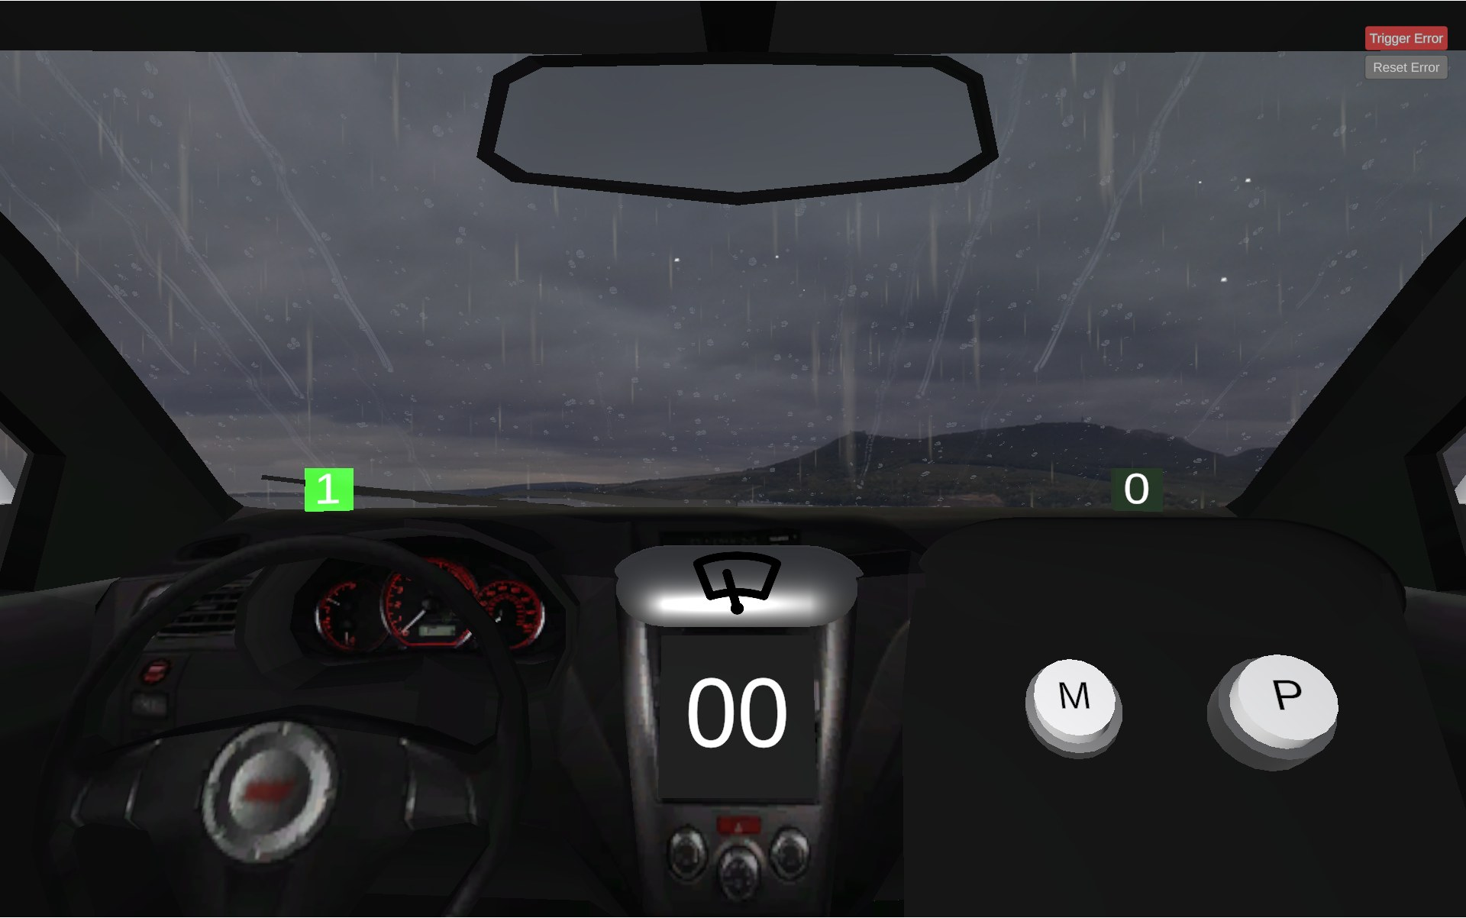
Figure 1. Wiper 2-Bit 3D simulation by Giovanna Lani and WebLab-Deusto, University of Deusto (Spain).
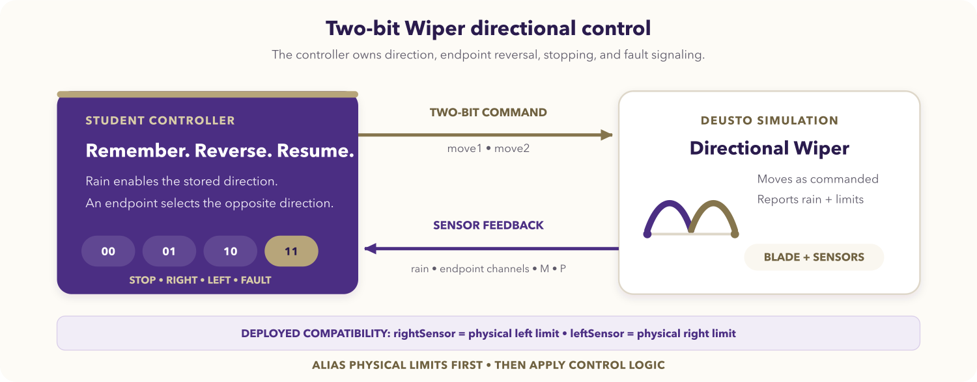
Figure 2. Directional two-bit Wiper control loop.

Learning objectives
After completing the activity, you should be able to:
- separate a stateful control policy from Mbed GPIO glue;
- represent stop, right, left, and fault as a two-bit command;
- retain travel direction across polling iterations and dry pauses;
- reverse at coherent physical endpoint feedback;
- contain a deployed naming mismatch with semantic aliases;
- host-test reset, sequence, fault, and optional-input isolation.

Prerequisites
You should know C++ functions, small structs or enums, Mbed DigitalIn and DigitalOut, and polling loops. You need Mbed OS 6 or Mbed OS CE for NUCLEO_WB55RG and access to the Wiper 2-Bit simulation.
Open the REDTAIL Wiper 2-Bit simulation and the current STM32 mapping before starting.

Compatibility contract
The deployed endpoint inputs are named for the opposite physical side:
Runtime input | Physical meaning
rightSensor / PA_6 | Blade is at the physical left-hand limit.
leftSensor / PB_9 | Blade is at the physical right-hand limit.

Read each pin once per loop and immediately create at_left_limit and at_right_limit values. Keep all policy code in physical terms. Do not swap the deployed pins.

Required behavior
The command pair is (move1, move2):
move1 | move2 | Physical command
0 | 0 | Stop
0 | 1 | Move physically right
1 | 0 | Move physically left
1 | 1 | Fault

The controller starts with rightward direction, moves only while rain is active, reverses at each physical endpoint, preserves direction across dry pauses, outputs 11 for simultaneous endpoints, and ignores M/P in the core.

STM32 signal mapping
Runtime signal | Mbed pin | Direction | Semantic use
Rain sensor | PC_13 | Input | Movement request
rightSensor | PA_6 | Input | Physical left limit
leftSensor | PB_9 | Input | Physical right limit
M button | PB_8 | Input | Optional extension
P button | PC_12 | Input | Optional extension
move1 | PC_4 | Output | First command bit
move2 | PD_0 | Output | Second command bit

Initialize both outputs low before the polling loop. The current REDTAIL mapping is authoritative over tables in older Deusto development documents.

Assignment

1. Define a host-testable policy
Represent direction as an enum and the output as a two-Boolean command. Write a policy step that receives the previous direction plus one input snapshot and returns the next direction and current command. Keep Mbed types out of it.

2. Create the Mbed application
Create main.cpp and a small policy header:
enum class Direction { toward_right, toward_left };
struct Command {
bool move1;
bool move2;
};
// Define a policy state and a step function without GPIO access.
int main() {
// Configure five inputs and two outputs, initially low.
// Read one complete snapshot per loop.
// Alias runtime endpoint names to physical limits.
// Evaluate the policy and write both command bits together.
}
Complete the policy yourself. A dry input must suppress the command without resetting stored direction. A physical endpoint should change direction before the command is returned for that iteration.

3. Host-test sequences
Test complete sequences, not only isolated truth-table rows. Include reset, right travel, right-endpoint reversal, a dry pause, resume toward the left, left-endpoint reversal, dual-endpoint fault, recovery, and M/P non-interference.

4. Compile and program
- Select NUCLEO_WB55RG, the Mbed environment, and Wiper 2-Bit simulation.
- Compile the application and run the host policy tests.
- Program the board with both outputs initially low.
- Compare (move1, move2) with physical blade direction throughout the live test.

Required test sequence
Test | Action | Expected command and behavior
Reset, dry | Initialize with rain off. | 00; default direction is right.
Rain start | Enable rain between endpoints. | 01; move physically right.
Right endpoint | Assert runtime leftSensor. | 10; reverse physically left.
Dry pause | Disable rain while travelling left. | 00; left direction is retained.
Dry resume | Re-enable rain away from endpoints. | 10; left travel resumes.
Left endpoint | Assert runtime rightSensor. | 01; reverse physically right.
Button isolation | Toggle M and P while dry and while raining. | Required commands remain unchanged.
Sensor fault | Assert both endpoint inputs. | 11.
Fault recovery | Clear the contradiction. | Coherent endpoint or stored direction determines travel.

Deliverables
Submit the state diagram, policy and application sources, host and live test evidence, and a short explanation of the aliases and dry direction retention.

Optional extensions
- Give M or P a documented manual behavior without changing the rain core.
- Add transition logging outside the policy and a fault indicator with explicit acknowledgement.
- Schedule the polling step periodically while retaining atomic snapshots.

Completion checklist
- GPIO reads are separated from the host-testable policy.
- Runtime endpoint names are translated to physical aliases once per snapshot.
- Direction reverses at each physical endpoint and survives dry pauses.

