REDTAIL LABORATORY EXERCISE
Directional Wiper Controller
DE1-SoC with VHDL
LEVEL Intermediate | TIME 90-120 minutes | PLATFORM Altera DE1-SoC

Design and test a stateful two-bit controller for a simulated vehicle windshield wiper. Unlike the one-bit Wiper, this simulation expects your VHDL design to remember the travel direction and reverse it at each endpoint.
The Wiper 2-Bit 3D simulation and original remote-laboratory exercise were created by Giovanna Lani and WebLab-Deusto at the University of Deusto in Spain. This lesson adapts their directional VHDL challenge to the current REDTAIL mapping. The completed implementation is provided separately to verified instructors.
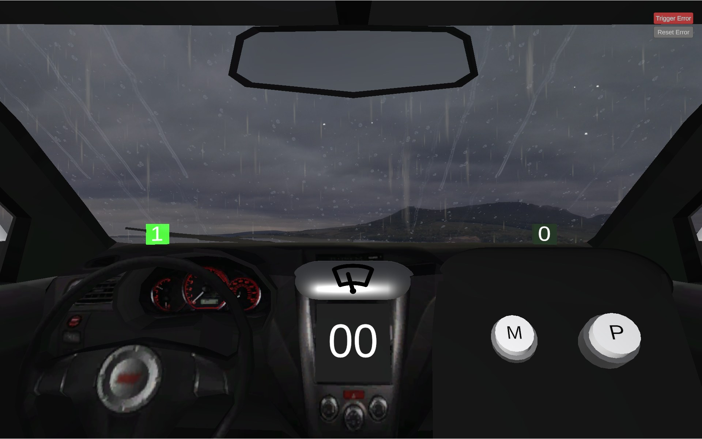
Figure 1. Wiper 2-Bit 3D simulation by Giovanna Lani and WebLab-Deusto, University of Deusto (Spain).
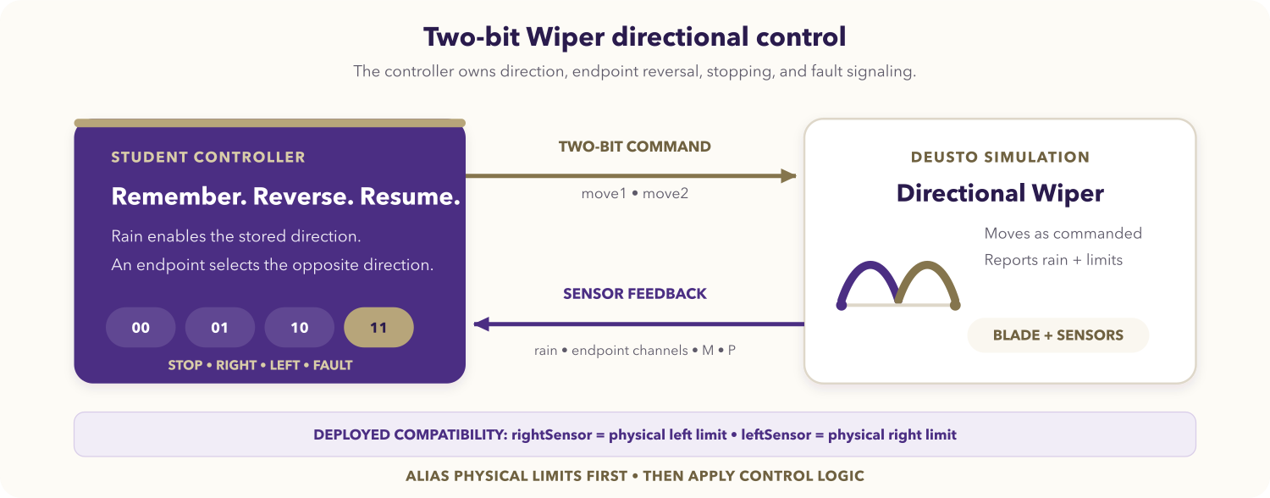
Figure 2. Directional two-bit Wiper control loop.

Learning objectives
After completing the activity, you should be able to:
- design a small synchronous state machine in VHDL;
- encode stop, right, left, and fault commands on two outputs;
- preserve direction through a dry pause and resume;
- reverse immediately and safely at physical travel limits;
- isolate runtime signal names from their physical meanings with aliases;
- verify reset, endpoint, persistence, and contradictory-sensor behavior.

Prerequisites
You should know VHDL entities, enumerated state types, clocked processes, combinational output logic, and std_logic. You need the DE1-SoC VHDL Code-IDE and access to the Wiper 2-Bit simulation.
Open the REDTAIL Wiper 2-Bit simulation and the current DE1-SoC mapping before starting.

Compatibility contract
The deployed two-bit simulation uses endpoint signal names that are reversed relative to their physical locations:
Runtime input | Physical meaning in this simulation
rightSensor | Blade is at the physical left-hand limit.
leftSensor | Blade is at the physical right-hand limit.

Create semantic aliases such as at_left_limit and at_right_limit as soon as you read the inputs. Use those aliases throughout the state machine. This compatibility contract is intentional for this exercise and must not be "corrected" by changing pins or renaming the deployed channels.

Required behavior
The output pair is interpreted in (move1, move2) order:
move1 | move2 | Physical command
0 | 0 | Stop
0 | 1 | Move physically right
1 | 0 | Move physically left
1 | 1 | Fault

Your core controller must:
- stop while rain is inactive;
- begin by moving physically right after reset when rain is active and no endpoint supplies a direction;
- reverse toward the left at the physical right endpoint;
- reverse toward the right at the physical left endpoint;
- remember the most recent direction during a dry pause and resume it;
- output 11 whenever both endpoint sensors are high;
- ignore M and P in the required solution.

DE1-SoC signal mapping
Runtime signal | VHDL access | Direction | Semantic use
M button | V_GPIO(23) | Simulation to FPGA | Optional extension
P button | V_GPIO(24) | Simulation to FPGA | Optional extension
move1 | V_GPIO(26) | FPGA to simulation | First command bit
move2 | V_GPIO(27) | FPGA to simulation | Second command bit
Rain sensor | V_GPIO(28) | Simulation to FPGA | Movement request
rightSensor | V_GPIO(29) | Simulation to FPGA | Physical left limit
leftSensor | V_GPIO(30) | Simulation to FPGA | Physical right limit
Reset | V_BT(0) | Board to design | Active low

The virtual GPIO indices are LabsLand bus positions. The REDTAIL mapping is authoritative over tables in older development versions of the Deusto guide.

Assignment

1. Model direction explicitly
Draw a two-state diagram with toward_right and toward_left. Add transitions for both physical endpoints and show which conditions preserve state. Treat rain as an output enable, not as a reason to erase the remembered direction.

2. Create the VHDL top level
Create wiper_2bit_deusto.vhd:
library ieee;
use ieee.std_logic_1164.all;
entity wiper_2bit_deusto is
port (
CLOCK_50 : in std_logic;
V_BT : in std_logic_vector(3 downto 0);
V_GPIO : inout std_logic_vector(35 downto 23);
G_LED : out std_logic_vector(9 downto 0) := (others => '0')
);
end entity wiper_2bit_deusto;
Complete the architecture yourself. Define physical endpoint aliases, update direction in a clocked process, and derive both command bits in complete combinational logic. Drive only V_GPIO(26) and V_GPIO(27).

3. Review priority and timing
Give the dual-endpoint fault highest output priority. Make an endpoint reversal effective immediately in the command logic so the controller cannot continue driving into an active physical limit while waiting for the next clock edge. Explain how the direction register makes a dry resume deterministic.

4. Compile and program
- Select the DE1-SoC VHDL environment and Wiper 2-Bit simulation.
- Add the source and select wiper_2bit_deusto as the top level.
- Synthesize and resolve relevant multiple-driver, latch, or undriven warnings.
- Program the FPGA and observe physical travel direction beside the command bits.

Required test sequence
Test | Action | Expected command and behavior
Reset, dry | Hold reset, then release it with rain off. | 00; default stored direction is right.
Rain start | Enable rain between endpoints. | 01; blade moves physically right.
Right endpoint | Activate physical right limit (leftSensor). | 10; blade reverses physically left.
Dry pause | Disable rain while travelling left. | 00; left direction is retained.
Dry resume | Re-enable rain away from the endpoints. | 10; left travel resumes.
Left endpoint | Activate physical left limit (rightSensor). | 01; blade reverses physically right.
Button isolation | Press M and P while dry. | 00; neither button changes core behavior.
Sensor fault | Activate both endpoint inputs. | 11; no movement command is issued.
Fault recovery | Clear the contradiction with rain active. | Travel resumes according to the coherent endpoint or stored direction.

Deliverables
Submit the state diagram, compatibility aliases, wiper_2bit_deusto.vhd, test evidence for every row, and a short explanation of dry direction persistence and fault priority.

Optional extensions
- Give M or P a documented behavior without changing the core rain policy.
- Synchronize simulation inputs before clocked use.
- Latch a visible diagnostic fault until acknowledgement.
- Add assertions for command validity, endpoint reversal, and dry-state retention.

Completion checklist
- Endpoint runtime names are translated to physical aliases exactly once.
- 00, 01, 10, and 11 match the deployed command contract.
- Direction reverses at each physical endpoint and survives a dry pause.
- Dual endpoints produce 11; M and P do not affect the core.
- Reset and all required live sequences have been demonstrated.

