Introduction to STM32 Programming and Remote Lab
Lab Objectives
This lab introduces how to program STM32 development boards using the Arduino IDE and the STM32 remote laboratory.
Background
STM32
STM32 is a family of 32-bit microcontroller integrated circuits from STMicroelectronics, built around the ARM Cortex-M processor core. Known for balancing high performance, high superiority, and a rich set of peripherals, these chips are widely used in applications ranging from industrial control and the Internet of Things (IoT) to consumer electronics and automotive systems. Their popularity is further supported by a comprehensive development ecosystem, including the graphical STM32CubeMX development tool and extensive documentation, making them accessible to both professional engineers and hobbyists.
The STM32 development boards we will use are the STM32WB Nucleo-64 boards, specifically the NUCLEO-WB55RG model, as shown in Figure 1. This board features an ultra-low-power microcontroller with integrated Bluetooth® Low Energy (BLE) wireless technology, compliant with the Bluetooth SIG specification v5.2. In addition, the board supports programming through the Arduino IDE, making it accessible and versatile for embedded development.
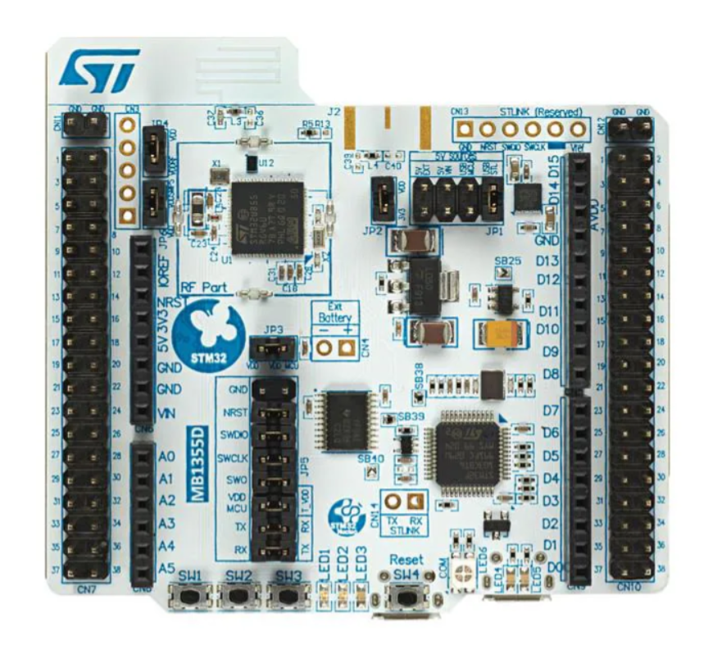
Figure 1

STM32 Remote Laboratory
In most of the lab assignments, we will use an STM32 remote laboratory available on LabsLand, a global network of educational remote laboratories.
To get access to the STM32 remote lab,
- Please contact RHLab or LabsLand to receive an access link to the remote lab. After you click the given link, you should see a similar page to that in Figure 2.
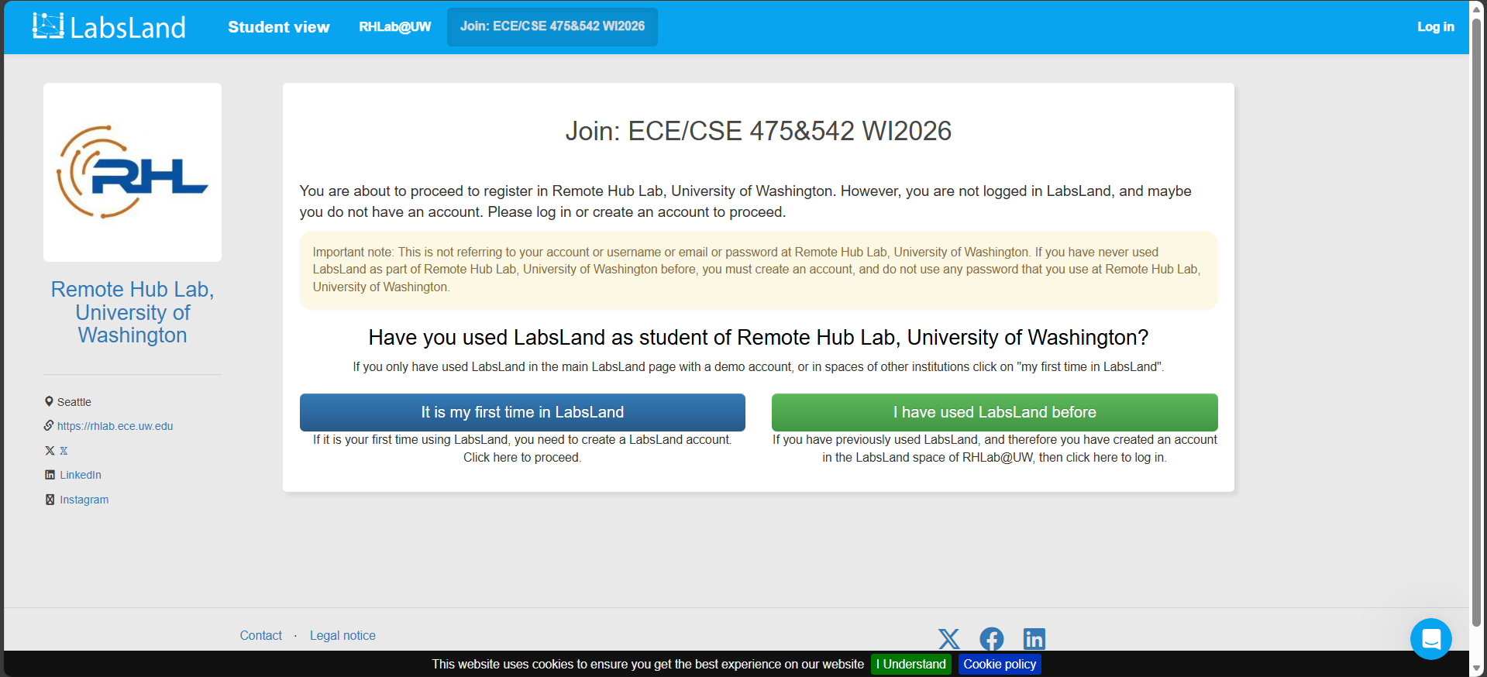
Figure 2
- If you already have a LabsLand account, sign in by clicking the green icon “I have used LabsLand before”.
If not, create a LabsLand account by clicking the blue icon “It is my first time in LabsLand”.
- After you sign up, you should see an invitation to join the course group in Figure 3. Click the blue icon in the middle of the page, “Yes, add me to your course name”.
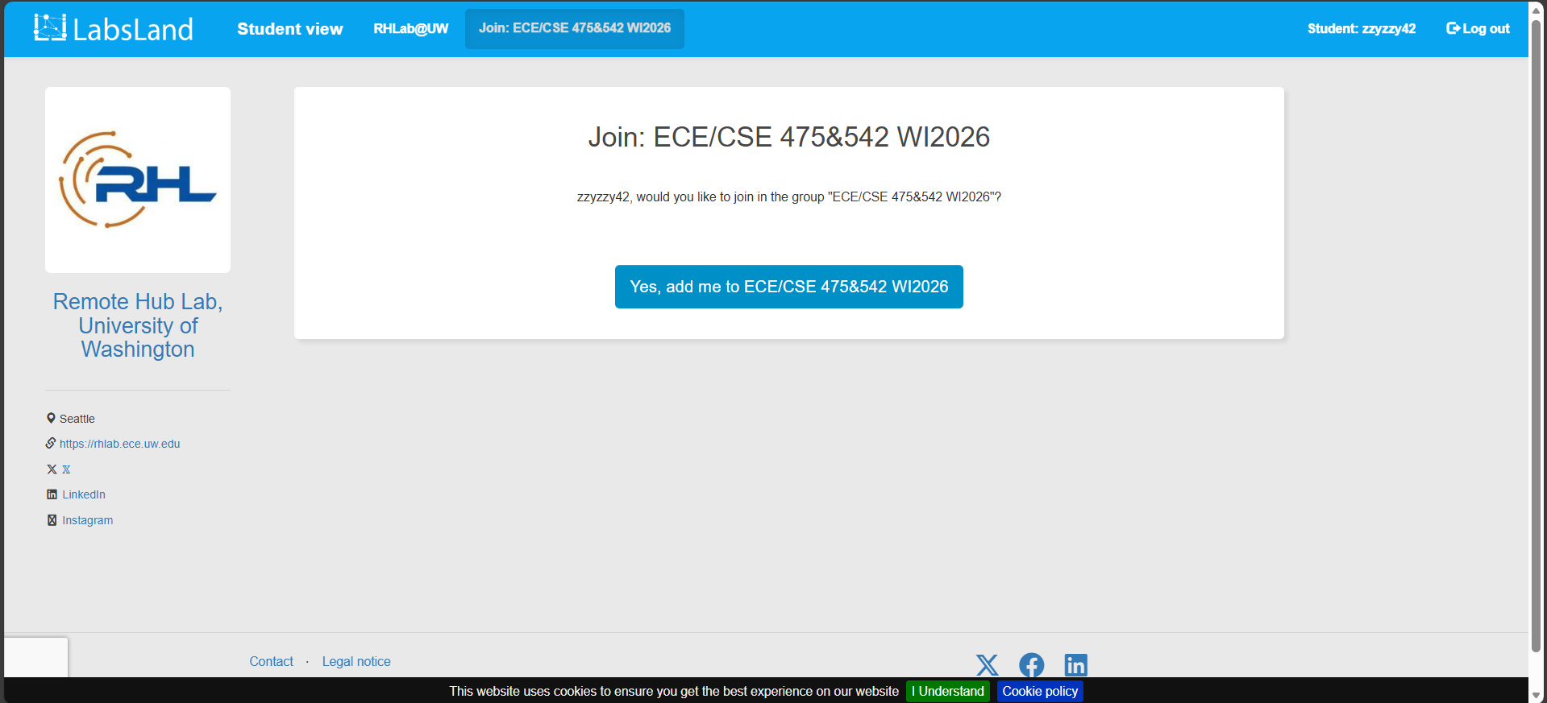
Figure 3
- You are now a part of the course group, as shown in Figure 4. Now, click the blue icon “Access this lab” to access the STM32 remote lab.
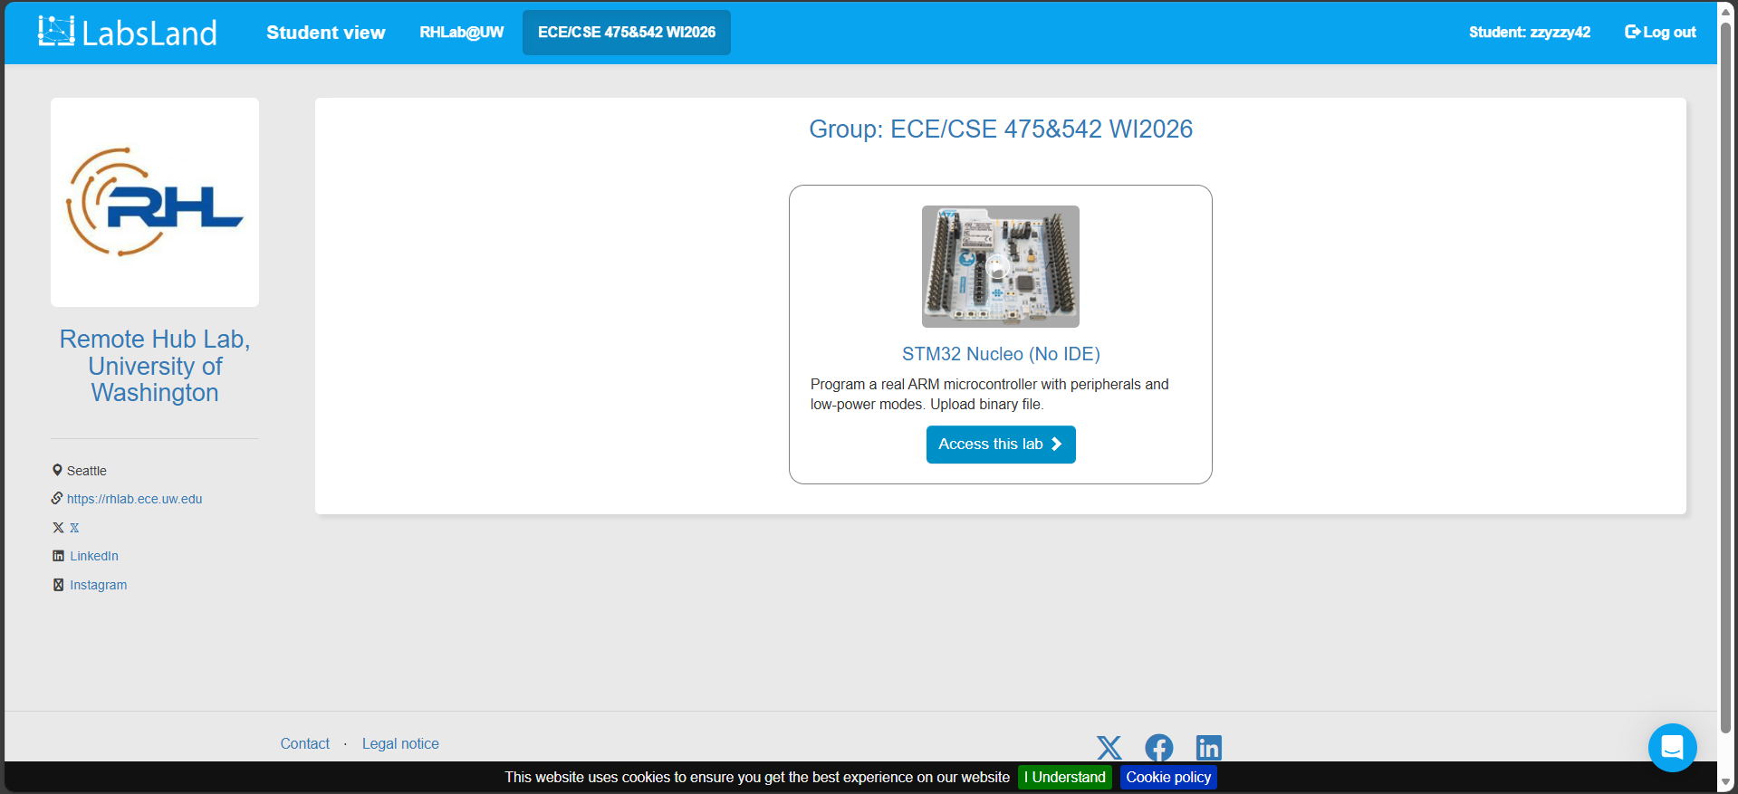
Figure 4
- For this assignment, we only need to use the basic STM32 remote lab. Click the orange icon indicated by the red arrow in Figure 5.
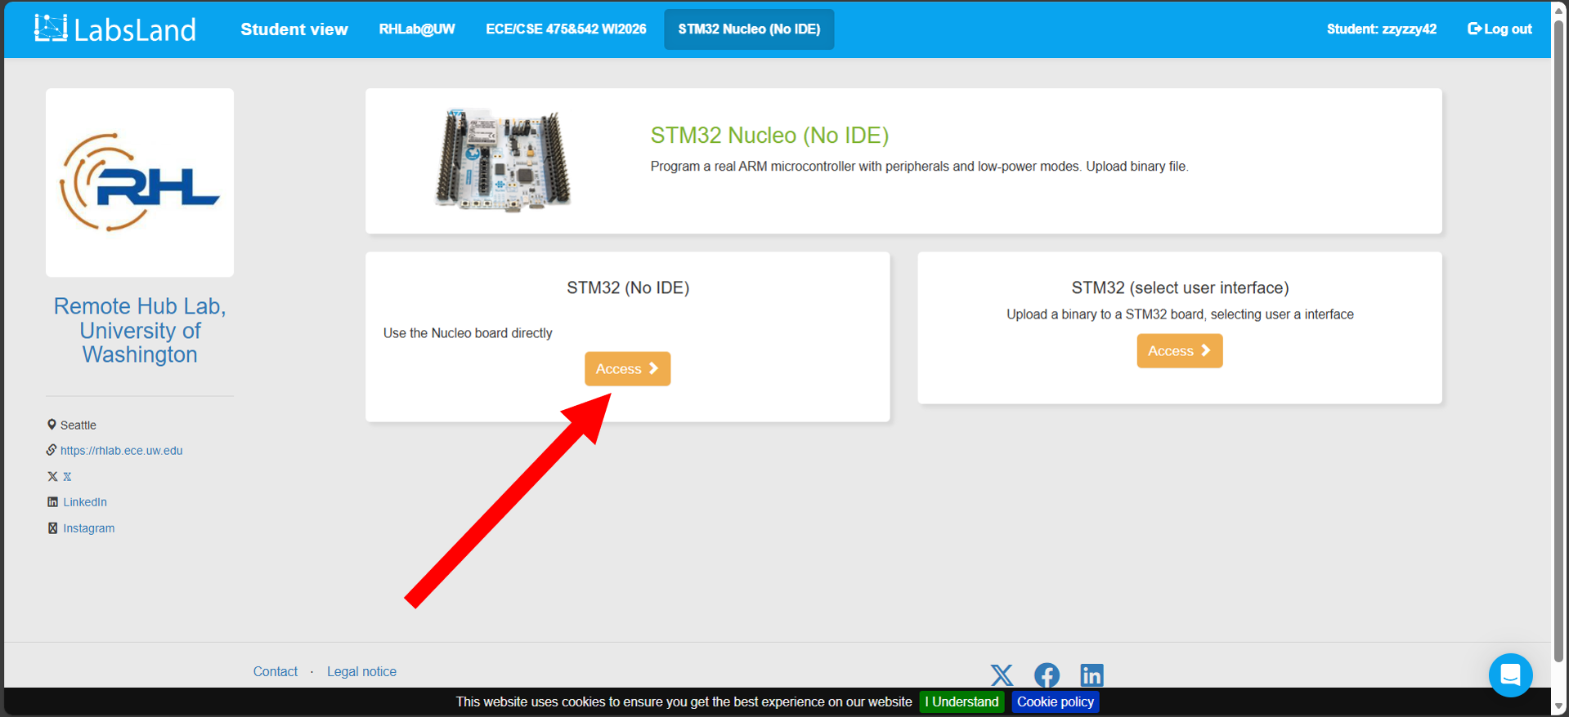
Figure 5
- Now we can see the STM32 development board assigned to us in this 3-minute session. Click “Choose File” to upload binary files, as indicated by the red arrow in Figure 6. Then, click the blue Upload button to program the STM32 board. Do not worry about the binary file now. We will create one together later.
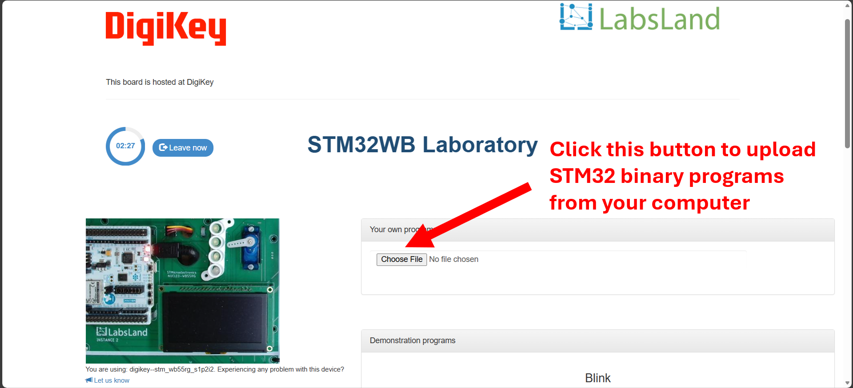
Figure 6
- Figure 7 shows the remote lab after a program is uploaded. Important sections (toggle switches, pushbuttons, potentiometers, and console window) are highlighted.
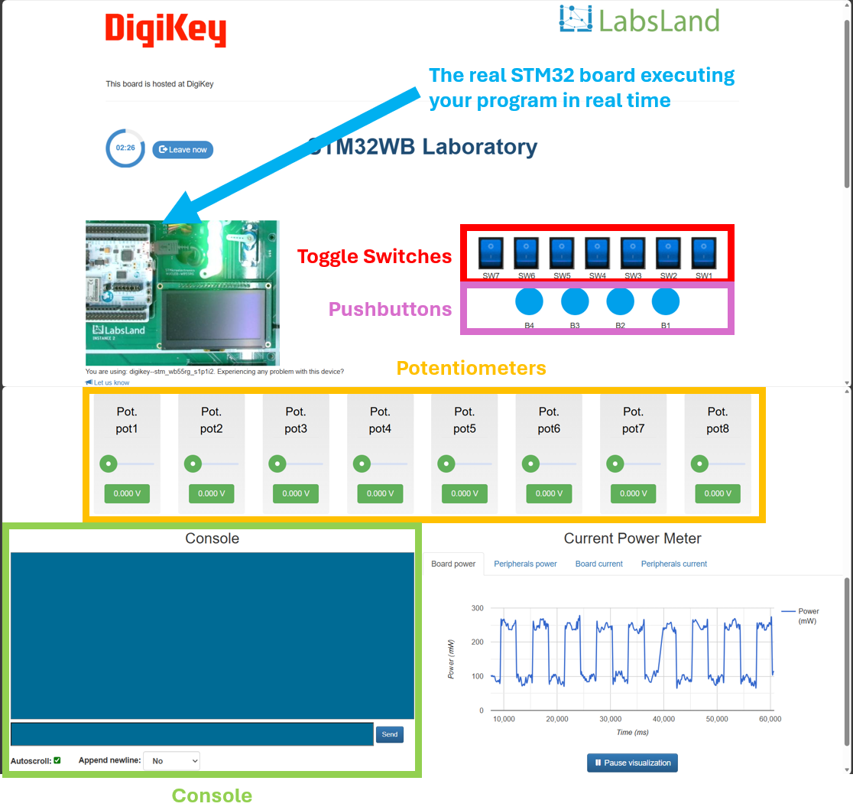
Figure 7
Hardware Connections
The STM32 remote lab has a hardware connection shown in Figure 8. We can find how peripherals, such as LEDs and pushbuttons, are connected to the GPIO pins. We will reference this diagram when we write our programs.
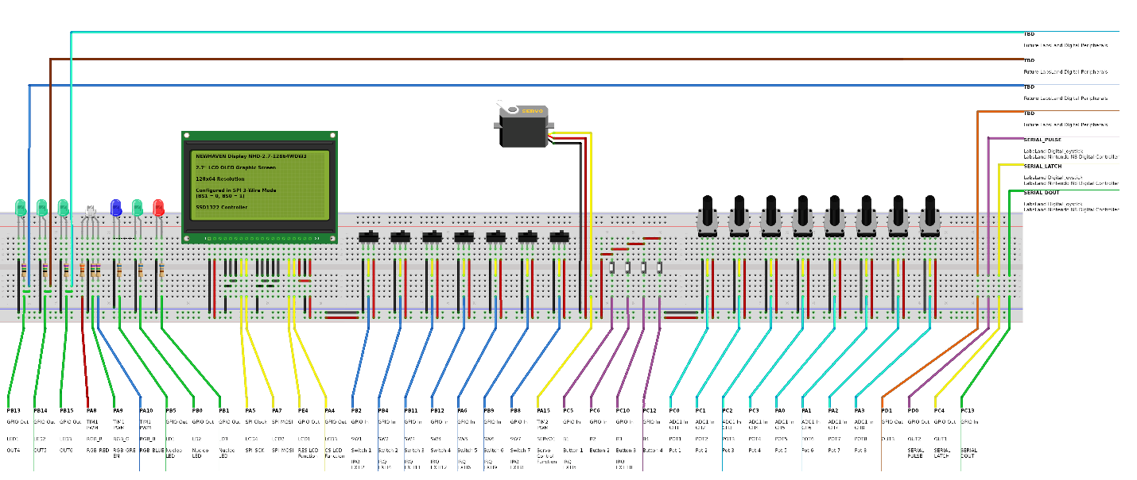
Figure 8
Arduini IDE
The Arduino IDE is a beginner-friendly software platform used to write and upload code to many popular microcontrollers. It provides a simple interface where users can create programs (called “sketches”) using a C/C++-based language. The IDE includes built-in tools for editing code, compiling it, and communicating with hardware through a USB connection, if the development boards support it. With extensive libraries and example projects, the Arduino IDE makes it easy to prototype electronics projects such as sensors, robotics, and embedded systems.
To get access to the Arduino IDE,
- Go to https://www.arduino.cc/en/software/
- Install it onto your computer using the default setting.
- Open the Arduino IDE.
- If you are using a Windows computer, go to File -> Preferences… by following the instructions in Figure 9.
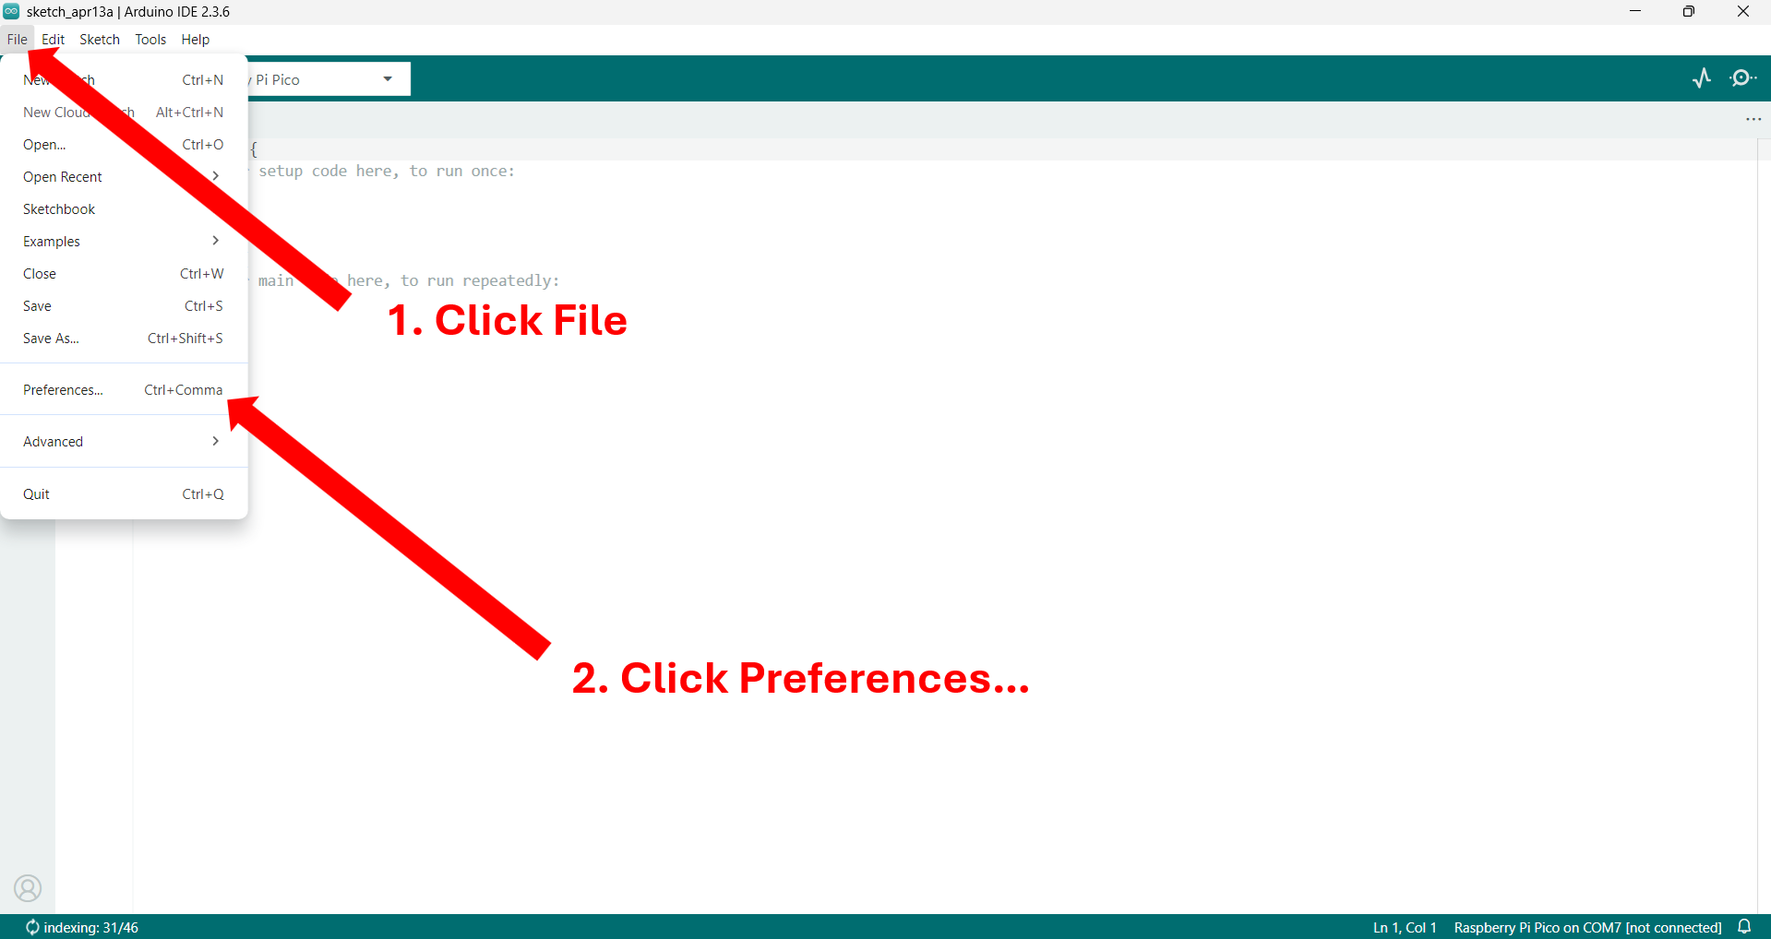
Figure 9
- If you are using a macOS computer, go to Arduino IDE -> Settings… by following the instructions in Figure 10.
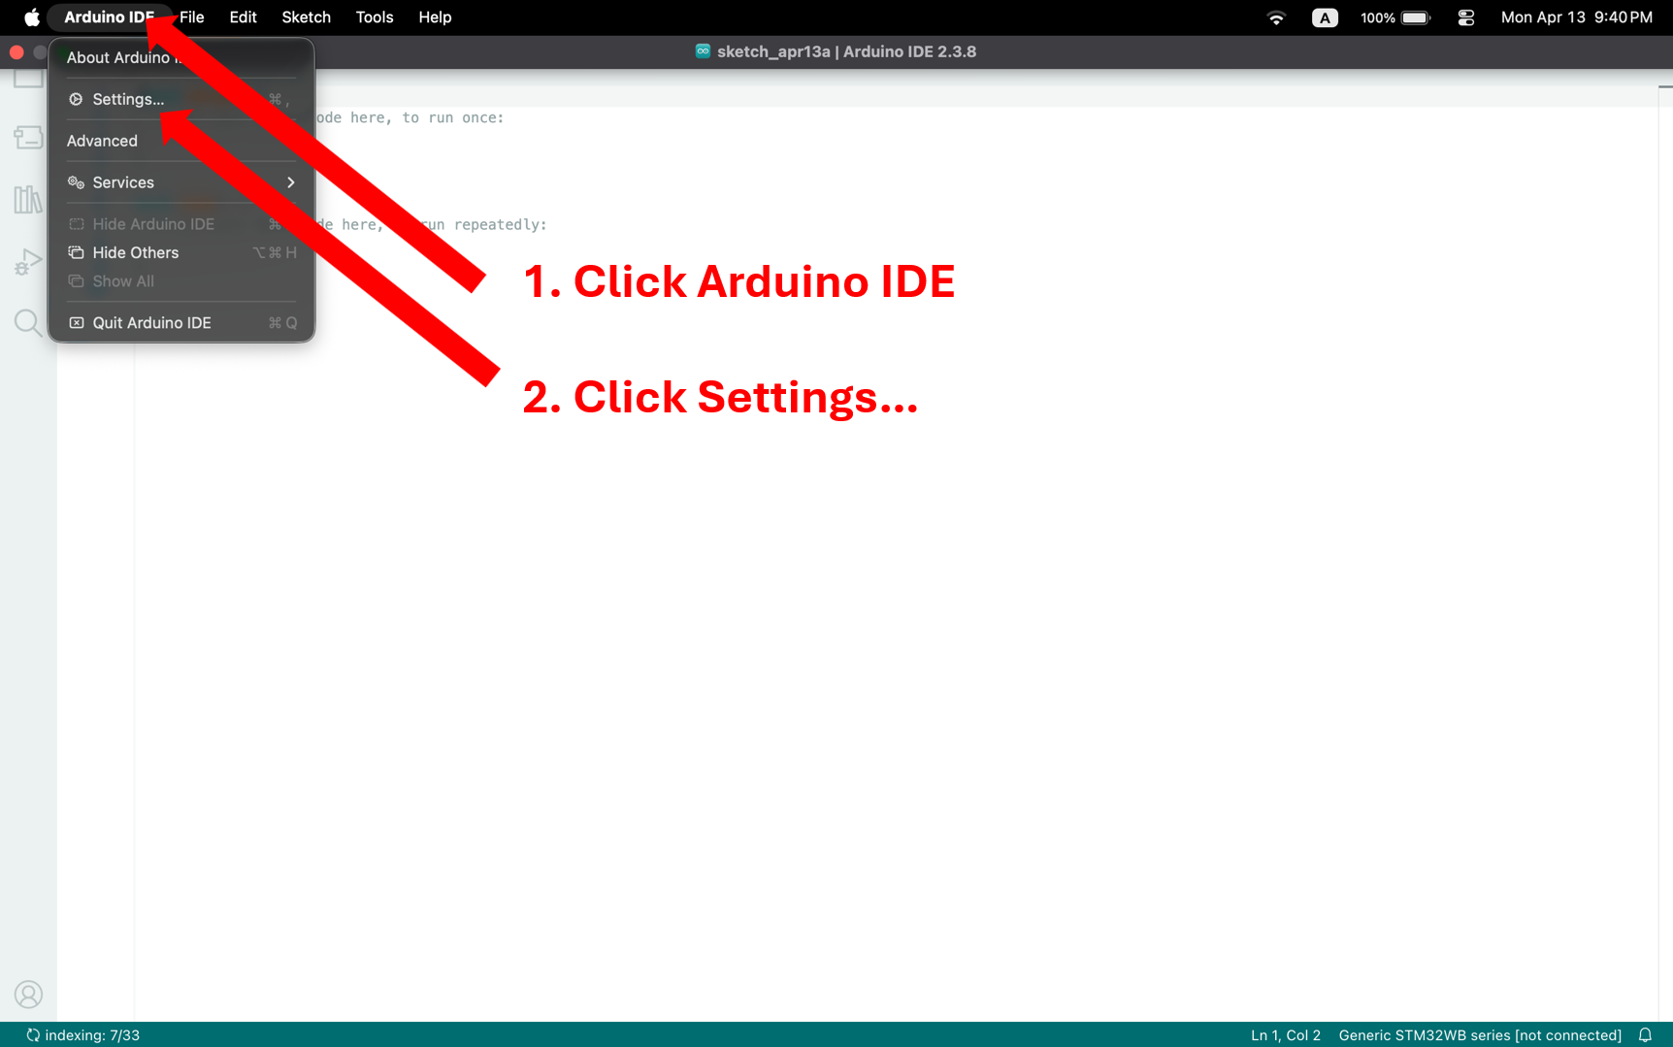
Figure 10
- Add the following link to the additional board manager textbox, as shown in Figure 11.
https://github.com/stm32duino/BoardManagerFiles/raw/main/package_stmicroelectronics_index.json
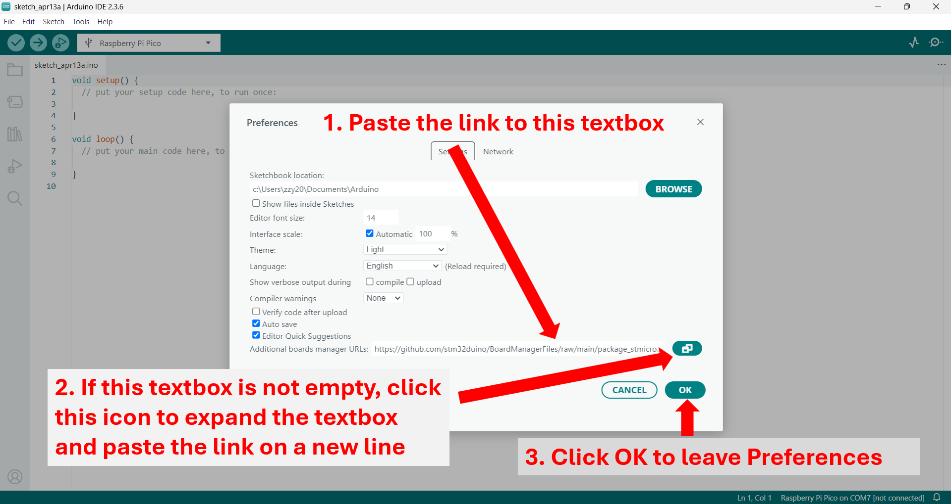
Figure 11
- Follow the instructions in Figure 12 to install the STM32 board package.
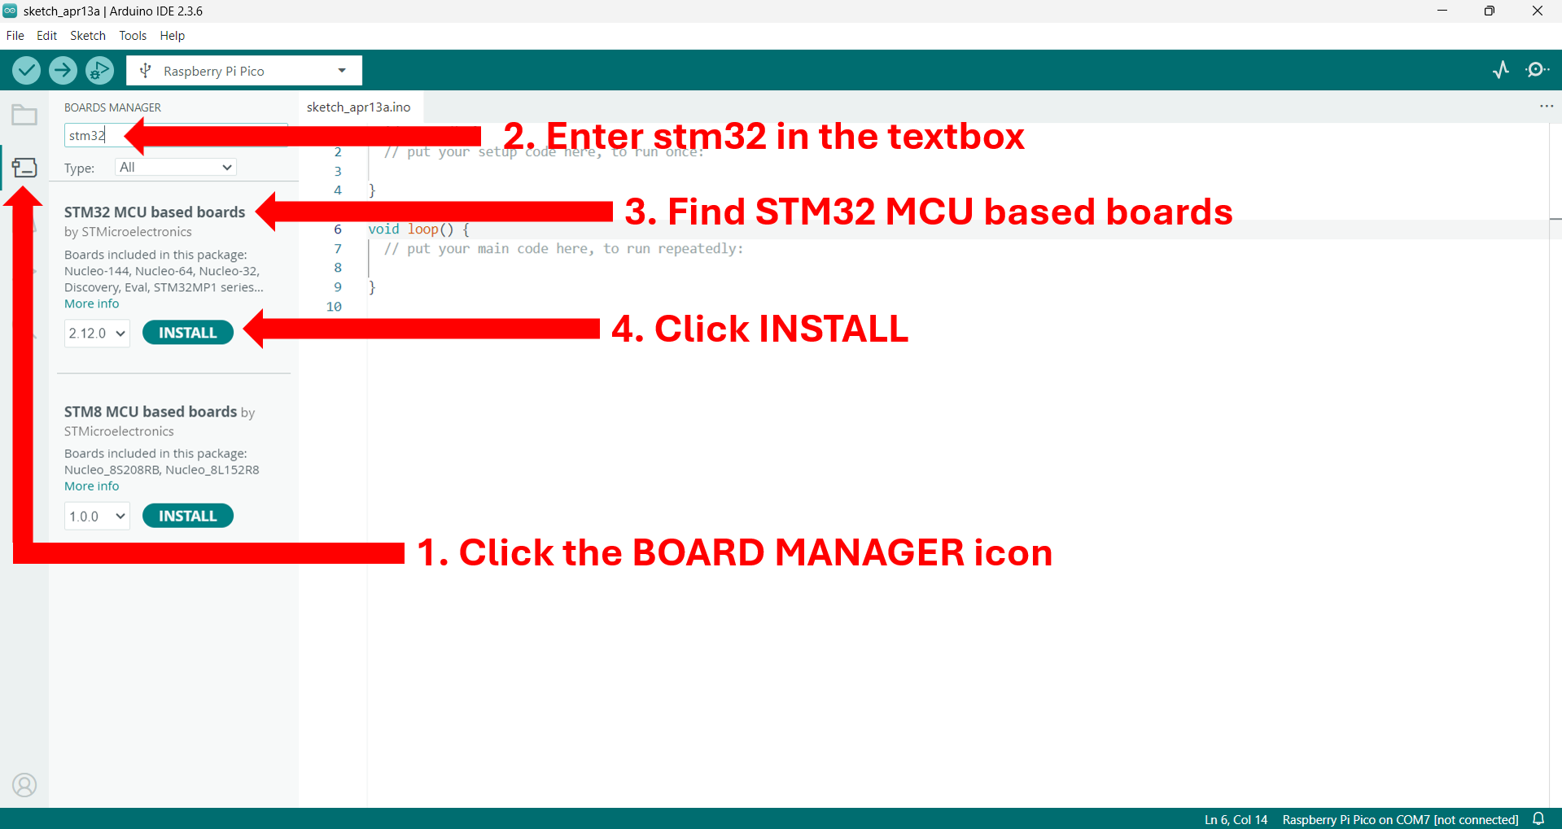
Figure 12
- Go to Tools -> Board -> STM32 MCU based boards -> choose Generic STM32WB series, as indicated in Figure 13.
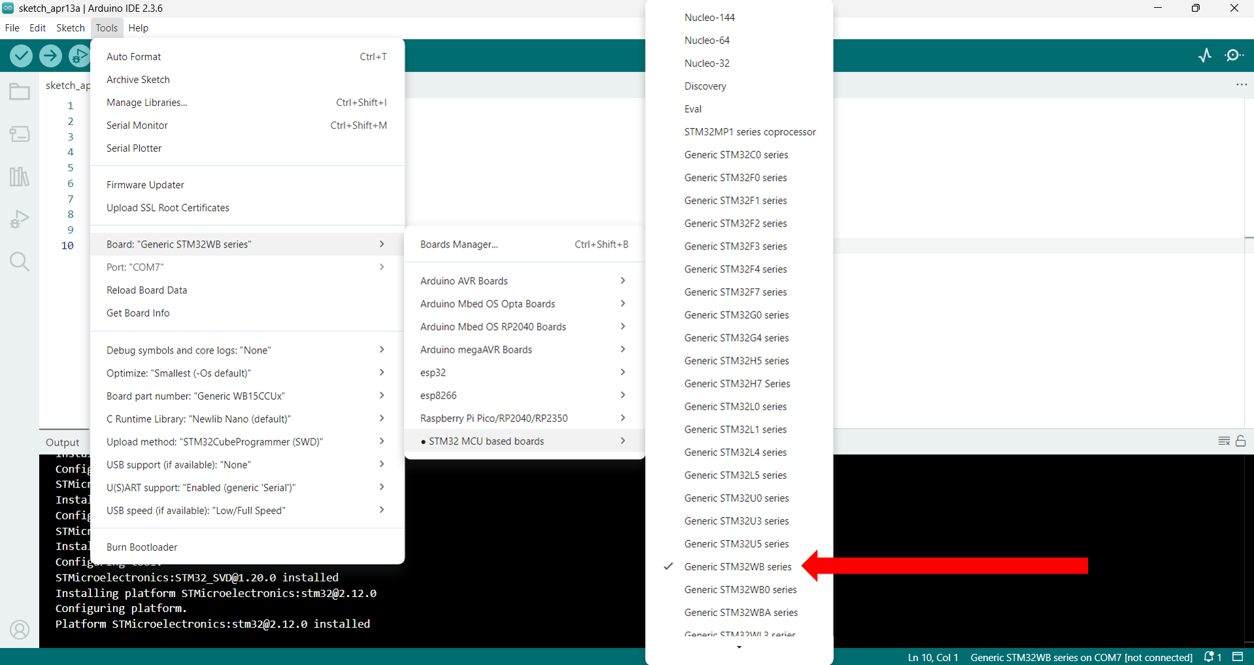
Figure 13
- Go to Board part number -> choose Generic WB55RGVx, as shown in Figure 14.
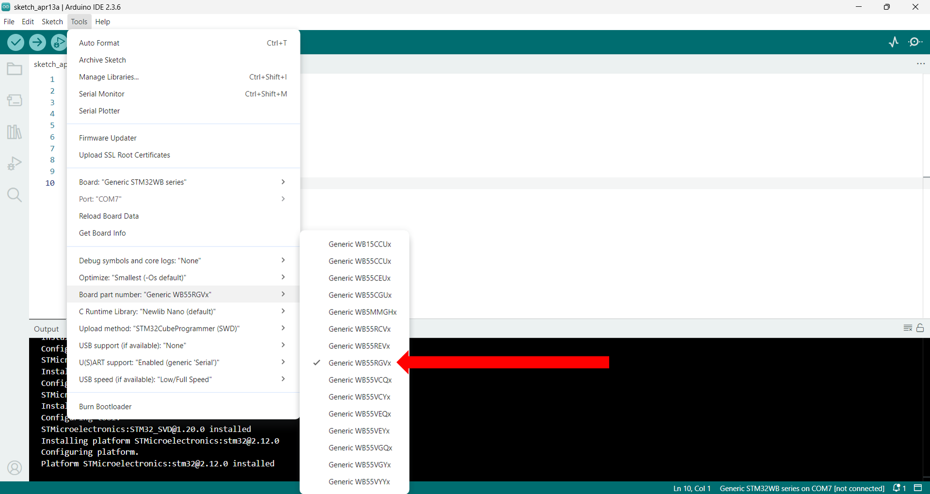
Figure 14
- Now the correct board is selected, and you can now program for the NUCLEO-WB55RG development boards.
- When your program is completed, compile the project by clicking Sketch -> Export Compiled Binary, as indicated in Figure 15. The binary file can be found in YOUR PROJECT MAIN FOLDER -> build -> STMicroelectronics.stm32.GenWB -> PROJECT_NAME.ino.bin.
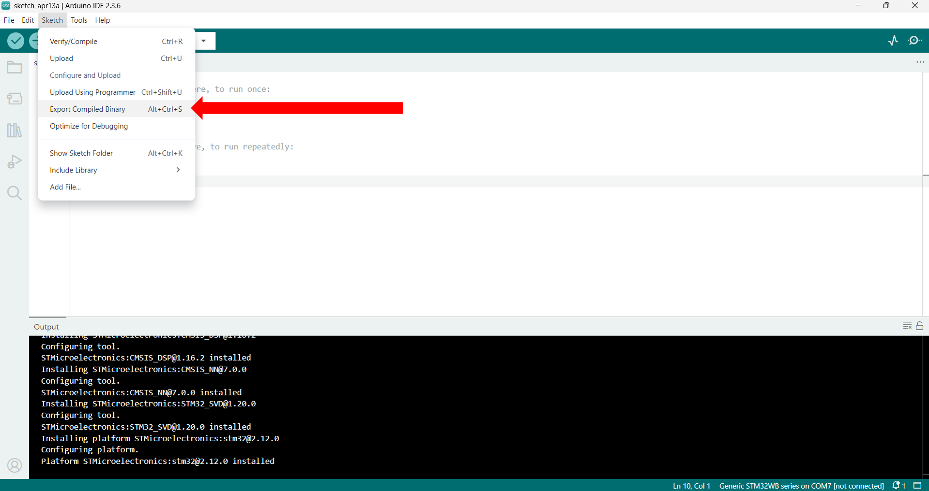
Figure 15

Assigned Task
Part 1
We will now create our first STM32 program. It is a simple program that blinks LED1 every second. Please take the following steps:
- Create a new project in Arduini IDE, as instructed in the Arduino IDE section.
- Copy and paste the following code into the project.
- /* Lab 0 Part 1 Example Code */

- /* Function: blinks LED1 every second */

- #define DELAY_DURATION_SHORT 500 // 500 ms time interval
- #define EXTERNAL_LED_1 PB13 // LED1 is connected to GPIO PB13 of the MCU

- void setup() {
- // Set up all the peripherals here
- pinMode(EXTERNAL_LED_1, OUTPUT); // Set LED1 as an output
- }

- void loop() {
- // put your main code here, to run repeatedly:
- digitalWrite(EXTERNAL_LED_1, 1); // Turn on LED1 by setting it to 1
- delay(DELAY_DURATION_SHORT); // Sleep (maintain the same states) for 500 ms

- digitalWrite(EXTERNAL_LED_1, 0); // Turn off LED1 by setting it to 0
- delay(DELAY_DURATION_SHORT); // Sleep (maintain the same states) for 500 ms
- }

- Compile the project by following the instructions in Figure 15.
- Upload this binary file onto the STM32 remote lab by following Steps 4 – 6 in the STM32 Remote Laboratory section.
- We should now see an LED on the top to the left of the servo blinking.

Questions (15 pts)
- It is important to know where all the peripherals are connected to the STM32 IC. We can do this by referring to the Fritzing diagram. In Figure 13,
- What text is hidden under the gray boxes 1, 2, and 3?
- What text is hidden under the gray boxes 4, 5, and 6?
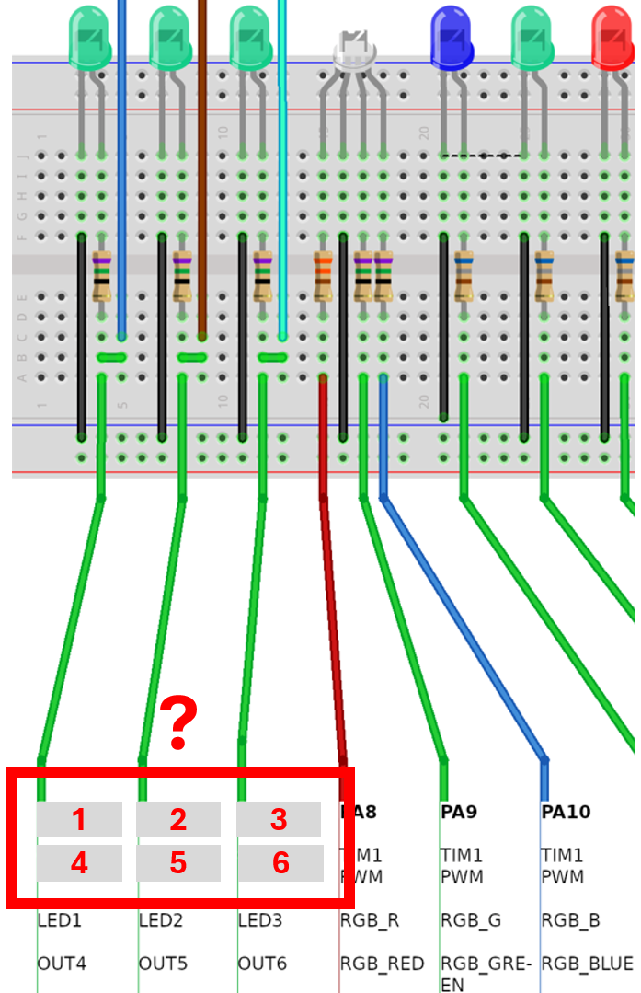
Figure 13
- Attach a screenshot of the board while the LED is on.
- If you wanted the LED to blink at a slower rate, such as stay 2 seconds turned on and then 2 seconds turned off, how would you go about it?

Part 2
We will now add pushbuttons into our project. A pushbutton is an input sensor that has different values, either 0 or 1, when it is pressed or released.
Mechanical pushbuttons are not ideal. When pressed or released, they often bounce and do not generate a clean 0->1 or 1->0 signal, also known as the chattering phenomenon. Instead, the signal usually looks like 0->1->0->1->1->0->0->1 or 1->0->1->0->0->1->1->0. An illustration of this phenomenon is shown in Figure 14. To overcome this, we can manually introduce a delay (usually between 50 – 100 ms) in our program after a button is pressed. In other words, we wait until the button stabilizes before we execute the next logic.
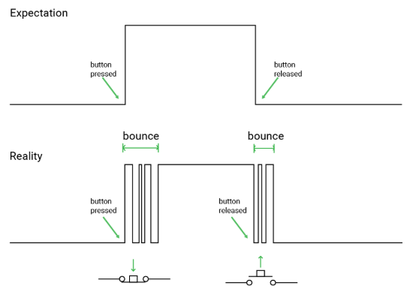
Figure 14
Two important lines of code for a pushbutton and their functionalities are shown below:
// Set up a button connected to GPIO EXTERNAL_Button_1 by setting
// its GPIO mode to INPUT_PULLDOWN
// The lab also supports INPUT_PULLUP. Free feel to experiment with different combinations.
void setup() {
pinMode(EXTERNAL_BUTTON_1, INPUT_PULLDOWN); // Set Button1 as an input
}

void loop() {
if (digitalRead(EXTERNAL_BUTTON_1)) {
delay(DELAY_DURATION_SHORT); // Delay for button debounce
}

Create a program that does the following:
- When Button 1 is pressed (click the blue circle and hold), blink LED1 every 1 second (0.5 s off + 0.5 s on).
- When Button 1 is not pressed, turn LED1 off.
Note: Button 1 in the Fritzing diagram is represented by B1 on LabsLand.
Questions (20 pts)
- Which GPIO pin did you use to read the state of Button 1?
- When setting up peripherals, why did we use DigitalOut for an LED and DigitalIn for a pushbutton?
- Is button debouncing logic necessary in this application? Why or why not? Try adding or removing it to see if you can observe any difference in behavior.
- Attach a screenshot of your program in the Arduino IDE.

Part 3
We will now replace the pushbutton in Part 2 with a toggle switch. A toggle switch is a simple electromechanical component that allows a microcontroller to digitally read its state—either 0 or 1—as a binary input for user interaction or mode selection.
Its program is very similar to a pushbutton introduced in Part 2, but because a switch does not suffer from the chattering phenomenon, we do not need to add any debouncing logic. We also do not need to set a PinMode for a switch, as it does not float if its circuit is properly connected.
Two important lines of code for a toggle switch and their functionalities are shown below:
// Set up a switch connected to GPIO EXTERNAL_SWITCH_1 by setting
// its GPIO mode to INPUT
void setup() {
pinMode(EXTERNAL_SWITCH_1, INPUT); // Set Switch1 as an input
}

void loop() {
if (digitalRead(EXTERNAL_SWITCH_1)) {}

Create a program that functions the same as Part 2, except with a toggle switch this time:
- When SW1 is set to 1, blink LED1 every 1 second (0.5 s off + 0.5 s on).
- When SW1 is set to 0, turn LED1 off.
Questions (15 pts)
- Which GPIO pin did you use to read the states of SW1?
- Attach a screenshot of the board while
- The SW1 is set to 1, and LED1 is on.
- The SW1 is set to 1, and LED1 is off.
- The SW1 is set to 0, and LED1 is off.
- Attach a screenshot of your program in the Arduino IDE.
Submission Instructions
Please compile your responses to the lab questions into a PDF report. Ensure that your report is well-organized and includes screenshots of the remote laboratory where necessary. Clearly label and number your responses according to the corresponding question numbers.

