Introduction to FPGA Programming and Remote Lab
Lab Objectives
This lab introduces how to write SystemVerilog programs on Quartus Prime for the DE1-SoC development board and interact with the DE1-SoC remote lab.

Background
Intel DE1-SoC Development Board
The DE1-SoC Development Board, shown in Figure 1, is a widely used educational and prototyping platform built around the Intel Cyclone V SoC, which integrates a dual-core ARM processor with FPGA fabric on a single chip. This combination allows developers to design projects that use programmable logic while simultaneously running software on the embedded processor, making it ideal for complex and demanding projects. The board includes a rich set of peripherals such as switches, LEDs, seven-segment displays, VGA output, audio interfaces, Ethernet, and GPIO headers, enabling rapid implementation of real-world digital systems. It is commonly used in courses that teach digital design, embedded systems, and computer architecture.
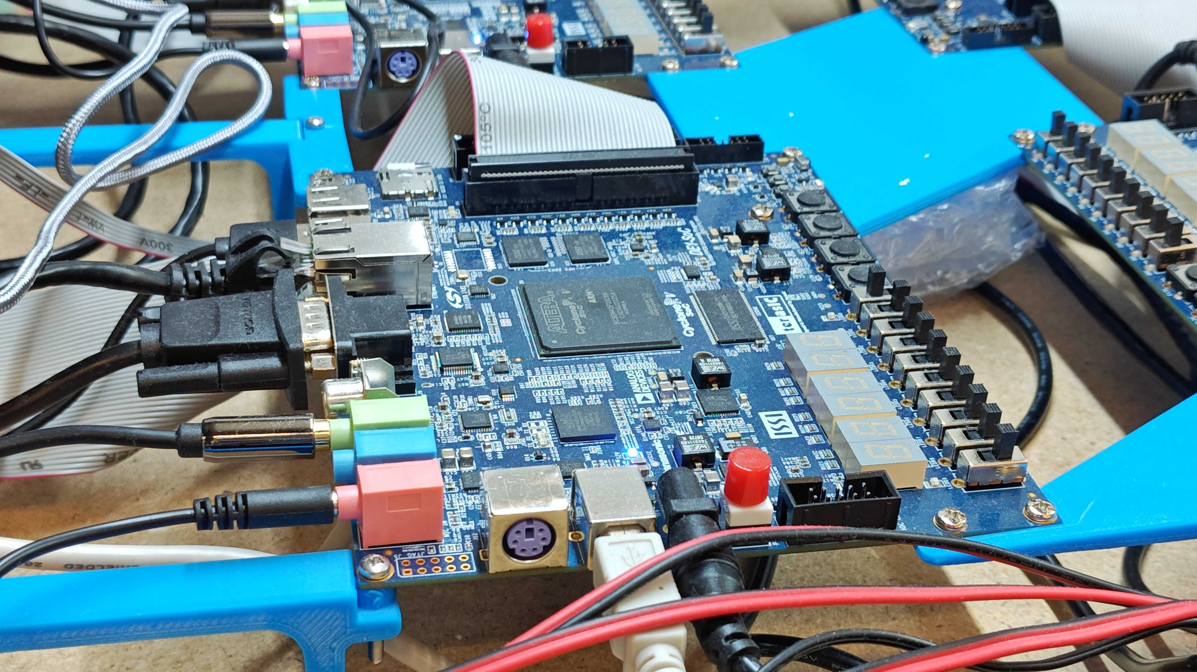
Figure 1
Installing Quartus Software
The designs in this class will be done through the Quartus software. You can install the software for free at
http://fpgasoftware.intel.com/17.0/?edition=lite&platform=windows&download_manager=dlm3
choose version 17.0 from the top drop-down menu, download the free web edition, and install it. Note that you will have to register to be able to download the software. Make sure you Select Edition “Lite” and Select Release “17.0”. The file to download is the 5.8 GB tar file under the “Combined files” tab. Extract the tar file using a program like 7-zip and run the QuartusLiteSetup-17.0windows.exe file. When it asks for the components to be installed, make sure you select each of these:
● Quartus Prime Lite Edition
● (Free) Devices: Cyclone V
● ModelSim: Intel FPGA Starter Edition (Free)
When the software installation is done, make sure to install the USBblaster driver. Run Quartus next, and if asked about licensing just run the software (we use the free version, so no license required).
It is highly recommended that you use windows machine to run Quartus. In the case that you use a Mac, you can install a virtual machine, such as VMWare Fusion, which allows you to run Windows on a Mac.

Remote Lab Platform
In this lab, we will leverage the capabilities of FPGA boards that are accessible remotely. These boards are housed in the Remote Hub Lab (RHLab), an initiative founded by Prof. Rania Hussein from the University of Washington. The RHLab is part of a distributed network of similar facilities across four countries. Initially created as a response to the challenges posed by the pandemic, the lab has since been validated by research from the RHLab team for its effectiveness in democratizing access to engineering education and enhancing design verification skills—competencies highly valued in the industry.
Furthermore, a comparative study led by Prof. Hussein on student learning outcomes revealed that the remote lab performed equally well, if not better, than traditional lab kits. This research received the Best Paper Award in the Electrical and Computer Division at the 2021 American Society for Engineering Education (ASEE) conference. To further promote equitable access to educational technologies and to better prepare students in utilizing design, simulation, and verification tools, we are extending the use of the remote FPGA lab.
You are recommended to use Quartus on your local machines to develop the code. When the code is correct and verified on a simulation tool, you run it on a remote FPGA. Alternatively, the FPGA remote lab has a code editor embedded. However, it does not support any simulation tool for logic verification.
To get access to the DE1-SoC remote lab,
- Please contact RHLab or LabsLand to receive an access link to the remote lab. After you click the given link, you should see a similar page to that in Figure 2. Click the green Create my student account to register an account on LabsLand.
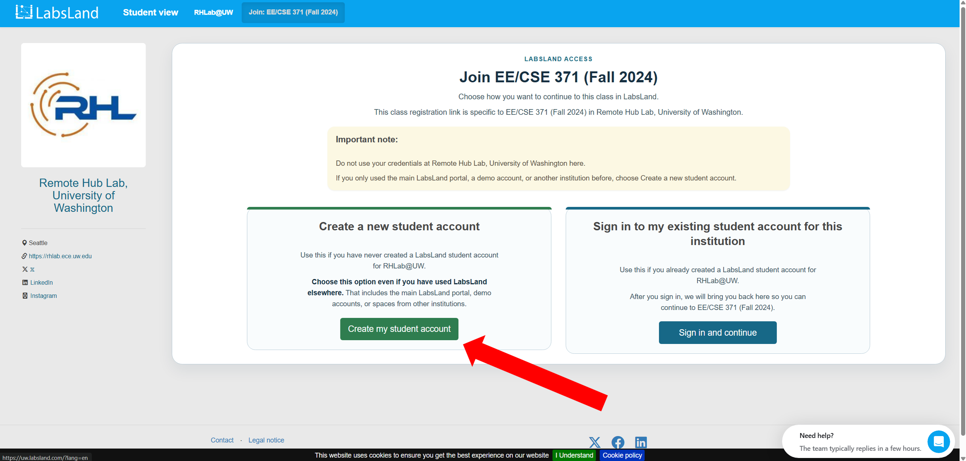
Figure 2
- After you create an account, you will be invited to join a group, as shown in Figure 3. Click the cyan Yes, add me to YOUR GROUP NAME button.
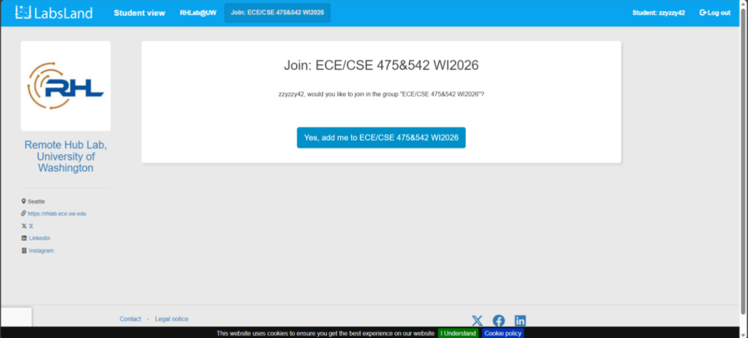
Figure 3
- Find your group and click the cyan Access this lab button under Altera DE1-SoC lab, as indicated in Figure 4. This lab does not involve any audio programming.
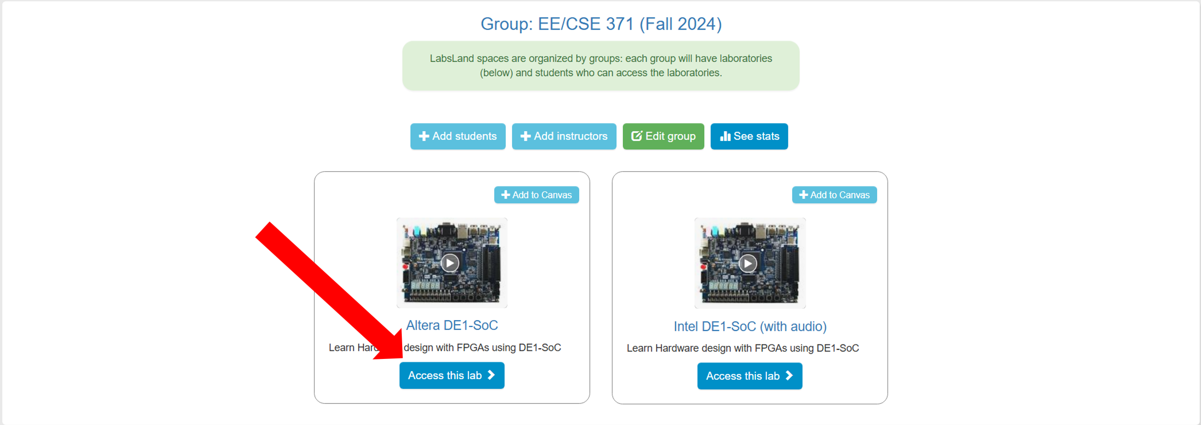
Figure 4
- Select a Hardware Description Language (HDL) you are using by clicking one of the Start laboratory session buttons to enter your lab workspace.
- Upload/write your program and execute them on real DE1-SoC development boards by following the instructions shown in Figure 5.
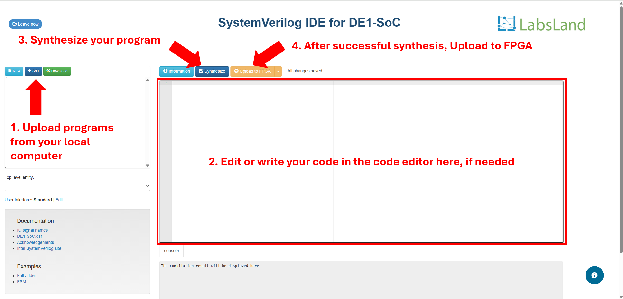
Figure 5
- Your 3-min session now begins. You can leave the session by clicking the cyan Leave now button on the upper left of the webpage. Figure 6 shows all the important parts of the remote lab for this exercise. You can click on the buttons and keys accordingly as inputs. It is important to note that ‘KEYS’ need to be held down, as they do not function like switches.
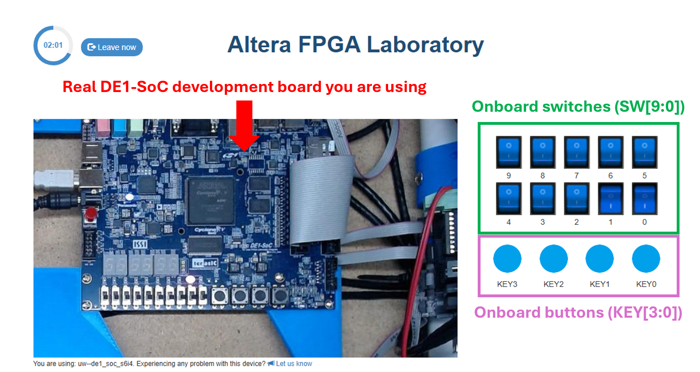
Figure 6
1-Bit Full Adder
A 1-bit full adder is another fundamental digital circuit that performs binary addition on three inputs: two significant bits and a carry-in bit. It produces two outputs: a sum bit and a carry-out bit. The circuit accounts for all possible input combinations, making it more versatile than a half adder, which does not include a carry-in. Full adders serve as the building blocks for constructing multi-bit adders used in arithmetic operations within processors and digital systems.
The truth table of a 1-bit full adder is shown in Figure 7. A and B represent the operands of the 1-bit full adder. Cin represents the carry in bit. Sum (S) represents the sum from the adder, while Cout represents the carry out bit.
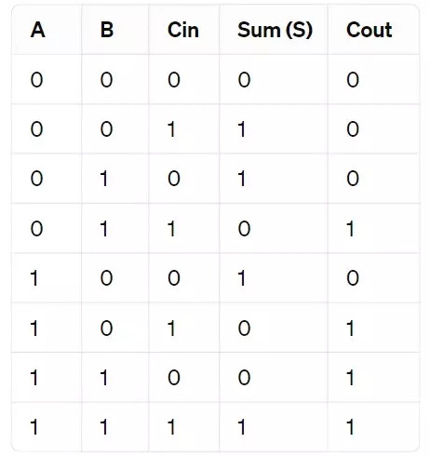
Figure 7

Assigned Task
- In this lab, you will write a SystemVerilog program that:
- Uses the state of SW[2] to control the input A of a full adder
- Uses the state of SW[1] to control the input B of a full adder
- Uses the state of SW[0] to control the input Cin of a full adder
- Displays the value of Sum (S) on LEDR[0]
- Displays the value of Cout on LEDR[1]
- Create a program with 2 modules:
- DE1_SoC: Top-level module that connects all the peripherals (switches and LEDs) to the full adder module
- fullAdder: A submodule that performs the computation of a 1-bit full adder
- Compile the program and simulate it in a simulation tool to verify its correctness.
- Upload all the SystemVerilog files onto the DE1-SoC remote lab and start experimenting.

Deliverables
- Demo Video
A short screen recording showing students interacting with the FPGA remote lab. The video should demonstrate the working system and highlight key interactions.
- Lab Report
The report should include a procedure section where students explain their approach to the task and detail their implementation. It should also contain a simulation section demonstrating their efforts in verifying the functionality of their designs using HDL simulation tools.

