Lab 2: STM32 + Parking Lot Simulation
Lab Objective
The objective of this lab is to create a parking lot management system using the STM32 remote lab and a virtual parking lot.

Background
In this activity, you are tasked with designing the logic for a "smart parking" system, to be implemented on an STM Nucleo-WB55RG board. This exercise is conducted using STM Nucleo-WB55RG remote laboratory on LabsLand. The parking system is represented by a 3D virtual model, similar to the LED matrix we used before. The parking simulation operates in tandem with the physical STM device, allowing for bidirectional interaction.

Parking Simulation Components
Figure 1 shows the Smart Parking: the virtual model that you will control using the real physical board.
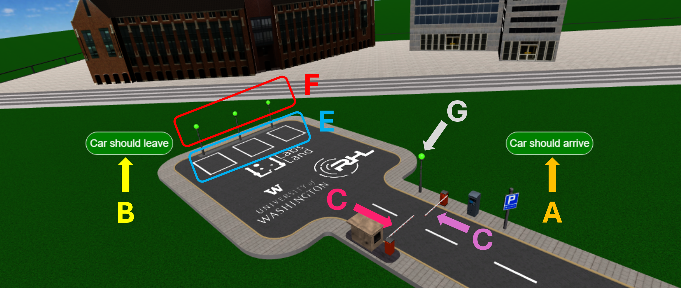
Figure 1

Its components are shown in Table 1.
Table 1
Indicator in Figure 1 | Component | Description
A | “Car should arrive” button | Will make a new car arrive at the entrance gate.
B | “Car should leave” button | Will make an existing car arrive at the exit gate.
C | Entry barrier | You can control whether it opens. There is a presence sensor in front of the barrier.
D | Exit barrier | You can control whether it opens. There is a presence sensor in front of the barrier.
E | Parking slots | The three parking slots where cars can park. They have occupancy sensors.
F | Availability indicators | You control these three lights, which should be used to indicate whether a spot is available or occupied.
G | Full indicator | You control this light, which should be used to indicate whether the parking lot still has slots available or is full.

STM32 Remote Lab Circuit
To design your logic you will need to know how this board is connected to the sensors and actuators (in this case, the Smart Parking model). Most of them are connected to single pins in the microprocessor. The connections are described in Table 2. Note that the names we use are the standard ones for the STM32 pins; and note that the type is from the microcontroller’s perspective (an output is an output for the microcontroller; e.g. an LED).
Table 2
Component | GPIO | GPIO Type | Description
Entry barrier presence sensor | PB8 | Input | Placed just in front of the barrier. Will be 1 when a car is present in front of the entry barrier, 0 otherwise.
Exit barrier presence sensor | PC12 | Input | Placed just in front of the barrier. Will be 1 when a car is present in front of the exit barrier, 0 otherwise.
Parking 1 presence sensor | PC13 | Input | 1 if a car is present in parking slot 1, 0 otherwise.
Parking 2 presence sensor | PA6 | Input | 1 if a car is present in parking slot 2, 0 otherwise.
Parking 3 presence sensor | PB9 | Input | 1 if a car is present in parking slot 3, 0 otherwise.
Entry barrier actuator | PB1 | Output | If the signal switches from 0 to 1 the barrier will briefly open so that a car may pass, and close again on its own after a while.
Exit barrier actuator | PB15 | Output | If the signal switches from 0 to 1 the barrier will briefly open so that a car may pass, and close again on its own after a while.
Parking full light indicator | PB0 | Output | If the signal is 1, the parking-full indicator will be red; if it is 0, the indicator will be green.
Parking Slot 1 indicator light | PC4 | Output | If the signal is 1, the parking slot 1 indicator will be red; if it is 0, the indicator will be green.
Parking Slot 2 indicator light | PD0 | Output | If the signal is 1, the parking slot 1 indicator will be red; if it is 0, the indicator will be green.
Parking Slot 3 indicator light | PD1 | Output | If the signal is 1, the parking slot 1 indicator will be red; if it is 0, the indicator will be green.

STM32 Remote Lab LED Matrix User Interface
To activate the parking simulation in the STM32 remote lab,
- Go to our LabsLand group and select the STM32 remote lab. Feel free to reference the STM32 Lab Introduction (Keil Studio) and STM32 + LED Matrix (Keil Studio) again.
- Select the STM32 (select user interface) remote lab this time, as indicated by the arrow in Figure 2.
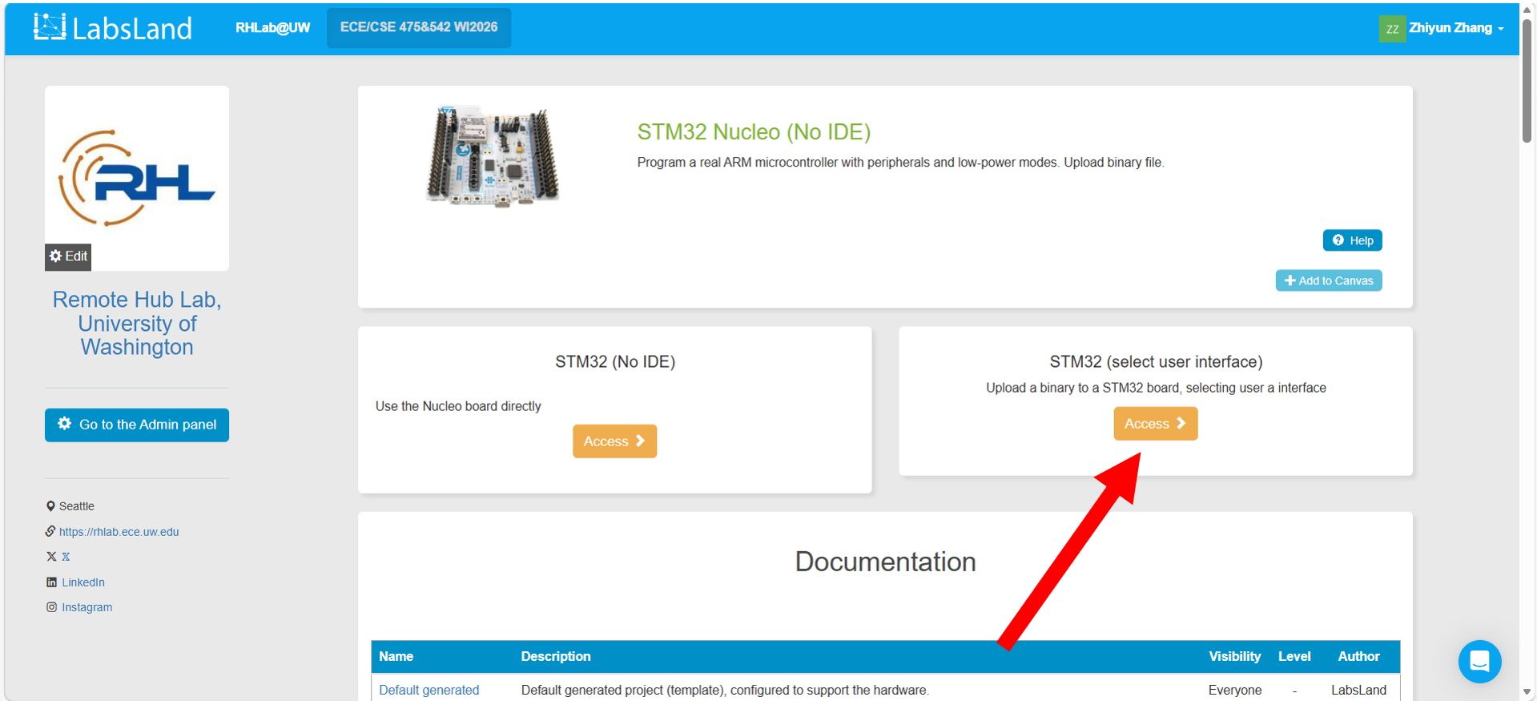
Figure 2
- Upload a binary file from your computer, as shown in Figure 3. You will have a binary file after you complete the parking management system program and compile it. If you encounter any error message that says, “The program could not be verified”, when you click the Verify upload button later (in Step 7), you can either upload another binary file from an earlier lab assignment or refresh the page.
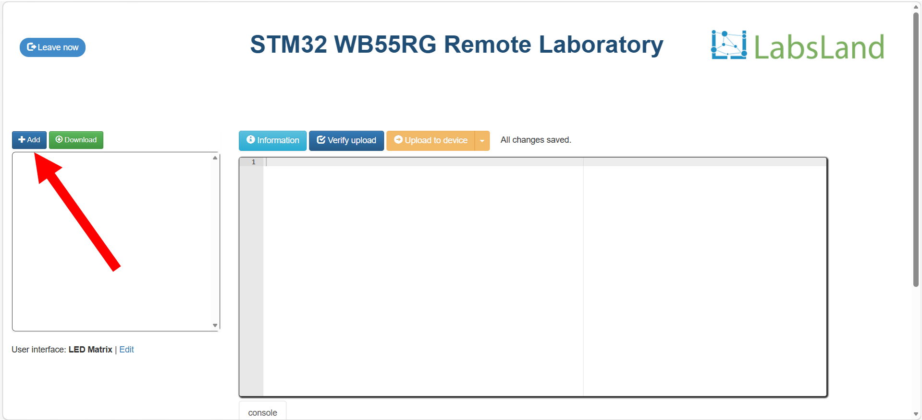
Figure 3
- To select the parking simulation as our user interface, go to the lower left corner and click the blue Edit button, as indicated by the red arrow in Figure 4.
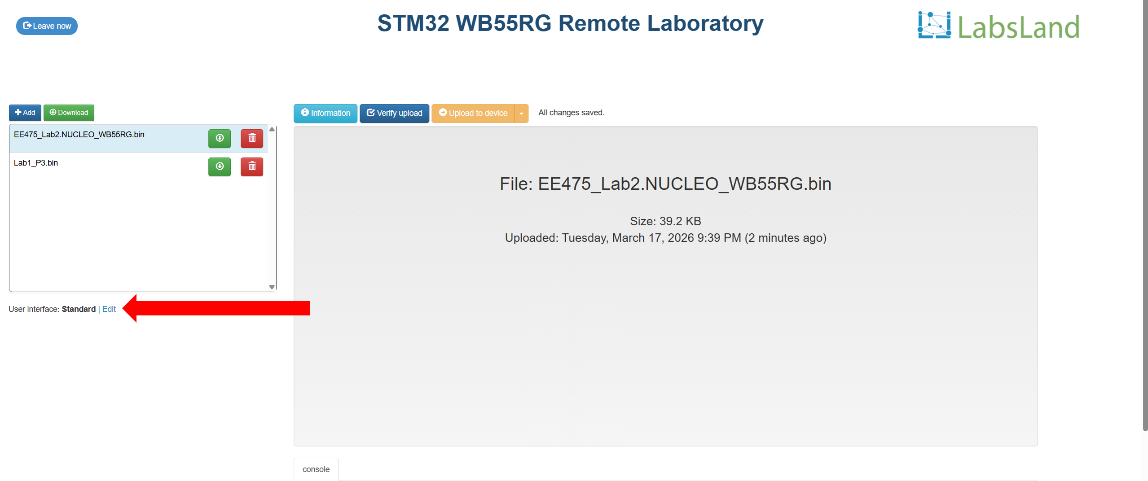
Figure 4

- Scroll down the User interface window, and select the Parking simulation, as indicated by Figure 5. Close the window by clicking the X button on the upper right corner of the User interface window, the Close button on the lower right corner of the User interface window, or anywhere outside of the User interface window.
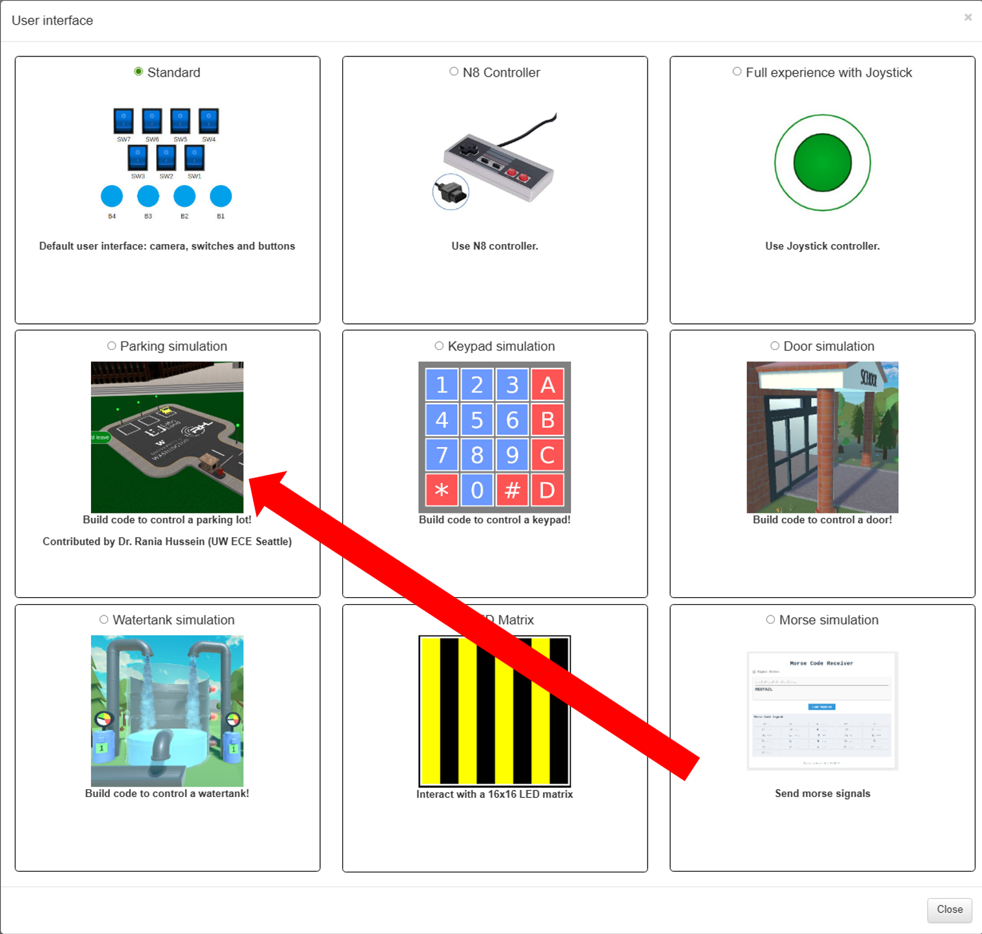
Figure 5
- Ensure the Parking simulation is selected as our user interface, as shown in Figure 6.
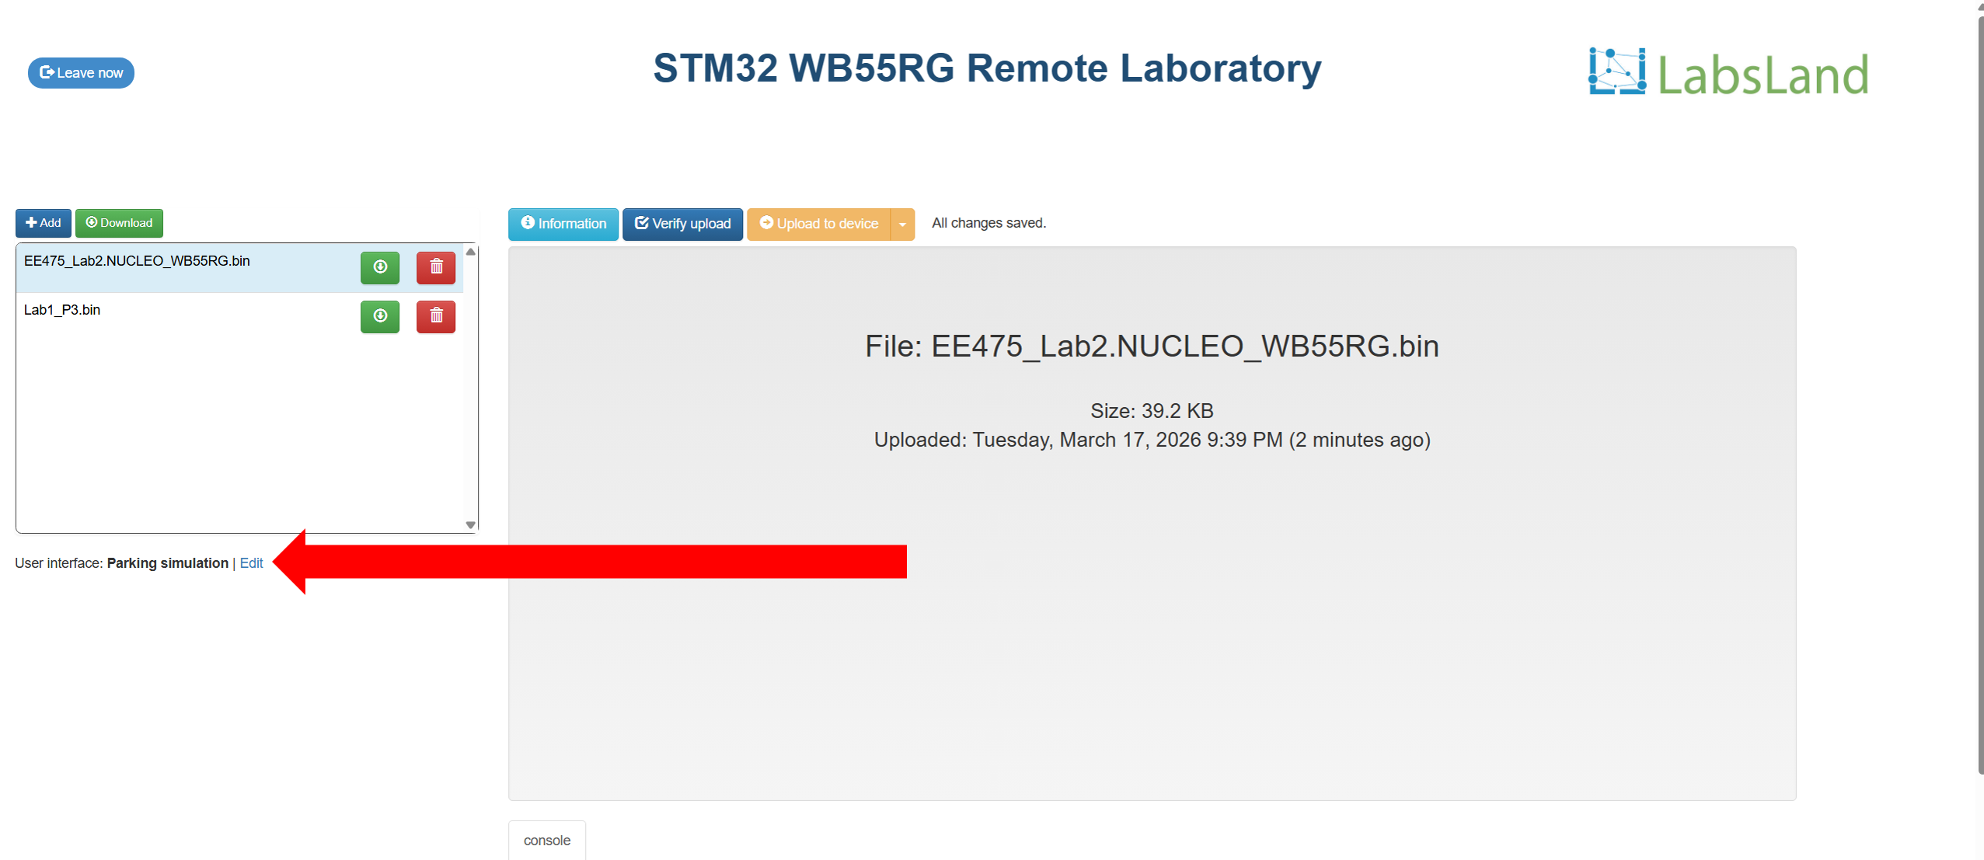
Figure 6
- Click the blue Verify upload button first. After the orange Upload to device button becomes clickable, click it. Please see Figure 7 for instructions.
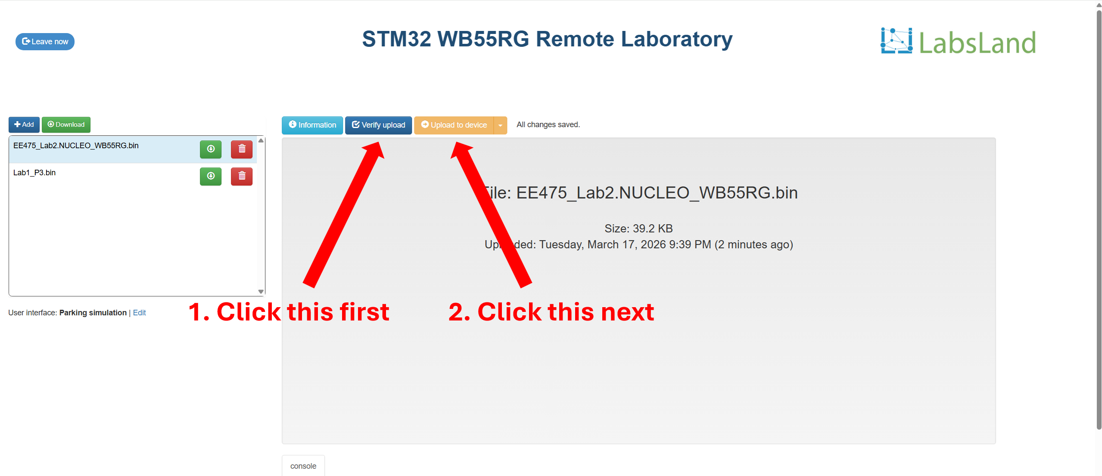
Figure 7
- After the 3-min lab session starts, the parking simulation will be displayed on the bottom of the page under the console window, as shown in Figure 8. To exit the lab session, click the blue Leave now button on the upper left of the screen next to the countdown clock.
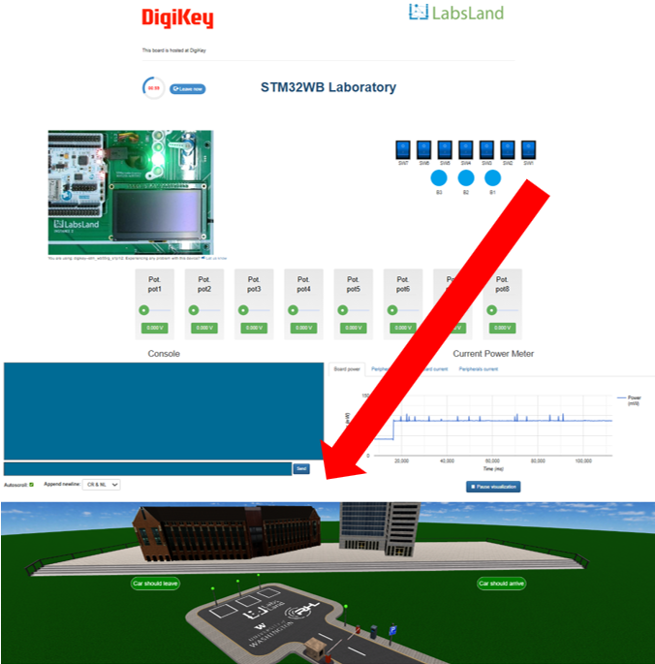
Figure 8

- For this lab, we recommend setting up the browser to use half of your screen, like in Figure 9. This way, after zooming out, you can see the complete remote lab interface, including the switches and parking simulation.
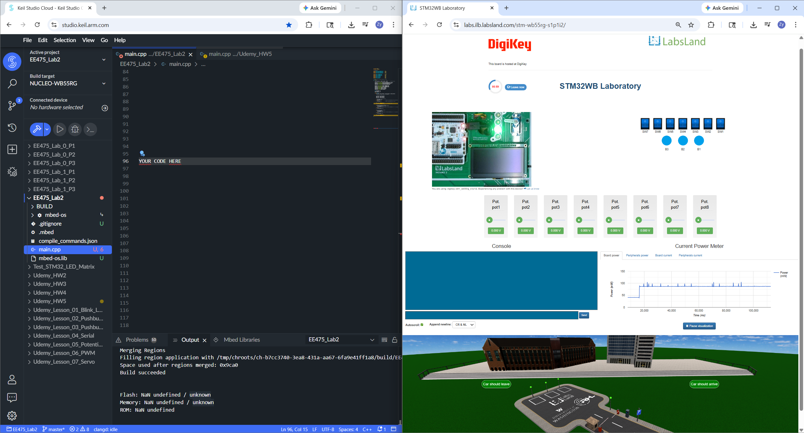
Figure 9
Assigned Task
We will now create our parking management system for the STM32 remote lab.
- Start by creating an empty project on Keil Studio Cloud. Instructions on how to use the Keil Studio Cloud can be found in Lab 0 handout.
- Design the logic and implement a program that does the following:
- If a car arrives and there are parking slots available, the entry barrier should open to let the car enter and park.
- If a car wishes to leave the parking, the exit barrier should open and let it exit.
- The barriers should not open unnecessarily, and if no parking slots are available the entry barrier should not open for more cars.
- If a car parks into one of the three designated parking lot spaces, then its light indicator should be illuminated red to indicate that it is occupied. Otherwise, if free, it should be lit green.
- If the parking lot is full the full parking indicator should be lit red. Otherwise, it should be lit green.

Questions (50 pts)
- Why does the third external LED light up when the exit barrier actuator is set to 1? (Hint: Please take a look at the Fritzing diagram, which pin does the third external LED use?)
- If we were to represent the parking slot presence sensors using common electronic components, should we use toggle switches or pushbuttons, or does it not matter? Why or why not?
- If we were to represent the entrance and exit gate presence sensors using common electronic components, should we use toggle switches or pushbuttons, or does it not matter? Why or why not?
- Attach a 2-3 min demo of the parking simulation while
- The parking lot is full, and a car is present at the entrance gate.
- The parking lot is not full, and the entrance gate rises to allow a new car to enter.
- The exit gate rises to allow a car to exit.
- Does it work as expected?
- Attach a screenshot of your program in the Keil Studio Cloud.
- If you were asked to improve this parking lot, what changes would you suggest? You may consider any perspective, such as enhancing the logic behind the management system or adding more sensors throughout the parking lot.

Submission Instructions
Please compile your responses to the lab questions into a PDF report. Ensure that your report is well-organized and includes screenshots of the remote laboratory where necessary. Clearly label and number your responses according to the corresponding question numbers.
Please upload a 2–3 minute demo of the Parking simulation using a screen recording tool, including a clear voiceover explaining how it works.

