Lab 1: STM32 + Digital Twin of an LED Matrix
Lab Objective
The objective of this lab is to introduce the concept of a digital twin by interfacing an STM32 development board with a virtual LED matrix in the remote lab environment.
If you have any questions, please post them on Ed.
Background
LED Matrix
An LED matrix is a two-dimensional grid of LEDs that can be individually controlled to display text, images, or simple animations. You can often find them on buses to display the name of the next stop. A common LED matrix is a monochrome 8(row)x8(column) LED matrix, usually in red or green, shown in Figure 1.

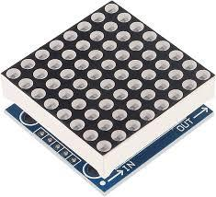
Figure 1
In a previous introductory course, we utilized a custom 16x16 bi-color LED matrix, where each pixel consisted of a red and a green LED. This configuration enabled the display of three distinct colors—red, green, and yellow (produced by illuminating both LEDs simultaneously)—as illustrated in Figure 2. The matrix's larger size and bi-color capabilities made lab assignments more engaging and opened up a wider range of project possibilities. However, these boards are costly to produce, as they require custom PCBs and manual assembly. As a cost-effective alternative, a basic digital twin of the 16x16 bi-color LED matrix has been developed, also shown in Figure 2. This digital twin (also called virtual LED matrix in this handout) is controlled using the same pins and protocol as the physical board, providing an equivalent platform for experimentation and learning.
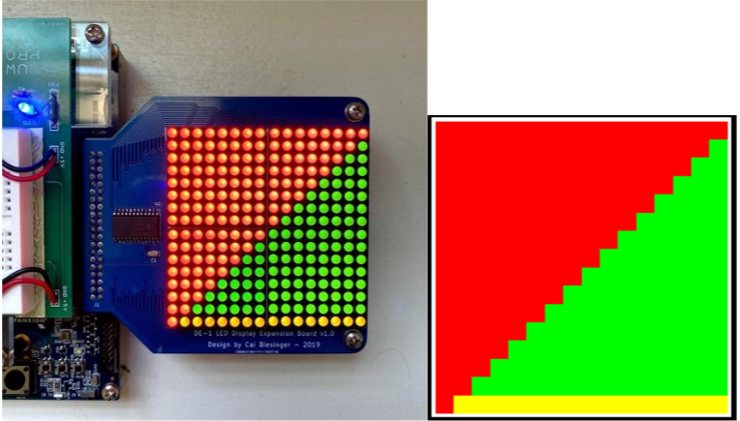
Figure 2. Original physical LED matrix (left) and its digital twin (right).

LED Matrix Control Logic
The virtual LED matrix module uses the following 4 pins for control logic:
- Latch: Asserting it tells the LED matrix that a sequence of 256 pulse cycles will load the color data into the LED matrix.
- Pulse: Each pulse cycle has a new LED pixel’s color set. Its red and green LEDs are updated at the same time.
- Green: The value of the green LED (1 = turned on; 0 = turned off).
- Red: The value of the red LED (1 = turned on; 0 = turned off).
Signal | Type | GPIO
Latch | STM32 Output (DigitalOut) | PC_4
Pulse | STM32 Output (DigitalOut) | PD_0
Green | STM32 Output (DigitalOut) | PD_1
Red | STM32 Output (DigitalOut) | PB_0

The LED number of the LED matrix is shown in Figure 3. If all LEDs need to be set, the first LED being set is the upper left LED (at the 1st pulse cycle), and at the 256th pulse cycle, the last LED at the lower right corner is set.
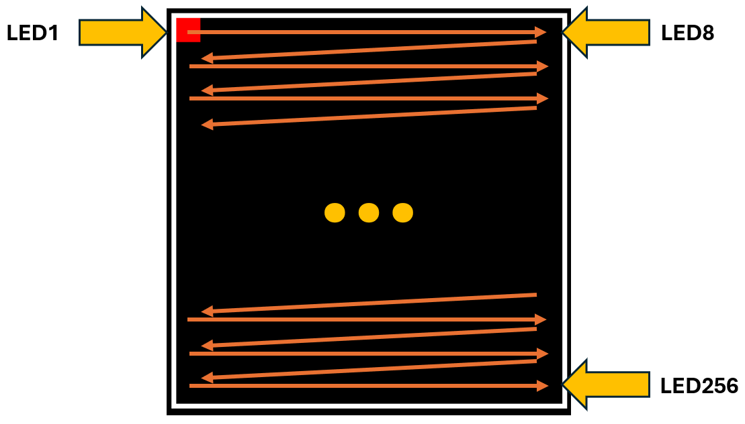
Figure 3
A signal diagram of an LED matrix program is shown in Figure 4. The Pulse signal must have a frequency of fewer than 1,500 Hz for reliable communication between the STM32 development board and the virtual LED matrix.
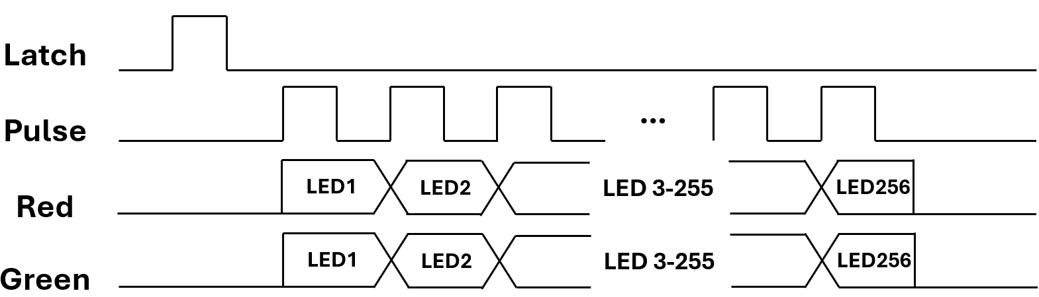
Figure 4
STM32 Remote Lab LED Matrix User Interface
To activate the virtual LED matrix in the STM32 remote lab,
- Go to our LabsLand group and select the STM32 remote lab. Feel free to reference Lab 0 intructions again.
- Select the STM32 (select user interface) remote lab this time, as indicated by the arrow in Figure 5.
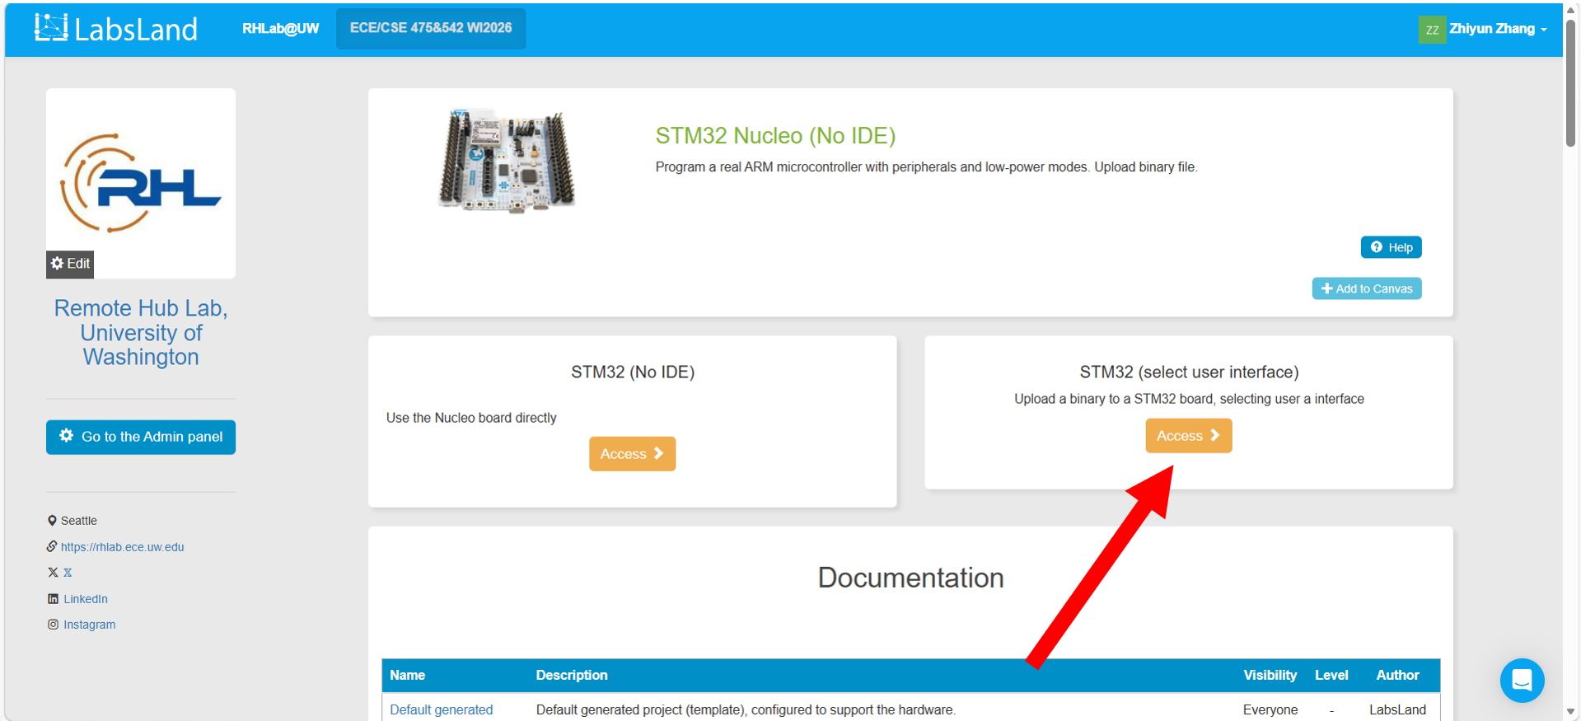
Figure 5
- Upload a binary file from your computer, as shown in Figure 6. We will create an LED matrix program together later.
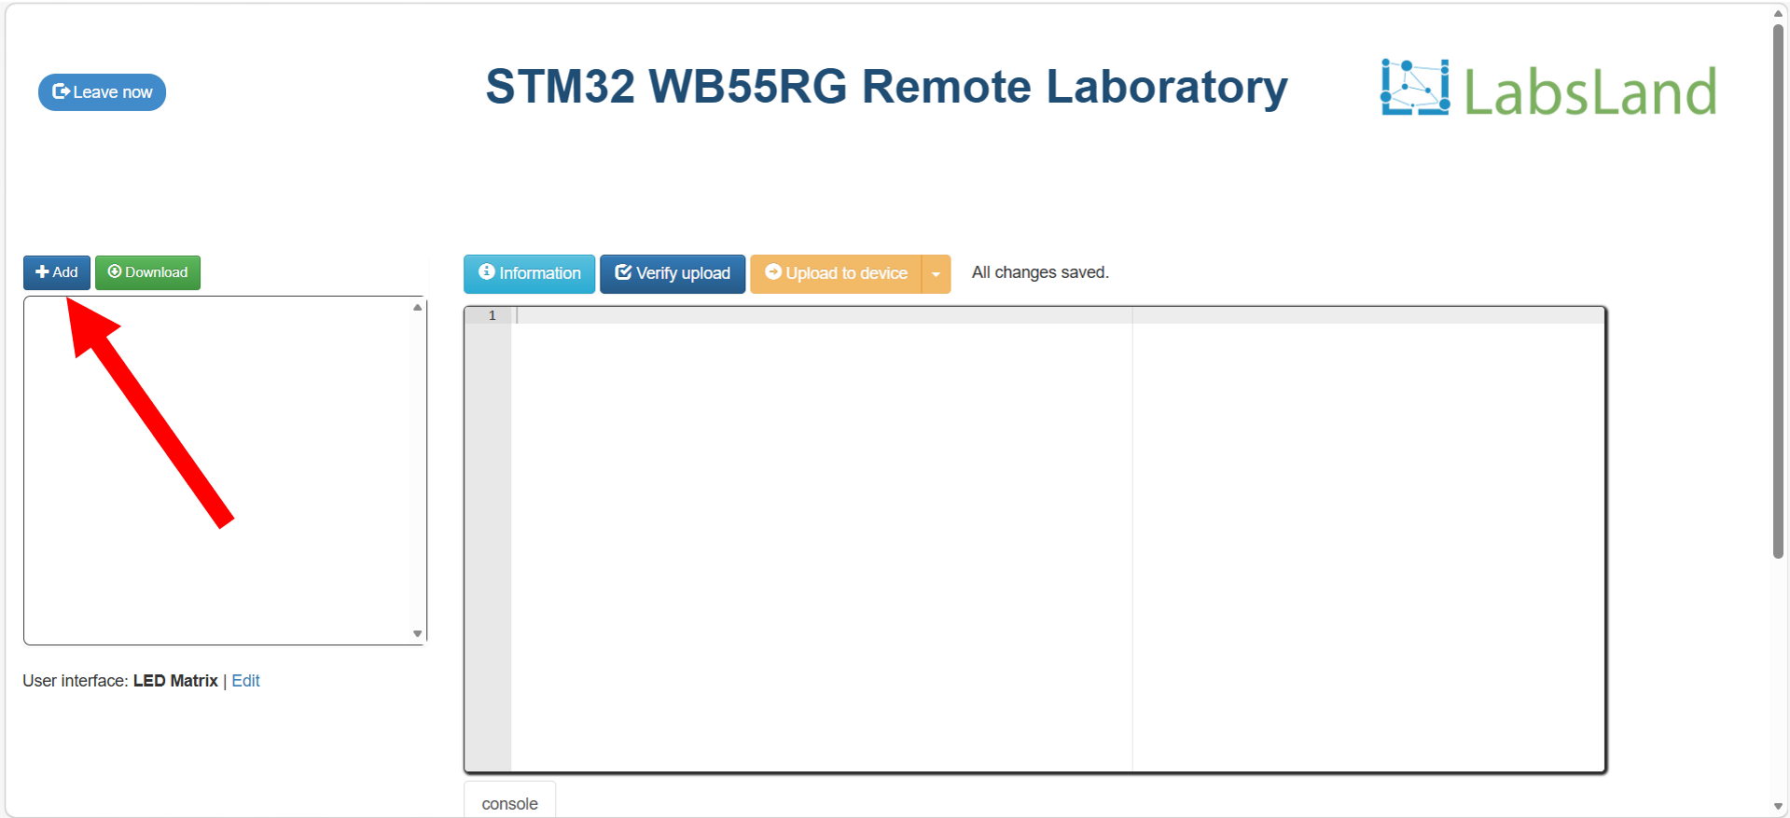
Figure 6
- To select the digital twin of an LED Matrix as our user interface, go to the lower left corner and click the blue Edit button, as indicated by the red arrow in Figure 7.
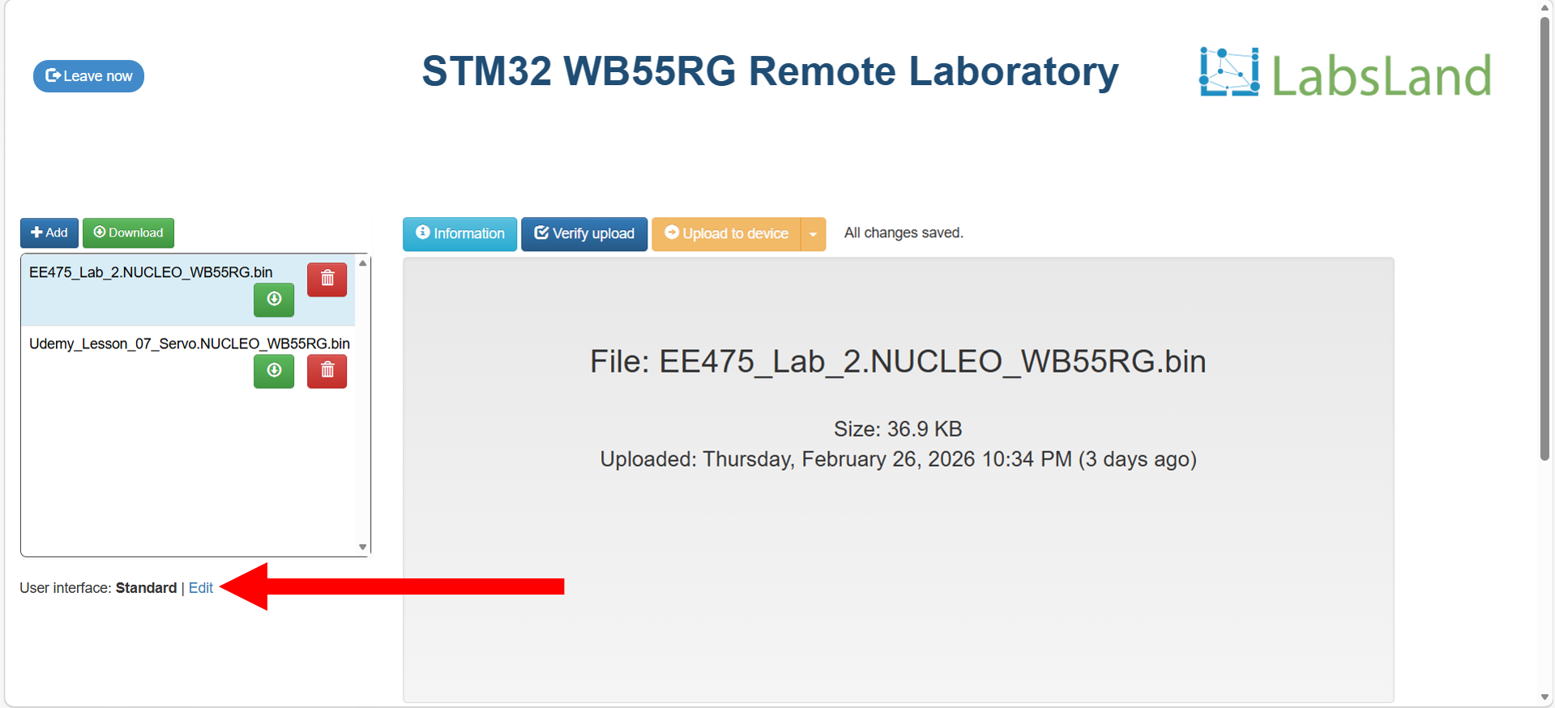
Figure 7
- Scroll down the User interface window, and select the LED Matrix, as indicated by Figure 8. Close the window by clicking the X button on the upper right corner of the User interface window, the Close button on the lower right corner of the User interface window, or anywhere outside of the User interface window.
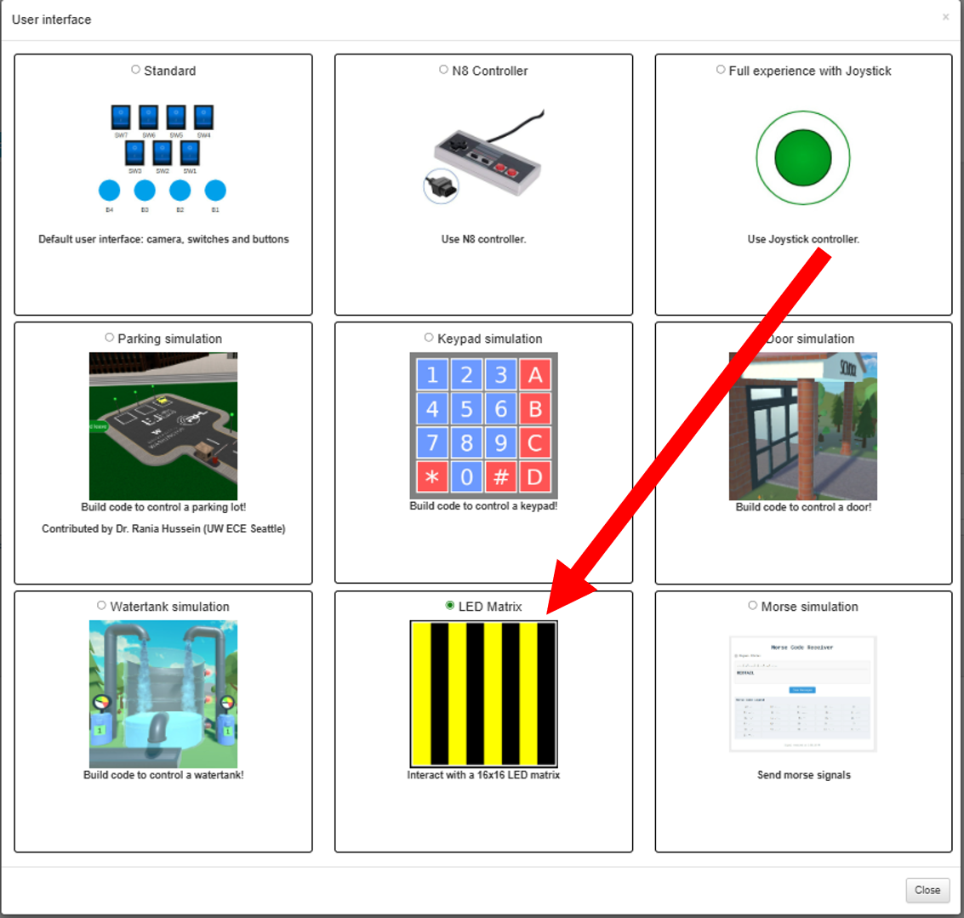
Figure 8
- Ensure the LED Matrix is selected as our user interface, as shown in Figure 9.
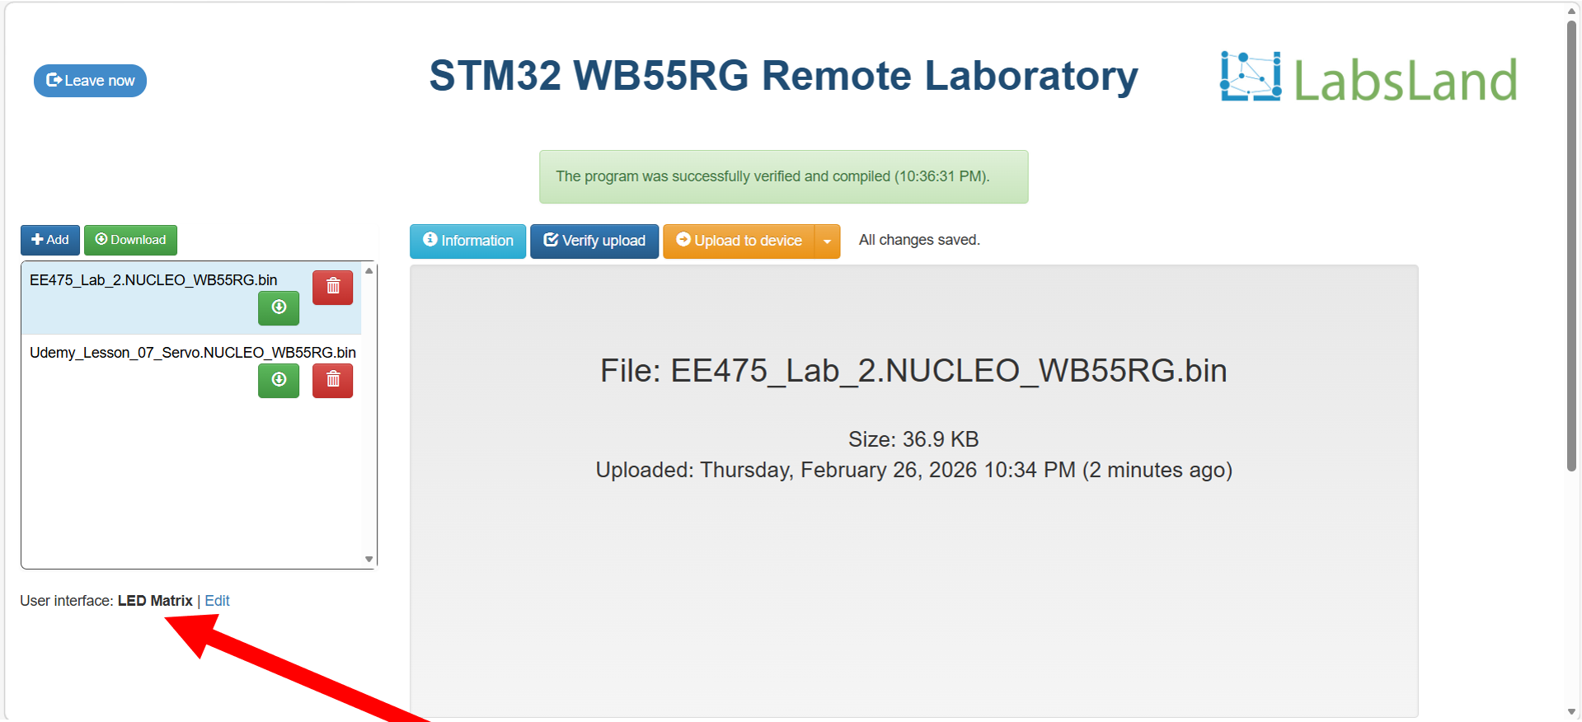
Figure 9
- Click the blue Verify upload button first. After the orange Upload to device button becomes clickable, click it. Please see Figure 10 for instructions.
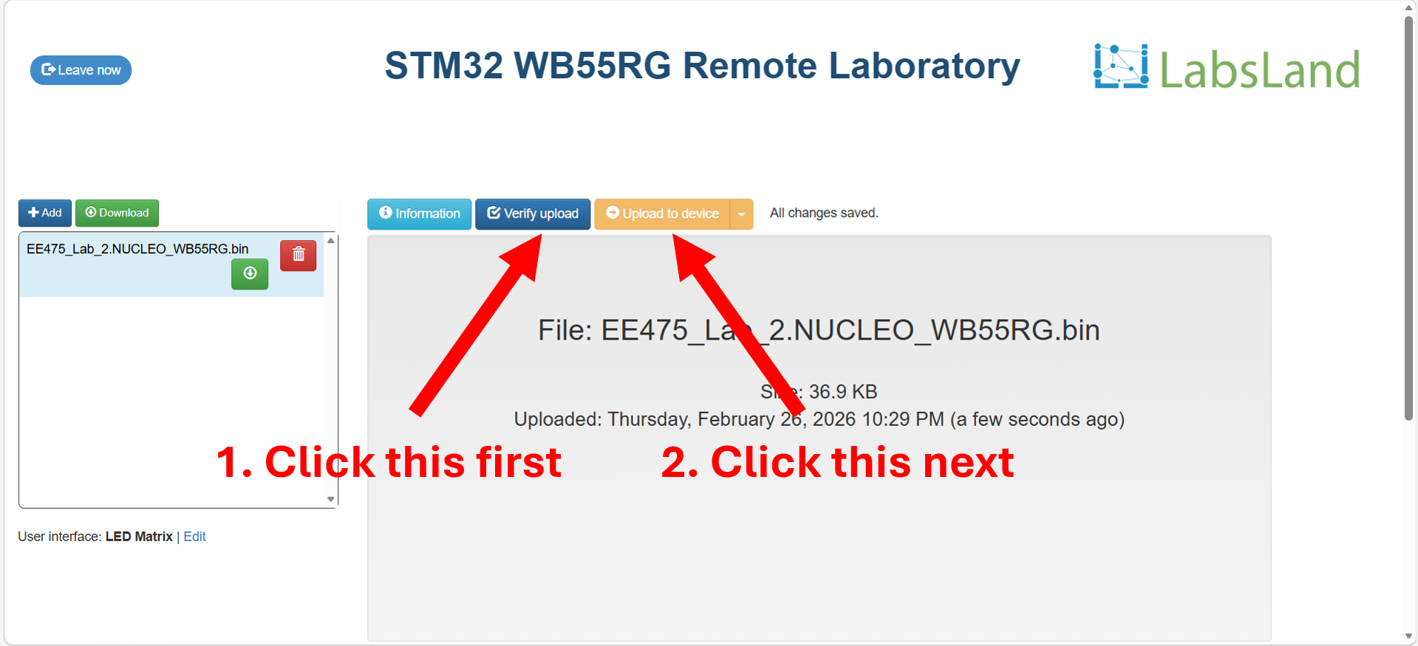
Figure 10
- If you encounter any error message that says, “The program could not be verified”, as shown in Figure 11, the system does not recognize a binary file. To overcome this, either refresh the webpage or add another binary file by following the instructions in Figure 12. Ignore this step if you do not see this error and are able to proceed with uploading your program to the device.
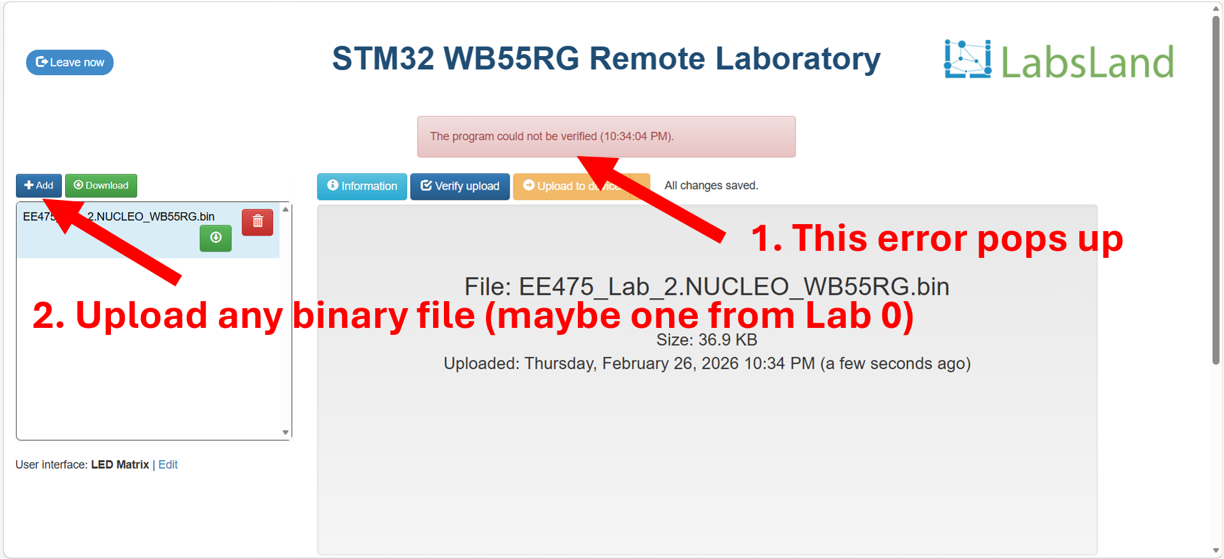
Figure 11
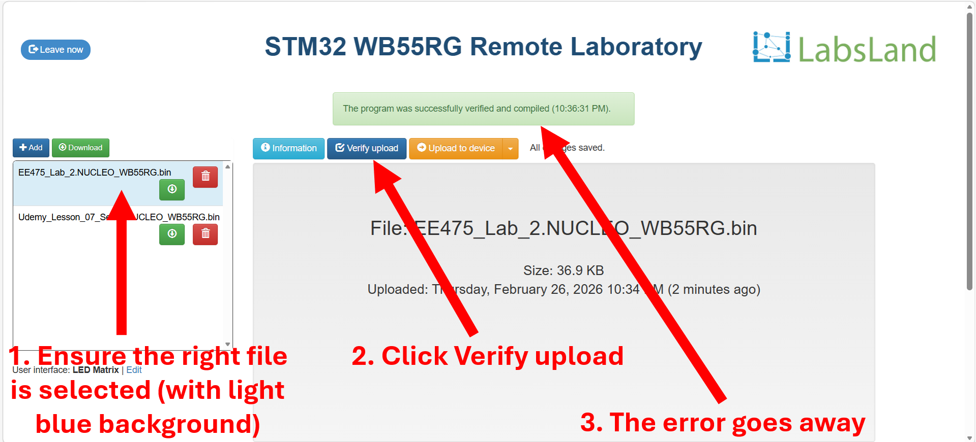
Figure 12
- After the 3-min lab session starts, the virtual LED matrix will be displayed at the bottom of the page under the console window, as shown in Figure 13. To exit the lab session, click the blue Leave now button on the upper left of the screen next to the countdown clock.
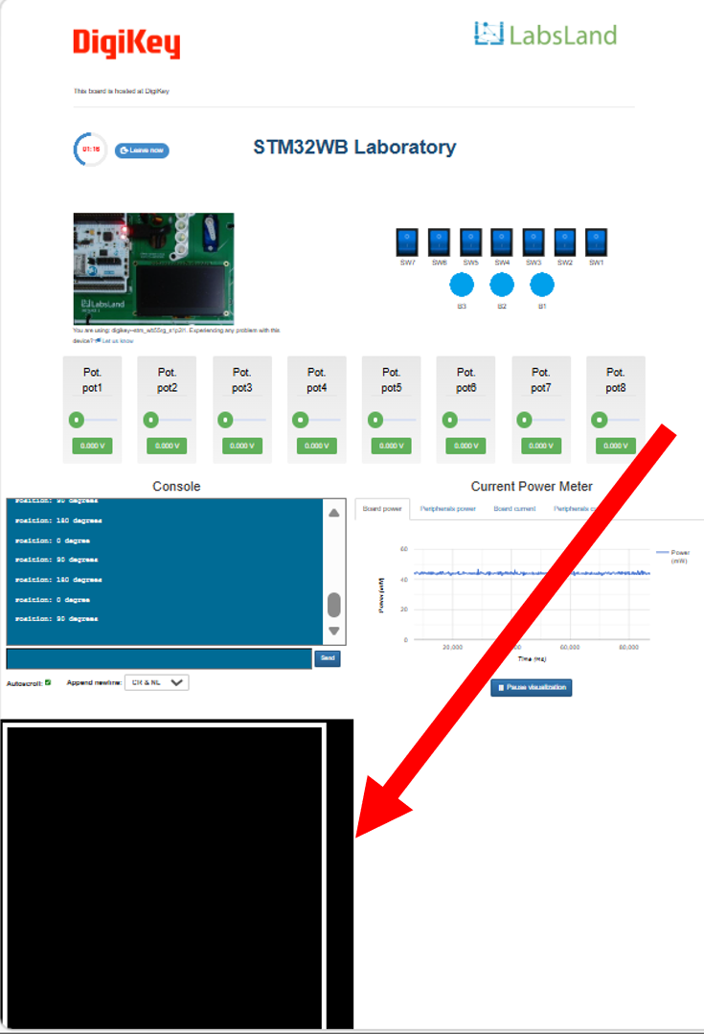
Figure 13

- For this lab, we recommend setting up the browser to use half of your screen, like in Figure 14. This way, after zooming out, you can see the complete remote lab interface, including the switches and LED matrix.
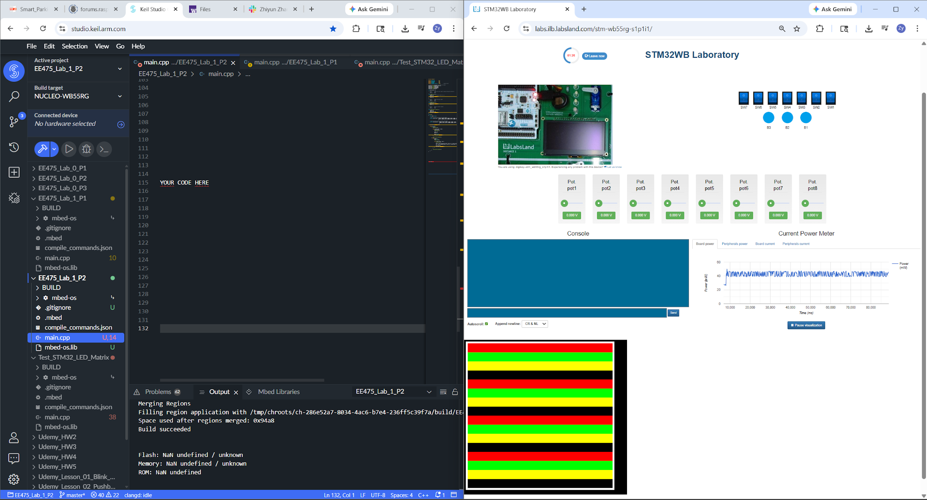
Figure 14
Assigned Task
Part 1
We will now create our first LED matrix program for the STM32 remote lab. It is a simple program that sets the top half of the LED matrix to red, and the bottom half of the LED matrix to green.
- Start by creating an empty project on Keil Studio Cloud. Instructions on how to use the Keil Studio Cloud can be found in the Lab 0 handout.
- Copy and paste the following code into the project. Important blocks of code are commented.
- #include "mbed.h"

- #define PIN_LATCH PC_4
- #define PIN_PULSE PD_0
- #define PIN_GREEN PD_1
- #define PIN_RED PB_0

- int main()
- {
- // Initialize the digital pin LED1 as an output
- DigitalOut latch(PIN_LATCH);
- DigitalOut pulse(PIN_PULSE);
- DigitalOut green(PIN_GREEN);
- DigitalOut red(PIN_RED);

- int pixel_count = 0;
- bool done = false;

- // Wait 2 seconds to ensure the STM32 is fully programmed
- ThisThread::sleep_for(2000);

- while (true) {
- if (!done) {
- // Beginning logic: assert latch
- latch = 1;
- pulse = 0;
- ThisThread::sleep_for(1);
- latch = 0;

- // Loop over 256 times to set the color of all LEDs
- while (pixel_count < 256) {
- // Toggle pulse
- pulse = 0;
- ThisThread::sleep_for(1);
- pulse = 1;

- // Set the color of a pixel
- if (pixel_count < 128) {
- red = 1;
- green = 0;
- } else {
- red = 0;
- green = 1;
- }

- pixel_count++;
- ThisThread::sleep_for(1);
- }

- // Ending logic: reset all the control signals
- latch = 0;
- pulse = 0;
- pixel_count = 0;
- ThisThread::sleep_for(1);

- done = true;
- }
- }
- }
- Compile the project and upload the binary file onto the STM32 remote lab by following Step 1-10 in the STM32 Remote Lab LED Matrix User Interface section above.
- We should now see the top half of the LED matrix being red, and the bottom half of the LED matrix being green.
Questions (10 pts)
- Attach a screenshot of the virtual LED matrix while your program is running.
- In the Background -> LED Matrix section, the LED matrix is said to support a third color, yellow. Explain how you would write the code to set an LED pixel to yellow? You do not need to show any code.

Part 2
We will now create a slightly more complex static LED matrix display. When set, it should display horizontal lines of 4 different colors, as shown in Figure 15.
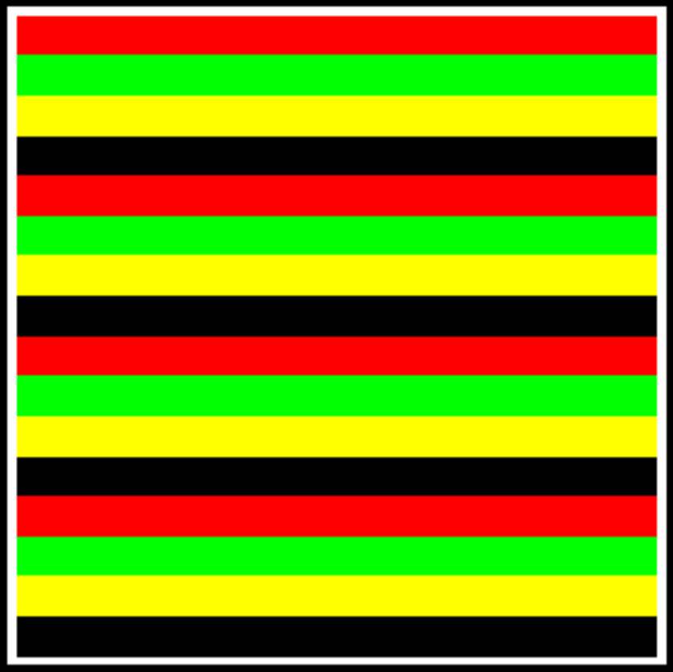
Figure 15
Use SW3 as a control signal:
- When SW3 is set to 0, clear the LED matrix (all pixels remain black).
- When SW3 is set to 1, display the pattern shown in Figure 15 on the LED matrix.
Hint:
- You can store the red and green values of pixels using either an array or an algorithm.
- Feel free to create separate modules that toggle the latch signal, toggle the pulse signal, and reset all control signals, so you can reuse them in your reset and non-reset blocks of code.

Questions (20 pts)
- Which GPIO pin did you use to read the states of SW3? (Hint: The Fritzing Diagram can be found under both Lab 0 and Lab 1 Canvas folders.)
- Did you store the red and green values of pixels using an array or used an algorithm? Please explain your approach.
- Attach a screenshot (with the switches) of the virtual LED matrix while
- SW3 is set to 0.
- SW3 is set to 1.
- Does it work as expected and match what is shown in Figure 15?
- Attach a screenshot of your program in the Keil Studio Cloud.
- If we need to display a letter, say “E”, using a single color, how would you approach this? Please explain using words. You do not need to show working code.

Part 3
We will now create a simple animation on the LED matrix. There are 4 vertical lines in 2 pairs. Each pair has one red and one green lines, with a space of one pixel between them, as shown in Figure 16. They will shift across the LED matrix from right to left and loop back to the right edge of the LED matrix again. Your LED matrix may start with any frame in the beginning.
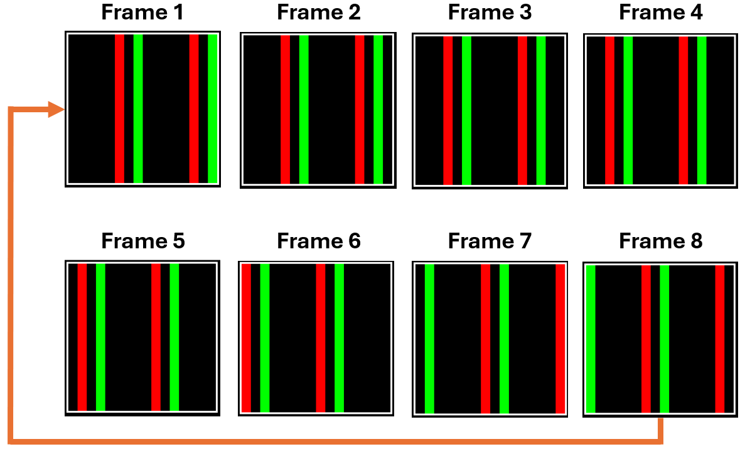
Figure 16
Similar to Part 2, we will use SW3 as a control signal:
- When SW3 is set to 0, clear the LED matrix (all pixels remain black).
- When SW3 is set to 1, display the pattern shown in Figure 16 on the LED matrix.
Hint:
- Consider using a shift logic, such as
red = pixel_red & (0x0001 << (number of bit shift));
green = pixel_green & (0x0001 << (number of bit shift));

Questions (20 pts)
- Did you load the red and green values of pixels using an array, a variable, or an algorithm? Please explain your approach.
- Attach a screenshot of the virtual LED matrix while
- SW3 is set to 0.
- SW3 is set to 1, and the LED matrix looks like one of Frame 1 to Frame 4 in Figure 16.
- SW3 is set to 1, and the LED matrix looks like one of Frame 5 to Frame 8 in Figure 16.
- Does it work as expected?
- Attach a screenshot of your program in the Keil Studio Cloud.
- If we need to display a word, say “NEXT”, using a single color, and slowly moving it to the left, like on a bus station display on buses, how would you approach this? Please explain using words. You do not need to show any code.

Submission Instructions
Please compile your responses to the lab questions into a PDF report. Ensure that your report is well-organized and includes screenshots of the remote laboratory where necessary. Clearly label and number your responses according to the corresponding question numbers.

