Virtual LED Matrix Example Exercise
Conway’s Game of Life
Hardware: FPGA
Simulation: LED Matrix
Language: English
Estimated Time: 60 minutes
Difficulty: Intermediate




Table of Contents
Table of Contents 2
1. Overview 3
2. Learning Objectives 4
3. Prerequisites 4
4. System Description 5
5. Exercise Requirements 8
6. Design Strategy 8
7. Implementation Guidelines 9
8. Testing Procedure 9
9. Deliverables 10
10. Extension Challenges (Optional) 10

1. Overview
Lab Objectives
In this lab, you will culminate the knowledge you gained throughout the quarter to design and simulate Conway’s Game of Life on the DE1-SoC board. To visualize the game simulation, we will be using the 16 x 16 LED array matrix provided to you through LabsLand.
Design Problem- Conway’s Game of Life
The Game of Life, also known simply as Life, is a cellular automaton devised by the British mathematician John Horton Conway in 1970. It is a zero-player game, meaning that its evolution is determined by its initial state, requiring no further input. One interacts with the Game of Life by creating an initial configuration and observing how it evolves.

Rules of the game
The universe of the Game of Life is a two-dimensional orthogonal grid of square cells, each of which is in one of two possible states, live or dead (or populated and unpopulated, respectively). Every cell interacts
with its eight neighbors, which are the cells that are horizontally, vertically, or diagonally adjacent.
At each step in time, the following transitions occur:
1. Any live cell with fewer than two live neighbors dies, as if by underpopulation.
2. Any live cell with two or three live neighbors lives on to the next generation.
3. Any live cell with more than three live neighbors dies, as if by overpopulation.
4. Any dead cell with exactly three live neighbors becomes a live cell, as if by reproduction.
These rules, which compare the behavior of the automaton to real life, can be condensed into the
Following:
1. Any live cell with two or three live neighbors survives.
2. Any dead cell with three live neighbors becomes a live cell.
3. All other live cells die in the next generation. Similarly, all other dead cells stay dead.
This link has a simulation of the game that you can play with to get an idea of how the game works.

Hardware + Simulation Context
You will display your Game of Life simulation on the 16x16 LED array and drive it from a DE1_SoC in real hardware through a virtual interface. The interaction is bidirectional.

Student Task Definition

Students are responsible for designing a basic implementation of Conway’s Game of Life and following the rules of the game outlined earlier. While this game is sequentially executing, the student must design a driver for the LED matrix to show the game while it is being played. The logic will be executed on real hardware and will be interfaced through a simulated interface.

2. Learning Objectives
What students will be able to do after completing the exercise.

- Design simple control logic that, once instantiated, becomes a complex digital system
- Validate system behavior using real hardware feedback.

3. Prerequisites
What students need to know, or have, to complete the exercise.

Required Knowledge
- Basic SystemVerilog/Verilog) programming (variables, conditionals)
- Digital input/output concepts
- Basic sequential and combination programming
- Finite State Machine Design
- Digital System Design

Required Resources
- Instructor-provided login credentials
- Access to LabsLand remote environment
- IDE to compile C-code or Quartus Lite for synthesis (SystemVerilog/Verilog)

4. System Description

4.1 Concept Overview
This section contains the system logic model and conceptual behavior.
To simulate the Game of Life, you will have to set an initial pattern of lights. This pattern will dictate how your simulation progresses. For the initial configuration of your system, you are expected to have two modes: one mode where you toggle between 3 different persistent patterns (see below), and one mode where you use an LFSR to generate a pseudorandom pattern that runs until no cells remain or only persistent patterns remain.

To toggle between the two modes, you will use SW[0], where:
● Mode 1: SW[0] is low, and your LFSR creates a pseudorandom starting pattern.
● Mode 2: SW[0] is high, and SW[2:1] toggle between the three persistent, pre-loaded patterns.

Mode 1: Using an LFSR- Given below are suggestions/options regarding how you can use an LFSR to generate a pseudorandom starting pattern. Feel free to use a different method from the ones given below to generate the pseudorandom starting pattern.
- 8-bit LFSR: Note that the board has 256 LEDs (16x16). You can set a constant number of initial lights you want to set. For example, you want your initial pattern to light up 6 lights in random locations. You can do that by using an 8-bit LFSR to generate a random number between 0 and 255 that maps to a single cell/LED on the array matrix. You can call on the LFSR 6 times to generate 6 unique pseudorandom numbers between 0-255 that map to 6 lights on the LED array. You will have to use for- loops to iterate over each of the 256 positions of the LED array and turn on the lights dictated by the indices generated by the LFSR.
- 10-bit LFSR: You can use a 10-bit LFSR just as you did for the Tug-Of-War lab. However, because the LED dot matrix is 16x16, you will need to extend this signal to be 16 bits in length, which can be done in a variety of ways, including adding a 16-bit signal of all zeros and storing it to a 16-bit signal, or by bit-width casting.
- 16-bit LFSR: Unlike the Tug-Of-War lab, you will need to create a 16-bit LFSR, which must be made in a 4-tap configuration. The 4 taps to the 16-bit LFSR must occur at positions 16, 14, 13, and 11 as shown in Figure 1.
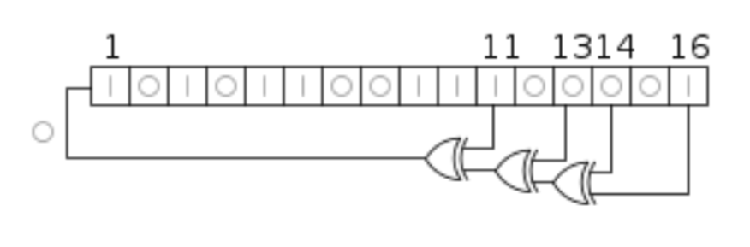
Figure 1

- Regardless of whether you choose a 10-bit LFSR where you augment the signal to be 16 bits or a 16-bit LFSR, you will need to create your starting pattern by using for-loops to iterate over each of the 256 positions in your starting pattern array. (Note: If you simply write your 16-bit signal to each row or each column by only using one loop, your starting pattern will consist of multiple parallel lines and therefore lacks the randomness we wish to achieve by using the LFSR. Because of this, your starting pattern cannot consist solely of parallel lines, and you are expected to ensure your starting pattern appears random.)
Mode 2: Using pre-loaded patterns:
- Pattern A: The first pattern you are expected to demonstrate is the beehive, which does not move if programmed correctly.
- Pattern B: The second pattern you are expected to demonstrate is the two-period toad, which oscillates between two states if programmed correctly.
- Pattern C: The third pattern you are expected to demonstrate is the middle-weight spaceship, which should move laterally across your LED dot matrix if programmed correctly.
Please refer to the Wikipedia page for Conway’s Game of Life for descriptions of each of these patterns, and note that it does not matter what position Pattern B or C starts in, so long as they demonstrate the proper periodic behavior. It is also important that these three patterns are loaded based on the positions of SW[2:1], as loading them at the same time may lead to conflicts between the patterns, which may result in either all cells ‘dying’ or persistent patterns that are not intended.

Digital Twin Simulation Example:
An example is shown in Figure 2 for a Flappy Bird game.
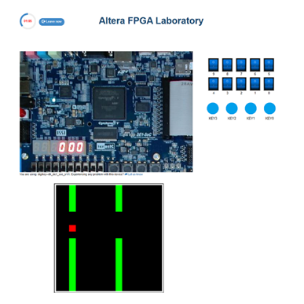
Figure 2

4.2 Hardware Mapping (needs edits)
This section contains the hardware mapping(s) necessary for interacting with the system.

4.2.1 Inputs
none

4.2.2 Outputs
Signal Name | Description | V_GPIO
Green | Represents the state of the green channel for the current pixel | 32
Red | Represents the state of the red channel for the current pixel | 34
Latch | The “start communication” signal precedes 256 pulses. | 26
Pulse | Synchronization signal to tell the simulation device when to read values of the Green and Red GPIO signals. There must be 256 pulses following each Latch. | 27

5. Exercise Requirements
This section defines the observable behaviors your system must exhibit.

When synthesizing to the DE1_SoC through the LabsLand interface, the Mode 1 - LFSR implementation should follow the rules dictated by Conway’s Game of Life. For Mode 2, the pre-loaded patterns should behave as such:
- Pattern A: The first pattern you are expected to demonstrate is the beehive, which does not move if programmed correctly.
- Pattern B: The second pattern you are expected to demonstrate is the two-period toad, which oscillates between two states if programmed correctly.
- Pattern C: The third pattern you are expected to demonstrate is the middle-weight spaceship, which should move laterally across your LED dot matrix if programmed correctly.

6. Design Strategy
This section outlines key engineering considerations for structuring your solution.

A counter is used to select the rows of the LED matrix. The 4-bit counter can be thought of as an input to a 4 to 16 decoder, where each bit of the output maps to each row of the LED matrix. The output that is selected depends on the 4-bit counter value. For example, suppose the 4-bit counter is at 5 (0101 in binary), this means that the 5th bit of the output, corresponding to the 5th row of the matrix, will be set to high/selected. The column drivers for each row can then be set to the desired pattern for that row. See the
example code in the later section.

An image can be displayed on the LED array matrix by taking advantage of the persistence of vision. The idea is to activate only one row at a time, showing the appropriate pattern for each row using the red and green column drivers. By cycling quickly through the rows, the effect is indistinguishable from having
each LED controlled independently. The human eye is unable to detect any flickering if the frequency is sufficiently high. Therefore, if the counter is cycling through the rows at a high clock rate, then the light patterns of all the rows will be visible at the same time, creating the desired image.

7. Implementation Guidelines
This section provides practical tips for building your system.

Frequency Considerations
Cycling the LED array rows at the speed of CLOCK_50 (50 MHz) causes the LEDs to appear very dim. This could be because the capacitors at the GPIO pins do not have enough time to fully charge or discharge when their values are being cycled so fast. Lowering the frequency will make the LEDs brighter. However, ensure that your cycling is fast enough that the LEDs appear to be continuously lit. The LEDs should be bright enough for easy viewing when cycled at or below 1 MHz. You can use the clock divider module to get a slower clock, which will slow down the cycling. However, remember you should only use one clock for your whole design. So, if you are using a clock divider,
ensure that the clock is fast enough to be used for the rest of the project. If you want to use a faster clock for your project (like CLOCK_50), a way to slow things down just for
the LED matrix is to extend the length of the 4-bit counter and use the upper 4 bits of that counter to control your RowSelect variable (cycling through rows). For example, if you use the upper 4 bits of a 5- bit counter, it will change only every other clock cycle. If you use the upper 4 bits of a 6-bit counter, it will change only every 4th clock cycle and so on.

8. Testing Procedure
This section answers the question of how we know our system is working by using the simulation.
For preloaded patterns:
- Pattern A: The first pattern you are expected to demonstrate is the beehive, which does not move if programmed correctly.
- Pattern B: The second pattern you are expected to demonstrate is the two-period toad, which oscillates between two states if programmed correctly.
- Pattern C: The third pattern you are expected to demonstrate is the middle-weight spaceship, which should move laterally across your LED dot matrix if programmed correctly.
For non-preloaded patterns:

At each step in time, the following transitions occur:
1. Any live cell with fewer than two live neighbors dies, as if by underpopulation.
2. Any live cell with two or three live neighbors lives on to the next generation.
3. Any live cell with more than three live neighbors dies, as if by overpopulation.
4. Any dead cell with exactly three live neighbors becomes a live cell, as if by reproduction

9. Deliverables

A video or screen recording demonstrating the lab in 3-5 minutes, as well as a voice-over explaining your project with both modes.

10. Extension Challenges (Optional)
None for this exercise.

