Virtual Breadboard Example Exercise

Parking Lot Occupancy Counter
Hardware: DE1-SoC FPGA Development Board
Simulation: Breadboard
Language: English
Estimated Time: 4-6 hours
Difficulty: Intermediate




Table of Contents
Parking Lot Occupancy Counter 1
Table of Contents 2
1. Overview 3
2. Learning Objectives 3
3. Prerequisites 3
4. System Description 4
5. Exercise Requirements 5
6. Design Strategy 6
7. Implementation Guidelines 7
8. Testing Procedure 7
9. Deliverables 8
10. Extension Challenges (Optional) 8
11. Reflection Questions (Optional) 8
Appendix A — Remote Lab Access 9

1. Overview

Paragraph 1: Real-World Framing
In this lab, students will design a parking lot counter system using the digital twin of a breadboard and the FPGA remote lab. The system will track the number of cars in a parking lot and control both entry and exit gates. This hands-on assignment serves to refresh students' knowledge of Finite State Machines (FSMs) and digital circuit design and construction. Additionally, it introduces students to using and interfacing with the GPIOs on the DE1-SoC development board.

Paragraph 2: Hardware + Simulation Context
This lab exercise uses the DE1-SoC remote laboratory with real DE1-SoC development boards. Students will also need to choose the digital twin of a breadboard as the user interface and construct their circuit on it. Complex logic, including FSMs, is executed on the real DE1-SoC development boards, which bidirectionally communicate with the virtual breadboard.

Paragraph 3: Student Task Definition
Students are responsible for developing FPGA logic using Finite State Machines (FSMs) and constructing their digital circuit on the digital twin of a breadboard using toggle switches and LEDs. The FPGA reads the state of the switches, executes the FSM logic, and outputs the resulting system states to the LEDs on the virtual breadboard. Communication between the development board and the breadboard digital twin is handled through the GPIO interface.

2. Learning Objectives
After the completion of this lab exercise, students will be able to design complex programs using FSMs and GPIO pins on the DE1-SoC development boards. They will also learn how to construct basic digital circuits using the virtual breadboard.

3. Prerequisites

Required Knowledge
- One of the Hardware Description Languages (HDLs)
- Basic combinational and sequential FPGA logic
- Finite State Machine (FSM)
- General Purpose Input/Output (GPIO)

Required Resources
- Access to the remote lab environment.
- An IDE to develop HDL programs. For the DE1-SoC remote lab, we recommend using the official development software, Quartus Prime. There is also an online code editor in the remote lab that can be used to write code, synthesize, and generate binary files for the development boards.
- Documentation of the digital twin of a breadboard.

4. System Description

4.1 Concept Overview
Consider a parking lot with a single entry and exit gate. Two pairs of photosensors are used to monitor the activity of cars, as shown in Figure 1. When an object is between the photo transmitter and the photoreceiver, the light is blocked, and the corresponding output is asserted to 1. By monitoring the events of two sensors, we can determine whether a car is entering or exiting, or a pedestrian is passing through. For example, the following sequence indicates that a car enters the lot:
- Initially, both sensors are unblocked (i.e., the a and b signals are 00).
- Sensor a is blocked (i.e., the a and b signals are 10).
- Both sensors are blocked (i.e., the a and b signals are 11).
- Sensor a is unblocked (i.e., the a and b signals are 01).
- Both sensors become unblocked (i.e., the a and b signals are 00).
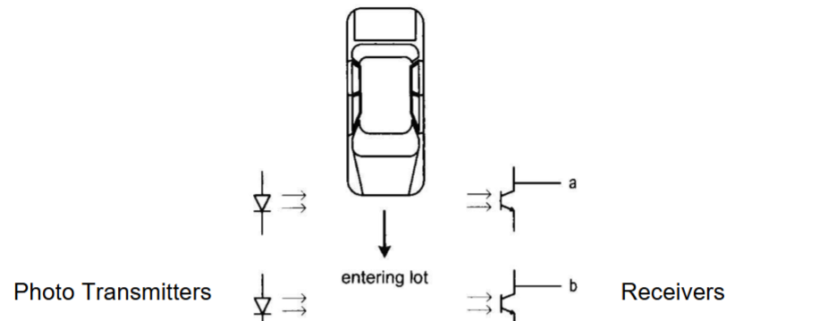
Figure 1. Photo transmitters and receivers setup.

4.2 Hardware Mapping
- Input GPIO Pins
Five V_GPIO pins from the DE1-SoC development board can be used as inputs to the FPGA: 23, 24, 28, 29, 30. They all have the same capabilities.
- Output GPIO Pins
Seven V_GPIO pins from the DE1-SoC development board can be used as outputs to the FPGA: 26, 27, 31, 32, 33, 34, 35. They all have the same capabilities.

5. Exercise Requirements
- Design an FSM with two input signals, a and b, and two output signals, enter and exit. The enter and exit signals assert true for one clock cycle when a car enters or exits the lot, respectively. Do not assume that cars will not change direction while entering or exiting the parking lot.
- Design a counter with two control signals, inc and dec, which increment and decrement the counter when asserted. Assume that the maximum capacity of the parking lot is 5 spots. Derive the HDL code for the FSM and simulate it in a simulation software tool.
- Combine the counter and the FSM, and then model the parking lot, using two switches on the breadboard to mimic the two sensor outputs and the seven-segment displays to display the car count. Your system should have the following:
  - Display the car counts as they enter the parking lot on the seven-segment displays HEX0 and HEX1.
  - If the counter reaches 25 (or 5 for simulation and demo purposes), display the word “FULL” on HEX5-HEX2
  - As cars exit the lot, the counter decrements, and the corresponding number should be displayed on HEX0 and HEX1.
  - When the lot is empty, display the word “CLEAR” on HEX5-HEX1 and display the number ‘0’ on HEX0.
  - Use 2 LEDs on the breadboard to represent the a and b signals. When a is 1, turn on the LED on the left, and when a is 0, turn off the LED on the left.
  - Stimulatingly, when b is 1, turn on the LED on the right, and when b is 0, turn off the LED on the right.
  - Use the third switch on the breadboard as the reset signal.
- Please read the breadboard documentation for the instructions regarding how to wire and use switches and LEDs. The general rule is labeled as follows.
  - Wire 2 LEDs to any output ports
  - Wire 3 switches to any input ports
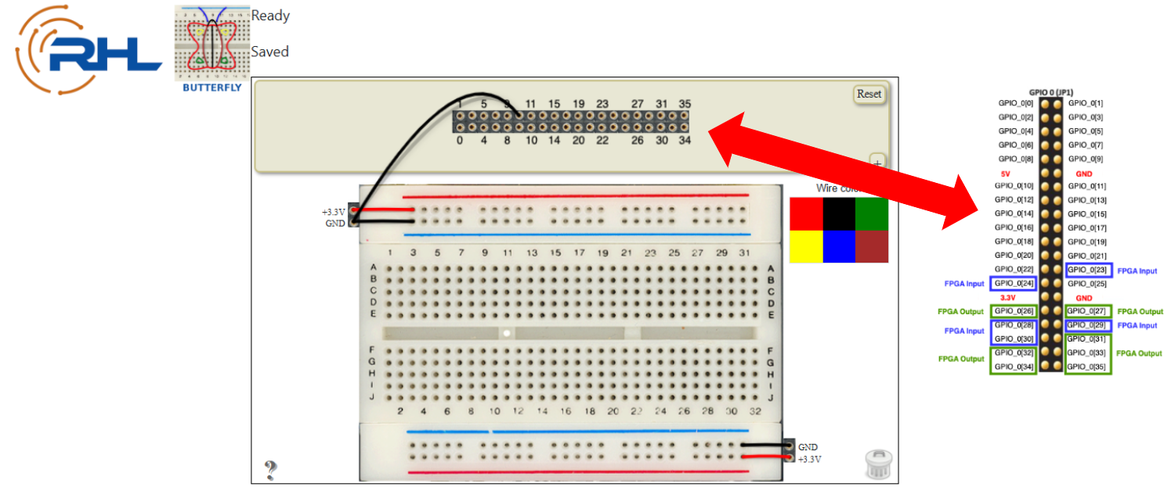
Figure 2. LabsLand GPIO headers

- Simulate the system in a simulation software tool.
- Upload the program onto the LabsLand FPGA remote lab and record a 2-3 mins video to demonstrate your work. Note, we do not need to see your compilation part.
- Create a block diagram for your system and include it in your lab report.
- In the report, include the state diagram(s) that you used in designing this system.

6. Design Strategy
- Students must carefully consider how they will implement their FSMs to cover edge cases. For example, when a car passes one of the 2 sensors and then backs out, it should not count as a car entrance or exit.
- It is up to instructors to decide how students’ designs should respond to other edge cases, such as a pedestrian crossing the gates, when only one sensor is triggered at a time.
- There are many approaches to solving this lab, such as whether students should divide their program into submodules or use a single top-level module. It is largely dependent on the style of instructors and course objectives.

7. Implementation Guidelines
There are many approaches to solving this lab. One approach is to divide the program into 4 different modules:
- top: the top-level module whose inputs and outputs are actual inputs and outputs on the FPGA's pins. The inputs must include all the onboard 7-segment displays, GPIOs, and the onboard 50 MHz clock
- detection: takes in the outputs of the two pairs of photo sensors and outputs whether a car entrance or exit has been detected
- counter: takes the signal and updates the number of cars currently in the parking lot
- Display: controls what is displayed on the onboard 7-segment displays

8. Testing Procedure
- The toggle switches and LEDs on the digital twin of a breadboard are connected to the valid input and output GPIO pins. An example is shown in Figure 3.
- The 2 LEDs on the digital twin of a breadboard must sync correctly with their corresponding toggle switches.
- When the reset switch is toggled, the 7-segment displays must fall back to displaying 0 cars in the parking lot, no matter how many cars it contained prior to reset.
- When a car entrance sequence is detected, the number displayed on the HEX0 7-segment displays should increment.
- When a car exit sequence is detected, the number displayed on the HEX0 7-segment displays should decrement.
- When the parking lot is empty, the HEX5 - HEX1 7-segment displays should display the word “CLEAR”.
- When the parking lot is full, the HEX5 - HEX2 7-segment displays should display the word “FULL”.
- Students should also demonstrate the behavior of their designs to edge cases, such as a pedestrian crossing. However, such behavior can be defined by instructors or vary by implementation if the approach is open-ended.

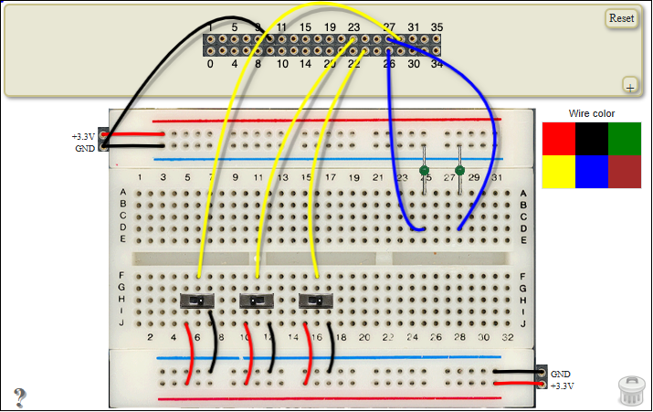
Figure 3

9. Deliverables
- Demo Video
A short 2–3 minute screen recording showing students interacting with the FPGA remote lab and the digital twin of a breadboard. The video should demonstrate the working system and highlight key interactions.
- Lab Report
The report should include a procedure section where students explain their approach to the task and detail their implementation. It should also contain a simulation section demonstrating their efforts in verifying the functionality of their designs using HDL simulation tools.
- Source Code
Students should submit all HDL code developed for the assignment. This allows instructors to check the originality of student work, assess coding style, and verify the correctness of the implementation.

10. Extension Challenges (Optional)
- Edge Cases
  - The parking lot should not register a car entrance or exit when a car enters or exits halfway and backs out.
  - What should happen when a pedestrian tries entering or exiting the parking lot (i.e., when only one sensor is blocked at a time)?
  - If the parking lot is empty, what would happen when a car exit sequence is detected?

