REDTAIL Simulation
Documentation

Parking Lot
Hardware: FPGA
Language: English




Table of Contents
Parking Lot 1
Table of Contents 2
1. Defining Remote and Simulated Laboratories 3
2. Simulation Overview 4
3. Simulation Components 5
4. GPIO Mappings 8
5. Possible Specifications 9
6. Suggested Learning Objectives 9

1. Defining Remote and Simulated Laboratories

What is a Remote Laboratory?
Remote laboratories are systems that combine hardware and software to allow students to perform real educational experiments over the Internet. In other words, students can control physical lab equipment and collect real data remotely, without being physically present in the laboratory.

These labs remove space and time barriers, allowing students to practice anytime, increasing the experience essential for STEM learning. They also encourage active and inquiry-based learning, promoting autonomy since students can work independently of instructors and lab hours.

What is a Simulated Laboratory?
Remote laboratories provide students with, over the Internet, access to real hardware hosted in a server room, while simulated laboratories virtualize the inputs, outputs, and internal behavior of hardware and entire systems. This allows students to work with digital twins of common industry standard hardware as well as unique and engaging systems that remote laboratories could not support, such as entire industrial dams, arcade machines, communication networks, and other expensive or niche hardware.

REDTAIL Hardware + Simulation Context
REDTAIL is a Remote Laboratory Simulation framework developed by the Remote Hub Lab at the University of Washington and LabsLand.

In REDTAIL, students write or upload code through a LabsLand web IDE. Their code is compiled and deployed to real physical devices (e.g., FPGAs and microcontrollers) that communicate bidirectionally with other devices running an instructor-selected simulation. These simulation devices communicate with LabsLand servers, allowing students to interact with and control the simulation via a web interface. This enables them to test their code in real time, as they would with a physical device or environment.

Each simulation can support many different lab assignments. We provide example specifications for each simulation, but instructors are welcome to create their own.

The remaining sections of this document describe one REDTAIL simulation in detail.

2. Simulation Overview

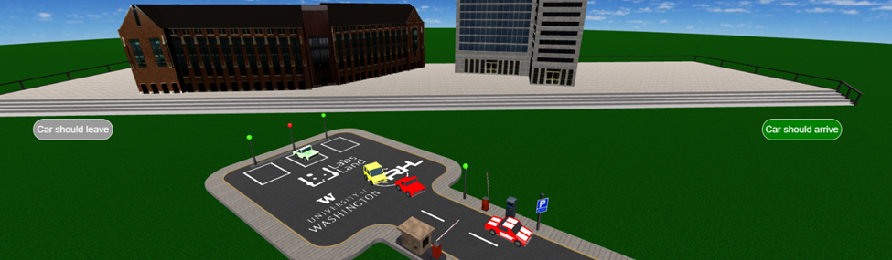
Figure 1: Screenshot of the Parking Lot Simulation
The 3D Parking Lot Simulation, shown in Figure 1, models a parking lot with one entry and one exit gate, and three parking spots. Only one car may enter or exit at a time. The user triggers car arrivals and departures via virtual buttons, while cars autonomously park or exit once inside. Gate operation is controlled via GPIO outputs, and car presence is detected through GPIO inputs.
Students can view the device under test via a live camera feed and interact with the simulation via buttons for car arrival and departure on the visualization iframe shown in Figure 1 and Figure 2. Using these web elements, students will test their design as they view the state of the parking lot change in real time.
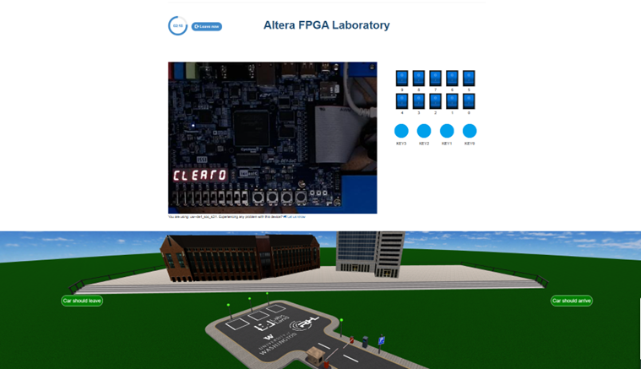
Figure 2: Simulation and Interaction Page

3. Simulation Components

3.1 Occupancy
The 3D parking lot can hold a maximum of three vehicles.

3.2 LEDs
There are four LEDs on the simulations: three of them to indicate the status of each parking space, and the fourth to indicate if the entire parking lot is full. These four LED colors can change between green and red. The color can be changed by asserting the appropriate V_GPIO connection to the FPGA (see the later page for GPIO mappings).

3.2 Car Arrival and Departure
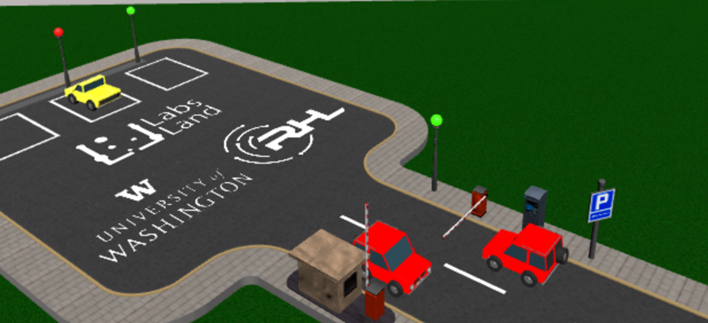
Figure 3: Close-up view of cars entering and exiting the parking lot.

Buttons
The 3D parking lot consists of two buttons: a “Car should arrive” and a “Car should leave”. See Figure 2 for a view of the buttons.

Entering
Pressing the “Car should arrive” button will automatically generate a car to wait at the parking lot barrier entrance.

Entrance Barrier
The barrier can be opened by asserting the appropriate V_GPIO connection to the device under test. When the barrier opens, the car waiting will automatically drive to the nearest available parking slot.

Exiting
When pressing the “Car should leave” button on the 3D parking lot simulator, one car parked in the parking lot (if any) will attempt to leave by driving to and waiting at the exit gate.

Exit Barrier
The exit barrier can be opened by asserting the appropriate V_GPIO connection to the device under test. When the exit barrier opens, the waiting car will automatically leave the parking lot.

Digital Twin Interface
To select the Parking simulation as our user interface, go to the FPGA remote lab and click Edit next to the User interface, as indicated by the red arrow in Figure 4.

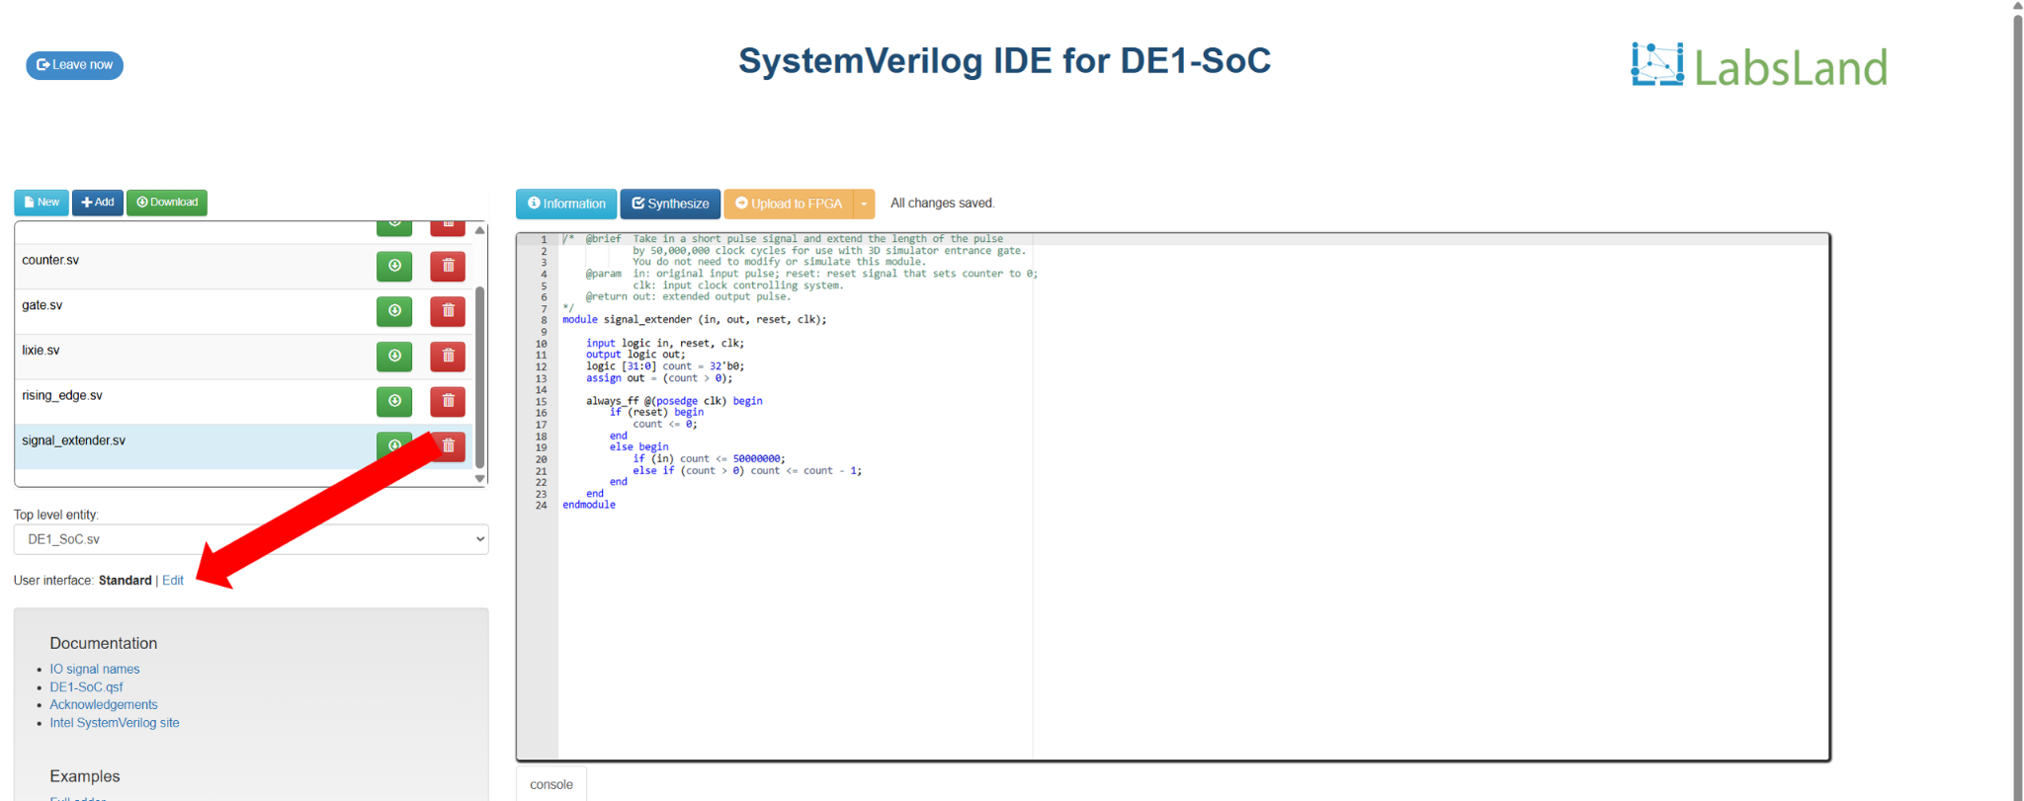
Figure 4

Next, locate the Parking simulation and click on it, as indicated by the red arrow in Figure 5.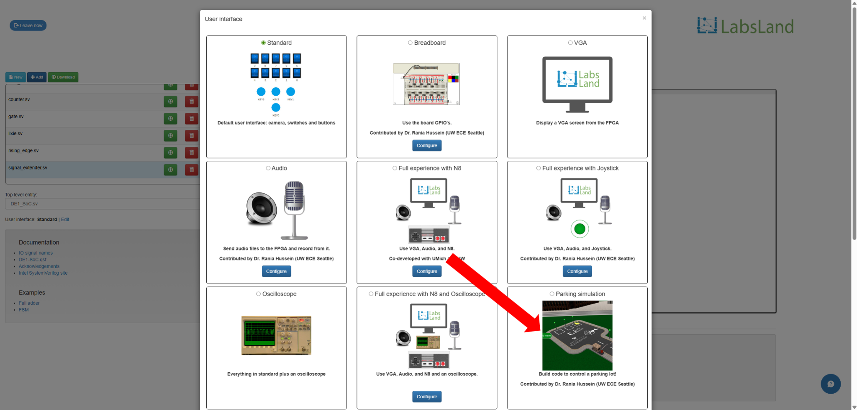
Figure 5

Exit the user interface selection window by clicking the X button on the upper right of the user interface selection window or anywhere outside of the user interface selection window.

Note: Because there is a lot of 3D data to load, it may take some time to load the parking simulation. The loading speed varies with network quality.

4. GPIO Mappings

4.1 Inputs

Signal Name | Description | V_GPIO
Presence Parking 1 | Indicate if there is a car in parking spot 1. | 28
Presence Parking 2 | Indicate if there is a car in parking spot 2. | 29
Presence Parking 3 | Indicate if there is a car in parking spot 3. | 30
Presence at Entrance Gate | Indicate if there is a car waiting at the entrance. | 23
Presence at Exit Gate | Indicate if there is a car waiting at the exit. | 24

4.2 Outputs

Signal Name | Description | V_GPIO
LED Parking 1 | Change the LED color of spot 1 (0 = green, 1 = red). | 26
LED Parking 2 | Change the LED color of spot 2 (0 = green, 1 = red). | 27
LED Parking 3 | Change the LED color of spot 3 (0 = green, 1 = red). | 32
LED Full | Change the LED color of the full indicator (0 = green, 1 = red). | 34
Open Entrance Gate | Opens the entrance gate when set to 1. The gate will stay open until a car enters the lot. | 31
Open Exit Gate | Opens the exit gate when set to 1. The gate will stay open until a car leaves the lot. | 33

5. Possible Specifications
This section briefly outlines possible ways to use this simulation to develop a laboratory assignment. Example specifications for this simulation go into further detail.

5.1 Standard Parking Lot
Use V_GPIO signals to manage the parking lot and obey occupancy rules. Read inputs for waiting cars and assert outputs for managing gate controls and LEDs.

5.2 Parking Lot Metrics
Building off of standard parking lot implementation, calculate metrics throughout the operation of the parking lot, including total cars, average number of spots filled throughout duration, peak traffic times, etc.

6. Suggested Learning Objectives
This section outlines possible learning objectives/topics students could demonstrate using this simulation.

Broad Learning Objectives
- Design a hardware system to meet specific system requirements
- Implement and debug a synchronous digital control system
- Interface with an external device using a defined communication protocol

Possible Hardware and Specification Specific Objectives
- Counters
- Memory (RAM / ROM)
- Finite State Machines (FSM)
- Algorithmic State Machine and Datapath (ASMD)
- On-board switches and buttons

