REDTAIL Simulation
Documentation

LED Matrix
Hardware: FPGA
Language: English




Table of Contents
LED Matrix 1
Table of Contents 2
1. Defining Remote and Simulated Laboratories 3
2. Simulation Overview 4
3. Simulation Components 7
4. GPIO Mappings 9
5. Possible Specifications 9
6. Suggested Learning Objectives 10

1. Defining Remote and Simulated Laboratories

What is a Remote Laboratory?
Remote laboratories are systems that combine hardware and software to allow students to perform real educational experiments over the Internet. In other words, students can control physical lab equipment and collect real data remotely, without being physically present in the laboratory.

These labs remove space and time barriers, allowing students to practice anytime, increasing the experience essential for STEM learning. They also encourage active and inquiry-based learning, promoting autonomy since students can work independently of instructors and lab hours.

What is a Simulated Laboratory?
Remote laboratories provide students with, over the Internet, access to real hardware hosted in a server room, while simulated laboratories virtualize the inputs, outputs, and internal behavior of hardware and entire systems. This allows students to work with digital twins of common industry standard hardware as well as unique and engaging systems that remote laboratories could not support, such as entire industrial dams, arcade machines, communication networks, and other expensive or niche hardware.

REDTAIL Hardware + Simulation Context
REDTAIL is a Remote Laboratory Simulation framework developed by the Remote Hub Lab at the University of Washington and LabsLand.

In REDTAIL, students write or upload code through a LabsLand web IDE. Their code is compiled and deployed to real physical devices (e.g., FPGAs and microcontrollers) that communicate bidirectionally with other devices running an instructor-selected simulation. These simulation devices communicate with LabsLand servers, allowing students to interact with and control the simulation via a web interface. This enables them to test their code in real time, as they would with a physical device or environment.

Each simulation can support many different lab assignments. We provide example specifications for each simulation, but instructors are welcome to create their own.

The remaining sections of this document describe one REDTAIL simulation in detail.

2. Simulation Overview

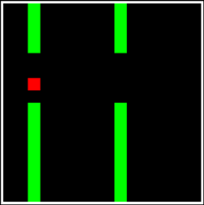 | 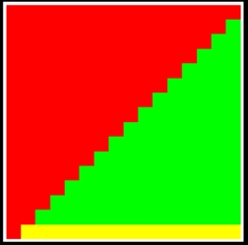 | 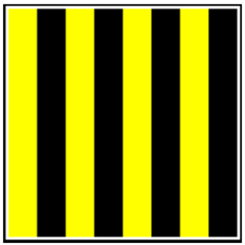
Figure 1: Screenshots of the Simulated LED Matrix
The LED Matrix Simulation, shown above with 3 example still frames in Figure 1, is a digital twin of the 16x16 LED Matrix Display shown below in Figure 2. Each LED in the matrix has two channels: red and green. When both channels are selected, the resulting color is yellow, and when neither is selected, the pixel is off and appears as black.

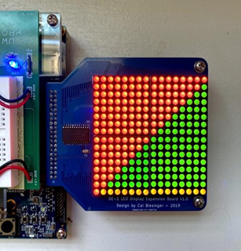
Figure 2: Physical LED Matrix

Digital Twin Interface
To select the virtual LED matrix as our user interface, go to the FPGA remote lab and click Edit next to the User interface, as indicated by the red arrow in Figure 3.

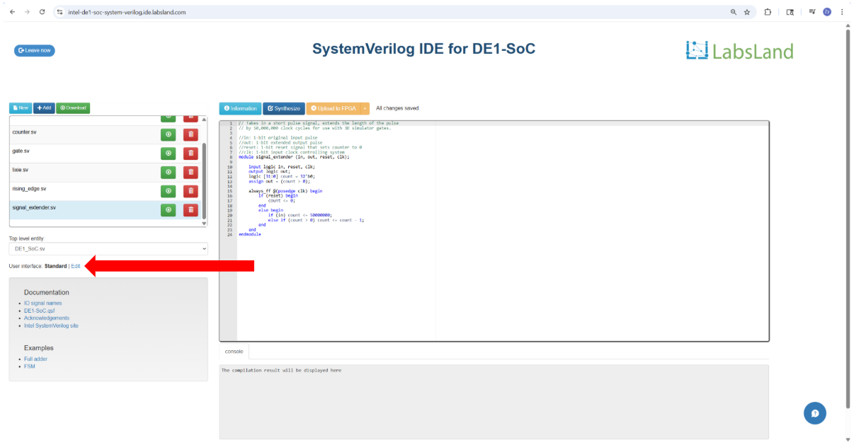
Figure 3

Next, locate the LED matrix and click on it, as indicated by the red arrow in Figure 4.
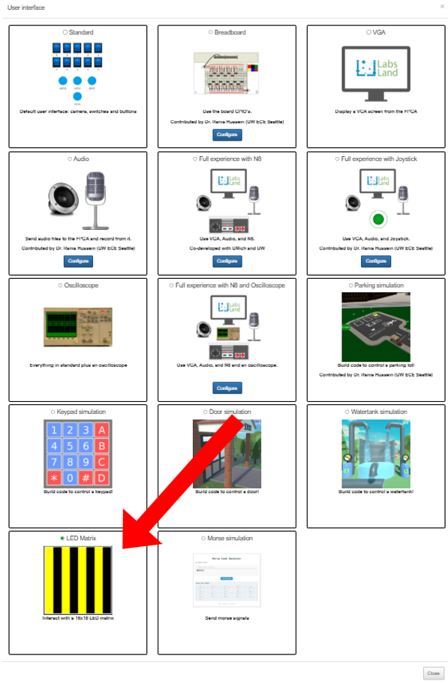
Figure 4

Exit the user interface selection window by clicking the X button on the upper right of the user interface selection window or anywhere outside of the user interface selection window.

3. Simulation Components

3.1 16x16 Matrices
The 16x16 LED output is modeled as two 16bit x 16bit arrays. One array represents the green channel for each LED, and the other array represents the red channel. Students will assign a bit to 0 to represent a channel being off and a bit to 1 to represent a channel being on. Resulting colors are shown in the table below.

Red Channel | Green Channel | Resulting Color
0 | 0 | Black (off)
0 | 1 | Green
1 | 0 | Red
1 | 1 | Yellow

3.2 Digital Display
The primary component of the LED Matrix is the 16x16 digital representation of the display located below the live camera view of the hardware device under test. This is shown in Figure 5 for the De1-SoC.

Note that the buttons and switches are standard DE1-SoC web interfaces and not unique to the LED Matrix simulation.
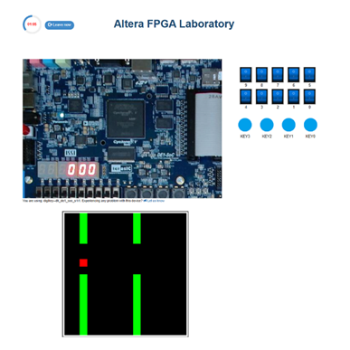
Figure 5: Simulation and Interaction Page
The largest difference between the digital and physical displays is largely aesthetics, with the digital appearing more similar to a modern display, while the physical hardware has clear zones and spacing between pixels reflecting the physical circuitry.

3.3 Included Virtual LED Driver
The simulation uses a Latch and Pulse GPIO communication scheme between the device under test (DUT) running the student’s code and the simulation device. Each frame of the display begins with a latch followed by 256 (16x16) pulses synchronized with accompanying data bits on the green and red GPIO. In Figure 6, this scheme is pictured for a single data output GPIO labeled “data”.

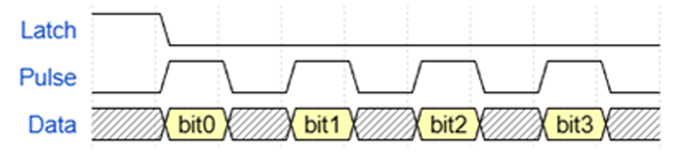
Figure 6: Communication Scheme between DUT and Simulation Device
This communication scheme is likely beyond the scope and goals of many laboratory exercises created for this simulation, and as such, we provide driver code for the simulation. Students need only provide basic signals, such as clock, reset, enable, green pixels, and red pixels, to use the given driver code.

Additionally, the need to send 256 pulses for each frame will likely require students to run their designs at clock speeds above 1kHz if they aim to create animated images.

4. GPIO Mappings

4.1 Inputs
none

4.2 Outputs

Signal Name | Description | V_GPIO
Green | Represents the state of the green channel for the current pixel | 32
Red | Represents the state of the red channel for the current pixel | 34
Latch | The “start communication” signal precedes 256 pulses. | 26
Pulse | Synchronization signal to tell the simulation device when to read the values of the Green and Red GPIO signals. There must be 256 pulses following each Latch. | 27

5. Possible Specifications
This section briefly outlines possible ways to use this simulation to develop a laboratory assignment. Example specifications for this simulation go into further detail.

5.1 Image Loader
Use the on-board switches of the device under test to select one of several pre-loaded static images to display. Static images could be hard coded or stored in a memory initialization file.

5.2 Paint Application
Use the on-board switches and buttons to select a pixel to edit and a color to set it to. Allow the user to undo and redo changes and save their image to memory during execution.

5.2 Arcade Game
Use the on-board switches and buttons to create a retro-style arcade game with real-time updates to the display.

6. Suggested Learning Objectives
This section outlines possible learning objectives/topics students could demonstrate using this simulation.

Broad Learning Objectives
- Design hardware that operates correctly in a time-varying environment
- Implement and debug a synchronous digital control system
- Interface with an external device using a defined communication protocol
- Manage frame-based rendering systems in hardware

Possible Hardware and Specification Specific Objectives
- Clock Domain Crossings
- Memory (RAM / ROM)
- Finite State Machines
- On-board switches and buttons

