Digital Twin of a Breadboard
Hardware: FPGA
Language: English


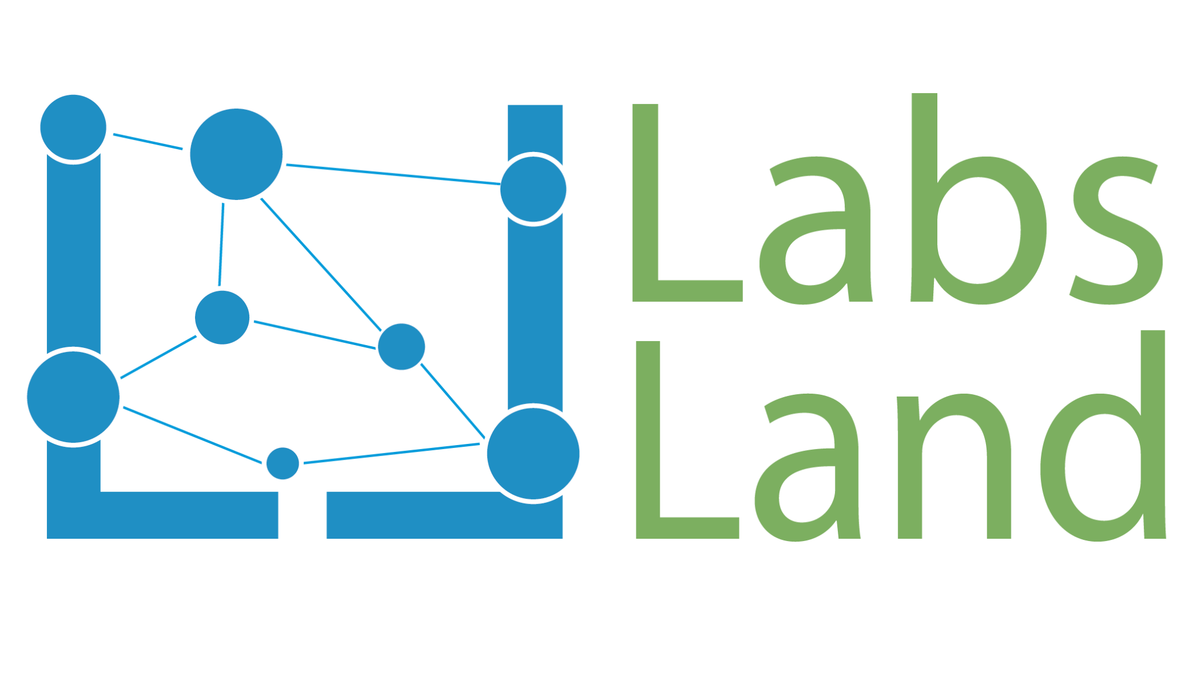

Table of Contents
Digital Twin of a Breadboard 1
Table of Contents 2
1. Defining Remote and Simulated Laboratories 3
2. Simulation Overview 4
3. Simulation Components 9
4. GPIO Mappings (Pinout is shown in Figure 9) 10
5. Possible Specifications 11
6. Suggested Learning Objectives 12

1. Defining Remote and Simulated Laboratories

What is a Remote Laboratory?
Remote laboratories are systems that combine hardware and software to allow students to perform real educational experiments over the Internet. In other words, students can control physical lab equipment and collect real data remotely, without being physically present in the laboratory.

These labs remove space and time barriers, allowing students to practice anytime, increasing the experience essential for STEM learning. They also encourage active and inquiry-based learning, promoting autonomy since students can work independently of instructors and lab hours.

What is a Simulated Laboratory?
Remote laboratories provide students with, over the Internet, access to real hardware hosted in a server room, while simulated laboratories virtualize the inputs, outputs, and internal behavior of hardware and entire systems. This allows students to work with unique and engaging systems that remote laboratories could not support, such as entire industrial dams, arcade machines, communication networks, and other expensive or niche hardware.

REDTAIL Hardware + Simulation Context
REDTAIL is a Remote Laboratory Simulation framework developed by LabsLand and the Remote Hub Lab at the University of Washington.

In REDTAIL, students write or upload code through a LabsLand web IDE. Their code is compiled and deployed to real physical devices (e.g., FPGAs and microcontrollers) that communicate bidirectionally with other devices running an instructor-selected simulation. These simulation devices communicate with LabsLand servers, allowing students to interact with and control the simulation via a web interface. This enables them to test their code in real time, as they would with a physical device or environment.

Each simulation can support many different lab assignments. We provide example specifications for each simulation, but instructors are welcome to create their own.

2. Simulation Overview
The digital twin of a breadboard enables students to create circuits using electronic components commonly taught in introductory digital circuit design courses.
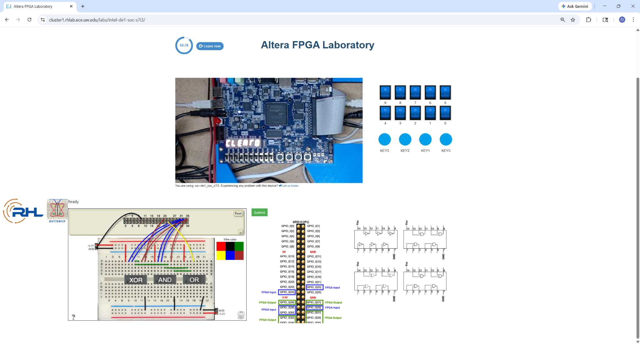
Figure 1. Image of the DE1-SoC development board (top) and the digital twin of a breadboard (bottom).

Specifically, the digital twin supports all the hardware shown in Figure 2:
- Green LEDs
- Toggle switches
- 4 different logic chips from the 7400-series IC: NOT, AND, OR, and XOR

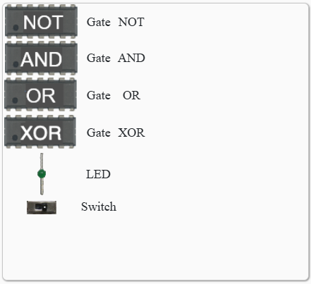
Figure 2. List of electronic components supported by the digital twin of a breadboard.

Digital Twin Interface
To select the digital twin of a breadboard as our user interface, go to the FPGA remote lab and click Edit next to the User interface, as indicated by the red arrow in Figure 3.

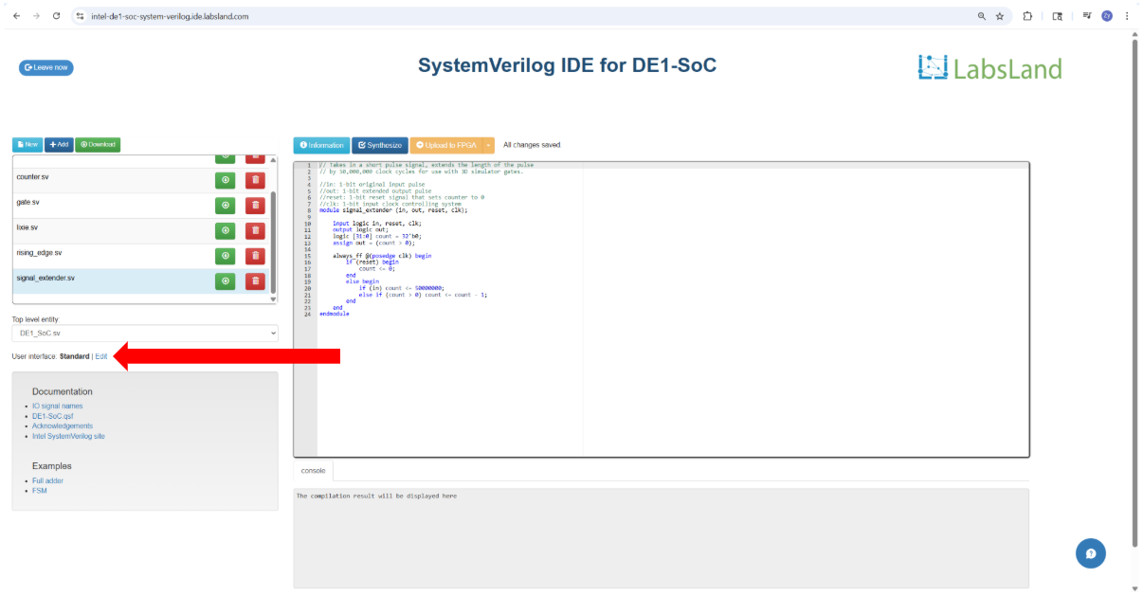
Figure 3

Next, locate the Breadboard and click on it, as indicated by the red arrow in Figure 4. Click the Configure button to construct a circuit, as indicated by the green arrow in Figure 4.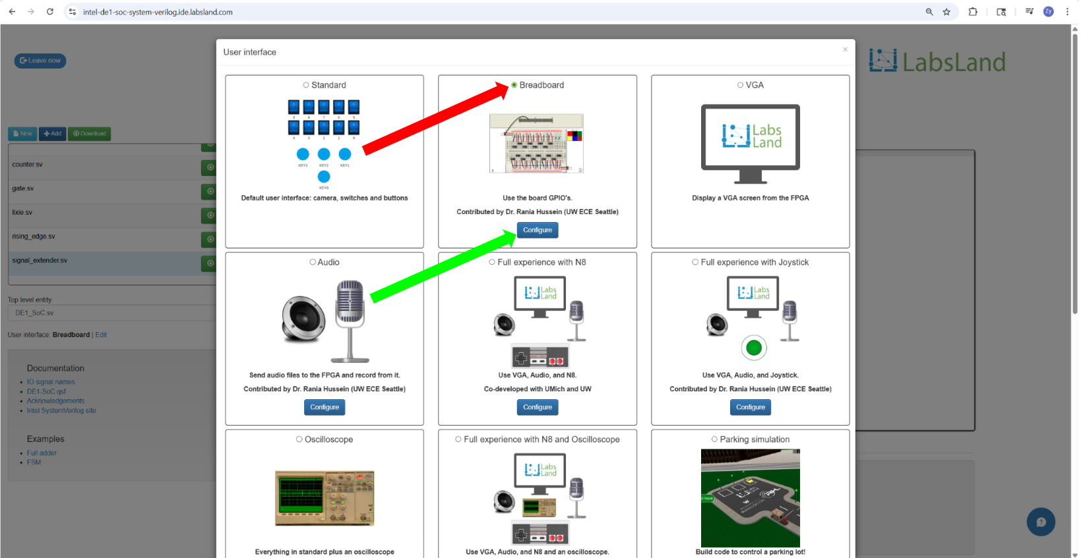
Figure 4

Important parts of the digital twin of a breadboard interface are highlighted in Figure 5. Clicking the + (indicated by the red arrow in Figure 5) will pull up a library of supported electronic components.
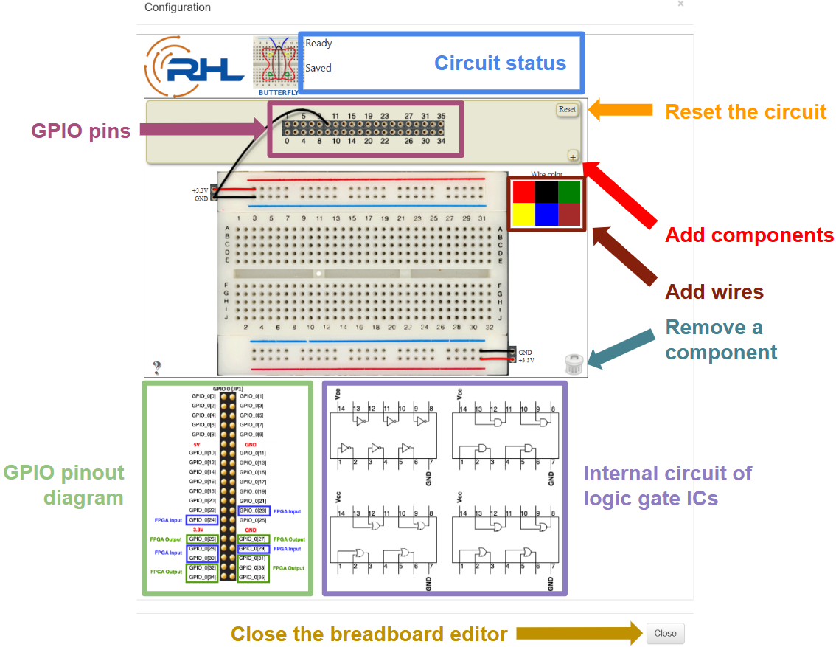
Figure 5

Each click on the name or image of an electronic component will add one instance of that component to the digital twin of a breadboard next to the GPIO Pins. The clickable region for each component is highlighted in Figure 6.
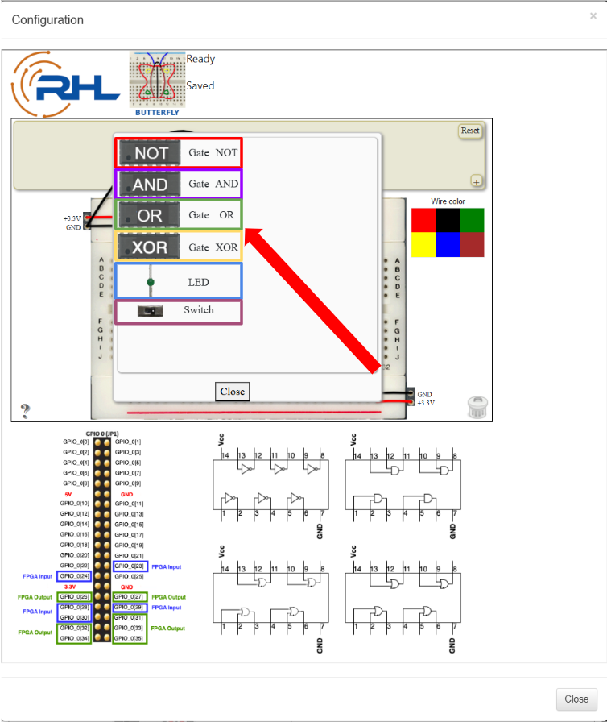
Figure 6

LED
The simulation only supports green virtual LEDs. One end of the LED must be connected to GND, as shown in Figure 7.
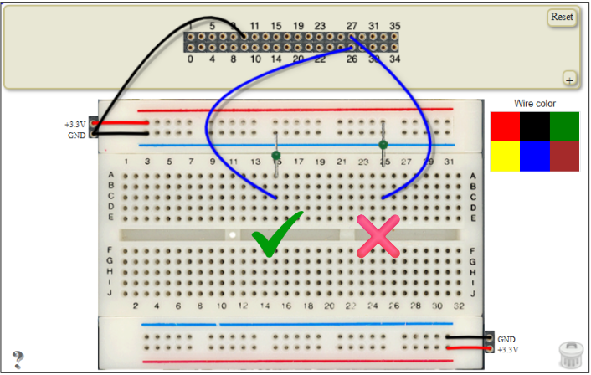
Figure 7. A working LED circuit (left) and a non-working LED circuit (right).

Toggle switches
For a switch, the left pin must be connected to +3.3V, while the right pin must be connected to GND, as shown in Figure 8.

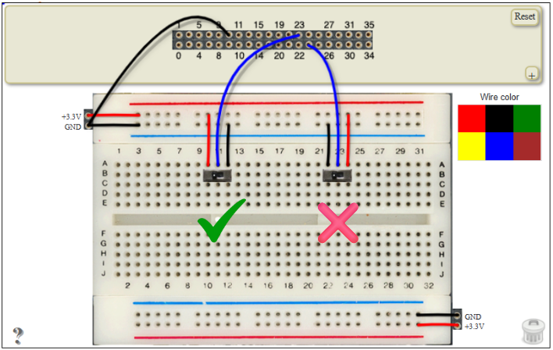
Figure 8

After the circuit on the virtual breadboard is constructed, and the circuit status shows no error, exit the breadboard editor by clicking on the Close button located on the lower right of the breadboard editor (also highlighted in Figure 5).

Exit the user interface selection window by clicking the X button on the upper right of the user interface selection window or anywhere outside of the user interface selection window.

3. Simulation Components
Describe all variables, visual queues, inputs, outputs, buttons, limitations, and so on in depth.

3.1 Example Limitation Component
- Virtual Breadboard Placement Bug
A rare bug affects the upper right corner of the virtual breadboard. Components, typically LEDs, placed in this specific area may incorrectly trigger a false error in the circuit status window, even when the circuit is properly constructed.
- Toggle Switch Interaction Bug
A rare bug affects the toggle switches. When clicking to change their state, the switches may unexpectedly shift position. If this occurs, gently moving the switch back to its original working position should restore normal functionality.

4. GPIO Mappings (Pinout is shown in Figure 9)

4.1 Inputs

Description | V_GPIO
All the input GPIOs work the same | 23, 24, 28, 29, 30

4.2 Outputs

Description | V_GPIO
All the output GPIOs work the same | 26, 27, 31, 32, 33, 34, 35

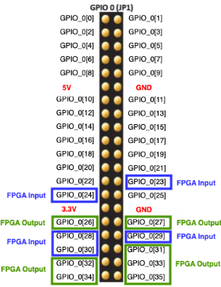
Figure 9

5. Possible Specifications
This section briefly outlines possible ways to use this simulation to develop a laboratory assignment. Example specifications for this simulation go into further detail.

5.1 Example 1: Introduction to GPIO
A foundational lab assignment introducing GPIO can utilize the digital twins of toggle switches and LEDs. Students can complete simple tasks, such as controlling the LEDs directly with the switches, to understand basic digital input and output concepts.

5.2 Example 2: Combinational Logic Design
A lab focusing on digital circuit design could have students develop complex circuits using digital twins of 7400-series ICs, which include NOT, AND, OR, and XOR gates. A practical example is constructing a 4:1 multiplexer (MUX). The inputs to the MUX can be driven by the FPGA—either by physical pushbuttons or onboard switches—or be generated entirely within the HDL code. The outputs of the MUX can be routed to the LEDs on the virtual breadboard or to the onboard peripherals (such as LEDs and 7-segment displays) of the development board.

5.3 Example 3: Integration to Complex Logic
A more advanced assignment would integrate the breadboard digital twin into a more complex task. For instance, students could design a sophisticated FPGA-based system using Finite State Machines (FSMs). In this scenario, the FSM reads inputs from the virtual switches—which simulate various sensor values—and controls the virtual LEDs on the breadboard to visually represent the different states of the system.

6. Suggested Learning Objectives
This section outlines possible learning objectives/topics students could demonstrate using this simulation.
Possible objectives
- Interfacing General Purpose Input/Output (GPIO)
- Designing and constructing digital circuits
- Learning combinational logic

Possible Topics
- GPIO
- Digital Circuit Design
- Common Electronic Parts (LED, Switch, 7400-series ICs)
- Combinational Logic

